Predictive Modeling Framework for Agricultural Yield Forecasting
Using machine learning to predict crop yield, with a worked example on test data
Week 4 Task | Internship Report

Summary
The aim of this task was to outline how machine learning could be used to forecast crop yields. I did not want to only describe the method, so I also tried it out. I built a test dataset, ran every step of the process on it, and measured how well it worked. The report explains each step and shows the numbers from that run.
One thing to say clearly: the test dataset is simulated. I generated it to behave like real farm data (more water and fertiliser raise yield, heat lowers it, and so on), because I did not have access to real farm records. So the results show how the method behaves, but they should not be read as the accuracy you would get on a real farm.
What | Result
Data | 650 records from 50 farms over 13 seasons (2011 to 2023)
Messy data | 177 of the 650 rows (27.2%) had something missing, and 9 impossible values were caught by the checks
Train / validation / test | 500 rows (2011 to 2020) / 50 rows (2021) / 100 rows (2022 and 2023)
Best model | Gradient Boosting: average miss of 0.50 t/ha (RMSE), MAPE 11.4%, R² 0.69
Compared with simple guessing | 55.6% smaller error than using last year's yield
What did not work well | Every model predicted about 0.26 t/ha too low on average. That is 7.0% of the mean yield, above the 5% limit I set. I explain this in Section 8.

1. Why Predict Crop Yield?
Farmers have to spend money long before they know what the harvest will be. Seed, fertiliser, water, labour, storage and sales contracts are all decided in advance. A bad guess is expensive. In my test data, yields in the test seasons ranged from about 1.3 to 6.0 t/ha, with an average of 3.69 t/ha. If a forecast is off by just 1 t/ha, that is a 27% error on the average farm, which is enough to upset a supply contract or waste a fertiliser budget.
The usual shortcut is to assume this year will look like last year, or like the long-term average. That ignores the weather and soil of the current season. In my test, "same as last year" had an average error of 1.13 t/ha, and its R² was negative (-0.55), which means it did worse than simply guessing the average every time. A machine learning model that looks at the actual conditions brought the error down to 0.50 t/ha.

Example: what a better forecast is worth
To make this concrete, imagine a cooperative that farms 500 ha and sells at USD 250 per tonne. These two figures are my own assumptions, just for illustration. The forecast error in tonnes is the error per hectare times the area. With last year's yield as the forecast, 1.13 × 500 = 563 t of typical error, worth about USD 140,750. With the model, 0.50 × 500 = 250 t, worth about USD 62,500. The difference is 313 t, or about USD 78,250, that no longer has to be hedged, stored "just in case", or bought in at the last minute.
The same model also helps with resource use. Once it is trained, we can feed it different inputs (for example nitrogen at 80, 100 and 120 kg/ha) and see how much extra yield each step gives. The sensible stopping point is where the extra yield no longer pays for the extra fertiliser.

2. The Modeling Process in Brief
The whole process has seven stages. For each one I wrote down what goes in, what comes out, and a simple test for whether it was done properly. The last column says where the stage is covered in this report.
# | Stage | Input | Output | Pass test | Section
1 | Define the problem | The business question | Target: yield in t/ha per farm per season | Target and timing written down | 1, 9
2 | Collect data | Farm, weather, soil, satellite records | 650 records, 9 features | At least 10 seasons | 3
3 | Clean and check | Raw table | Valid, filled-in table | No rule violations left | 4
4 | Build and pick features | Clean table | 18 model inputs | No pair with |r| > 0.85 | 5
5 | Train and tune | Training and validation data | Tuned models | Tuned on validation only | 6, 7
6 | Evaluate | Locked test data | Metrics and ranges | Pass marks in Section 8 | 8
7 | Use and monitor | Chosen model | Forecasts each season | Error checked every season | 10

3. The Test Data
The dataset has 650 rows, one for each farm in each season: 50 farms in 3 regions, over 13 seasons (2011 to 2023). The 2010 season is only used to work out "last year's yield" for 2011. I wrote the simulation so that yield goes up with water and nitrogen (with diminishing returns), goes down with heat stress and when soil pH is far from 6.7, goes up with soil organic carbon, and improves by 0.05 t/ha per year through better technology. I added random noise on top (standard deviation 0.28 t/ha). Then I deliberately made the data messy, with missing values from cloud cover and skipped soil tests, and a few typing mistakes, because real data always has these problems.
The model uses these inputs. A fuller data dictionary is in Appendix A.
Input | Unit | What it is
rainfall_mm | mm | Rain during the growing season
avg_temp_c | °C | Average temperature in the season
heat_days | days | Days hotter than 35 °C
soil_ph, soil_oc_pct | pH, % | Soil acidity and organic carbon
nitrogen_kg_ha | kg/ha | Nitrogen fertiliser applied
irrigation_mm | mm | Irrigation water applied
ndvi_peak | 0 to 1 | Peak satellite vegetation index (how green and healthy the crop is)
prev_yield | t/ha | The same farm's yield the season before

4. Checking the Data, Filling Gaps and Handling Outliers

4.1 Validation rules
Before any modeling, every value is checked against a sensible range. A value outside its range is not thrown away. It is marked as missing and then treated like any other gap (see 4.2). To test the rules, I had seeded the data with 9 mistakes, and all 9 were caught.
Variable | Valid range | Why this limit | Caught | Examples
rainfall_mm | 0 to 2,500 | Rain cannot be negative, and over 2,500 mm in a season would be a sensor or typing fault here | 3 | −35, 4,800, 9,999
soil_ph | 3.5 to 9.5 | Crops do not grow outside this range, and pH 14 is clearly a typo | 3 | 14.2, 0.0, 66.0
ndvi_peak | 0 to 1 | NDVI cannot go outside this range by definition | 3 | 1.4, 1.7, −0.2
avg_temp_c | −5 to 50 | Physical limits for a season average | 0 | none
nitrogen_kg_ha | 0 to 400 | Above 400 kg/ha is not realistic | 0 | none
yield_t_ha | 0 to 15 | Yield must be positive and below the crop maximum | 0 | none

There are three more checks. Each farm and season may appear only once (no duplicates were found). No input may be recorded after the date of the forecast, otherwise the model would be using information it would not really have. And any value more than 3 standard deviations away from that farm's own history is flagged for a person to look at, not deleted automatically.

4.2 Missing values
Before validation, the missing counts were 78 for ndvi_peak (12%), 52 for soil_ph (8%), 31 for rainfall_mm (4.8%) and 26 for nitrogen_kg_ha (4%). After the impossible values were turned into gaps, they became 81 (12.5%), 55 (8.5%), 34 (5.2%) and 26 (4.0%). How I fill a gap depends on how much of that column is missing:
Share missing | What to do | What I did here
Under 5% | Fill with the median (numbers) or the most common value (categories) | nitrogen_kg_ha (4.0%): median of 97.17 kg/ha
5% to 30% | Fill with the median and add a 0/1 "was missing" column, so the model can learn if missing data means something | rainfall (5.2%), soil pH (8.5%), NDVI (12.5%)
30% to 50% | Use a smarter fill (k-nearest-neighbour or iterative imputation) and check results with and without the column | Not needed
Over 50% | Drop the column | Not needed

Two rules stop information leaking from the test data into the model. The medians are worked out from the training rows only, and filling happens after the data has been split. The training medians were:
Input | Median | Input | Median
rainfall_mm | 648.35 | nitrogen_kg_ha | 97.17
soil_ph | 6.63 | ndvi_peak | 0.68

Here are three examples of how a gap gets filled. First, the simple way I used: a farm with no NDVI reading gets 0.681, the training median, plus the flag ndvi_peak_was_missing = 1.
Second, a better way for satellite data. If NDVI was 0.52 on day 160 and 0.64 on day 192, but clouds hid day 176, we can interpolate: (0.52 + 0.64) / 2 = 0.58. This works well when the two clear readings are less than 16 days apart.
Third, a better way for rainfall. If a rain gauge failed, use the two nearest stations within 25 km, weighted by how close they are. Say they are 10 km and 20 km away and recorded 600 mm and 660 mm. The weights are 1/10 = 0.100 and 1/20 = 0.050, so the estimate is (0.100 × 600 + 0.050 × 660) / 0.150 = 620 mm.

4.3 Outliers
For outliers I used the interquartile range (IQR) rule. A value is flagged if it is below Q1 − 1.5×IQR or above Q3 + 1.5×IQR. For training rainfall, Q1 was 537.9 mm and Q3 was 746.7 mm, so the IQR was 208.8 mm and the limits were 224.6 mm and 1060 mm. Only 2 of 474 values (0.4%) fell outside. Real droughts and floods do happen, so I did not delete flagged values. I capped them at the 1st and 99th percentile of the training data instead.

5. Choosing the Input Features

5.1 What goes in and why
Group | Features | Why they matter
Weather | Rainfall, average temperature, days above 35 °C, growing degree days | Water and heat during flowering and grain filling cause most of the year-to-year swings in yield
Soil | pH, organic carbon (and, if available, nitrogen, phosphorus, potassium) | Decides how much food and water the crop can get, and explains why neighbouring farms differ
Satellite | Peak NDVI (and, if available, EVI or soil moisture) | A direct, objective picture of crop health in each field
Management | Nitrogen, irrigation (and, if available, sowing date and variety) | These are the things the farmer can change, so they are needed for optimising inputs
History | Last season's yield | Shows how good a farm normally is and picks up the technology trend
Economic | Input and crop prices (not used in the test) | Lets yield forecasts be turned into revenue forecasts

5.2 Building new features (with examples)
Raw measurements are often less useful than a combination of them, so I created a few extra features. Total water is rainfall plus irrigation. For the first test farm that is 416.12 + 0 = 416.12 mm. The heat and temperature feature is heat days multiplied by average temperature, because a hot day hurts more in an already warm season. The soil pH feature is (pH − 6.7)², so that both acidic and alkaline soil count against yield: a farm at pH 6.51 scores (6.51 − 6.7)² = 0.036, while a farm at pH 5.5 scores 1.44.
Growing degree days (GDD) measure how much useful heat a crop has received: GDD = max(0, (Tmax + Tmin) / 2 − Tbase), with a base temperature of 10 °C. For five days with Tmax of 28, 31, 33, 30 and 26 and Tmin of 14, 16, 18, 15 and 11, the daily values are 11.0, 13.5, 15.5, 12.5 and 8.5, which adds up to 61 GDD. I did not use GDD in the test run because I only simulated seasonal summaries, but it is the first thing I would add when daily weather data is available.
For linear models the inputs are also standardised: z = (x − mean) / standard deviation. Training rainfall had a mean of 639.1 mm and a standard deviation of 147.9 mm, so the first test farm (416.12 mm) gets z = (416.12 − 639.1) / 147.9 = −1.51. In other words it was 1.5 standard deviations drier than normal. Tree-based models do not need this step.

5.3 How features were kept or dropped
Rule | Threshold | What happened
Too much missing data | Drop if over 40% missing | Nothing dropped. NDVI had the most missing at 12.5%
Two features say the same thing | If |correlation| is above 0.85, drop one | The closest pairs were rainfall and NDVI (r = 0.77) and temperature and heat days (r = 0.66). Both are under 0.85, so I kept everything
Not useful | Permutation importance under 0.01 t/ha is a candidate to remove | The seven strongest are in the chart below. The rest were all under 0.019 t/ha and are worth reviewing next time
Makes sense to an agronomist | Top features must be explainable | Heat, nitrogen, soil carbon and water came out on top, as expected

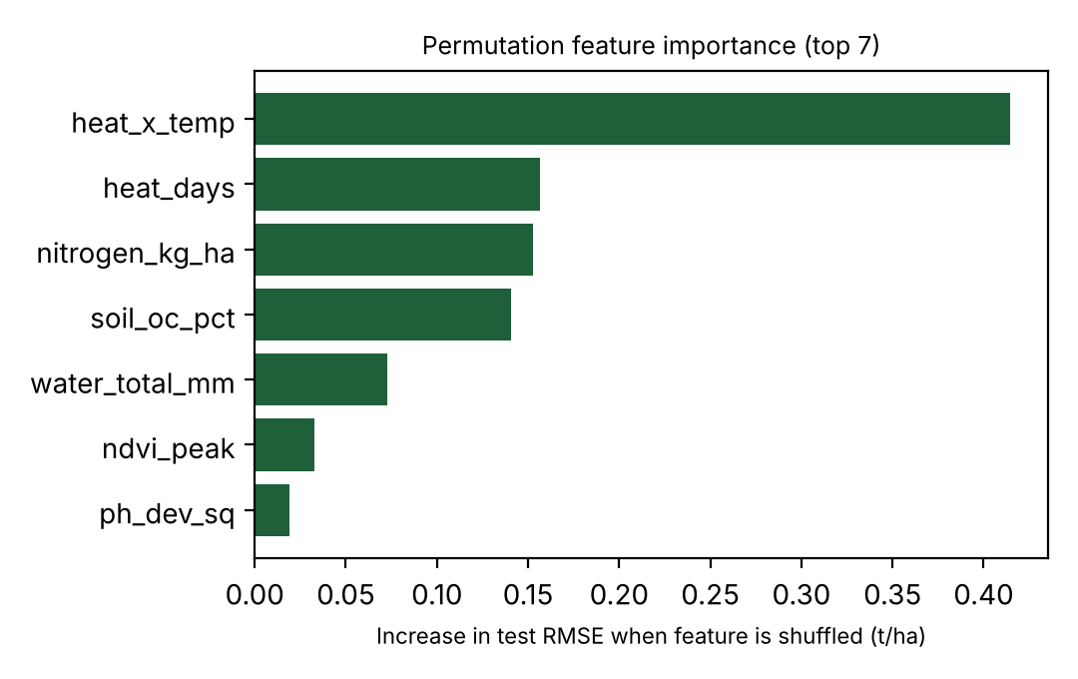
Figure 1. Permutation importance on the test set. It shows how much the error goes up when one feature is randomly shuffled.
The heat and temperature feature was the most important, followed by heat days, nitrogen and soil organic carbon. That matches how I built the data. It also shows that building good features helped more than using a more complicated model.

6. The Algorithms
I tried the models in order from simple to complex, and always compared them with two simple guesses: last year's yield, and the average yield in the training data. A model is only worth using if it clearly beats these.
Model | Settings tried (on 2021 data) | Setting chosen | Validation RMSE (t/ha)
Guess: last year's yield | None | - | -
Guess: training average | None | - | -
Linear regression | None (inputs standardised) | Ordinary least squares | -
Random Forest | Tree depth 6, 10, 14 and minimum leaf size 1, 3, 5 (9 combinations), 200 trees | Depth 14, leaf size 1; final model uses 300 trees | 0.497
Gradient Boosting | Learning rate 0.03, 0.05, 0.1 and depth 2, 3, 4 (9 combinations), 300 trees | Learning rate 0.03, depth 4 | 0.473
Ensemble | Average of Random Forest and Gradient Boosting | Equal weights | -

For a bigger real project I would also consider support vector regression for small datasets, neural networks once there are more than about 5,000 records, LSTM networks for daily weather sequences, and convolutional networks for satellite or drone images. I did not run them here. With 650 records and only seasonal summaries, deep learning would not be reliable.

7. Training the Models

7.1 Splitting the data
Yield data comes in order of time. If I had split it randomly, the model could have learned from future seasons and then been tested on earlier ones, which gives results that look better than they really are. So I split by year, which is also how a real forecast works: you only know the past.
Set | Seasons | Rows | Used for
Training | 2011 to 2020 | 500 | Learning from the data and calculating the medians
Validation | 2021 | 50 | Choosing settings and comparing models
Test (locked) | 2022 to 2023 | 100 | One final fair check; includes the 2022 drought

7.2 Repeating the test over several seasons
One test split could be lucky, so I also retrained the Gradient Boosting model four times. Each time it was trained on all earlier seasons and asked to predict the next one:
Season predicted | Training rows | Test rows | RMSE | MAE | MAPE % | R²
2018 | 350 | 50 | 0.520 | 0.423 | 12.7 | 0.655
2019 | 400 | 50 | 0.434 | 0.343 | 10.2 | 0.778
2020 | 450 | 50 | 0.476 | 0.409 | 10.5 | 0.558
2021 | 500 | 50 | 0.473 | 0.370 | 10.4 | 0.675
Average |  |  | 0.476 | 0.386 | 11.0 | 0.667

RMSE stayed between 0.434 and 0.520 t/ha. That is a spread of 0.086, or 18% of the average, so the model behaves in a steady way from one season to the next.

7.3 Avoiding overfitting
Overfitting means the model memorises the training data and does badly on new data. To guard against it I only tuned settings on the validation set and left the test set alone until the end. If validation error is more than 25% higher than training error, the plan is to simplify the model (shallower trees, lower learning rate, bigger minimum leaf size). And if a simpler model is within 5% of the best one, I would pick the simpler one.

8. How Well Does It Work?

8.1 The measures I used
Measure | How it is calculated | What it tells you
MAE | average of |predicted − actual| | The average miss in t/ha, easy to explain to a farmer
RMSE | square root of the average of (predicted − actual)² | A typical miss in t/ha; big misses count extra
MAPE | average of 100 × |error| / actual | The miss as a percentage, so crops with different yields can be compared
R² | 1 − SSE / SST | How much of the ups and downs in yield the model explains; 0 means no better than guessing the average
Bias | average of (predicted − actual) | Negative means the model usually predicts too low

8.2 A worked calculation on eight records
To show how these numbers come about, here are the first eight test records from the Gradient Boosting model. Error means predicted minus actual.
Record | Actual (t/ha) | Predicted (t/ha) | Error | |Error| | Error² | % error
1 | 4.57 | 4.50 | -0.07 | 0.07 | 0.005 | 1.5
2 | 3.84 | 3.87 | 0.03 | 0.03 | 0.001 | 0.8
3 | 3.40 | 3.97 | 0.57 | 0.57 | 0.325 | 16.8
4 | 4.63 | 4.41 | -0.22 | 0.22 | 0.048 | 4.8
5 | 3.96 | 3.89 | -0.07 | 0.07 | 0.005 | 1.8
6 | 5.09 | 4.57 | -0.52 | 0.52 | 0.270 | 10.2
7 | 4.59 | 3.87 | -0.72 | 0.72 | 0.518 | 15.7
8 | 5.53 | 4.63 | -0.90 | 0.90 | 0.810 | 16.3
Sum |  |  | -1.90 | 3.10 | 1.983 | 67.9

- MAE = 3.10 / 8 = 0.388 t/ha
- RMSE = √(1.983 / 8) = √0.2479 = 0.498 t/ha
- MAPE = 67.9 / 8 = 8.5%
- Bias = -1.90 / 8 = -0.24 t/ha, so the model predicted a little low on these eight
- R² = 1 − SSE / SST. The mean actual yield is 4.451 t/ha, SST (total variation around that mean) is 3.3571 and SSE (the sum of squared errors) is 1.983, so R² = 1 − 1.983 / 3.3571 = 0.409
That R² is lower than the 0.694 on the full test set, and that is expected. Eight records are a small and noisy sample, which is why I always report the measures on the whole test set.

8.3 Results on the full test set
The locked test set has 100 farm-seasons from 2022 and 2023, with an average yield of 3.69 t/ha.
Model | RMSE | MAE | MAPE % | R² | Bias
Naive (last year yield) | 1.126 | 0.874 | 26.4 | -0.548 | -0.209
Naive (train mean) | 0.946 | 0.757 | 22.4 | -0.094 | -0.277
Linear regression | 0.489 | 0.411 | 11.1 | 0.709 | -0.292
Random Forest | 0.532 | 0.438 | 11.8 | 0.654 | -0.268
Gradient Boosting | 0.500 | 0.414 | 11.4 | 0.694 | -0.259
Ensemble (RF + GB average) | 0.510 | 0.423 | 11.5 | 0.683 | -0.263
Test set results. RMSE, MAE and bias are in t/ha.
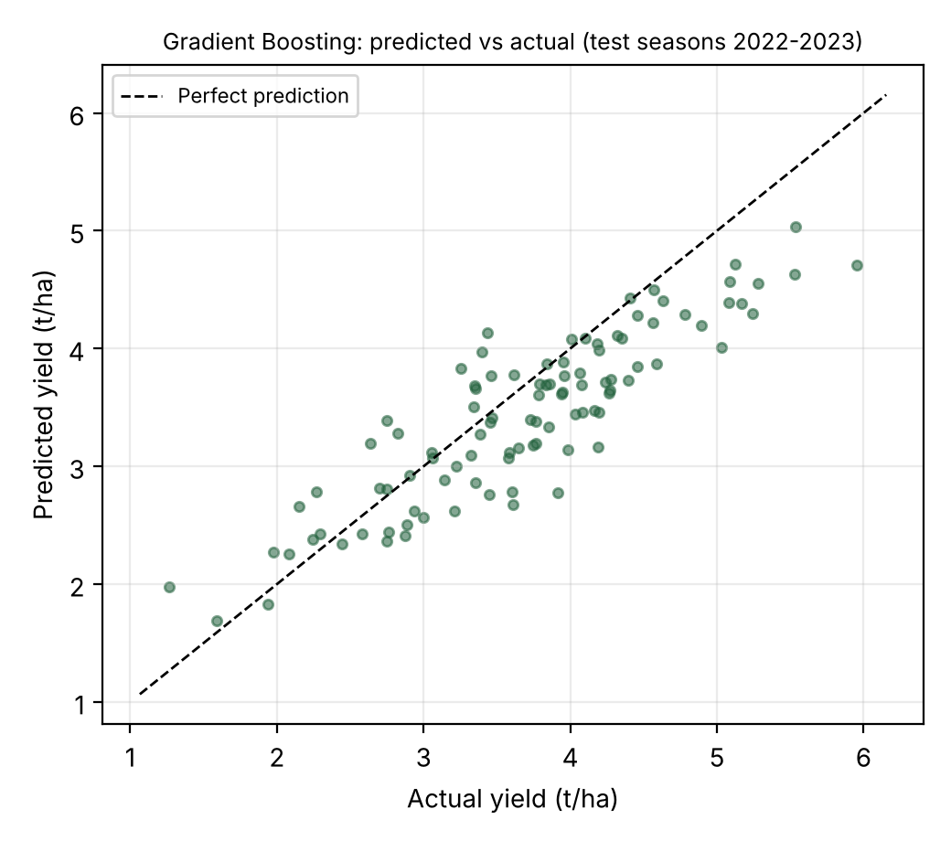
Figure 2. Predicted against actual yield for the 100 test records. A point on the dashed line would be a perfect prediction.
All the machine learning models beat both simple guesses by a wide margin. The interesting part is that plain linear regression (RMSE 0.489) did almost as well as Gradient Boosting (RMSE 0.500). The gap is only 0.011 t/ha, about 2.2%. I think the reason is that the features I built (total water, heat interaction, pH distance) had already captured the curved relationships, so the simple model had little left to miss. With real data, which is less tidy, I would expect the boosted model to pull ahead more, so I would keep both. Figure 2 also shows that the model slightly under-predicts the very highest yields, which is a common habit of tree-based models.

8.4 Did it pass?
Before looking at the test results I set pass marks. Here is how the Gradient Boosting model did against each one:
Check | Required | Result | Outcome
RMSE better than the best simple guess | At least 20% lower | 47.1% lower than the training average | Pass
MAPE | 12% or less | 11.4% | Pass
R² | 0.60 or more | 0.694 | Pass
Steadiness across seasons (RMSE spread) | 25% of average or less | 18% | Pass
Drought year vs normal year RMSE | No more than 1.25 times | 0.493 vs 0.508, ratio 0.97 | Pass
90% range really covers 90% | Between 85% and 95% | 85% | Just passes (lower edge)
Bias | Within 5% of mean yield | 0.259 t/ha = 7.0% | Fail

The bias check failed, and I want to be upfront about it because it matters for real decisions. Every model, even linear regression (bias -0.292), predicted about 0.26 to 0.29 t/ha too low in the test seasons. My best explanation is that the test seasons come after the training seasons and yields keep rising over time (the average was 3.15 t/ha in 2011 and 3.93 t/ha in 2023). Models trained on earlier years do not fully expect that. I have not tested the fixes yet, but I would try three things: add a year or trend feature, predict each farm's change from its own multi-year average instead of the raw yield, and retrain every season so the newest year is always included.

8.5 Prediction ranges and the drought test
A single number hides how unsure a forecast is, so each forecast should come with a range. I took the 5th and 95th percentiles of the validation errors (actual minus predicted), which were -0.456 and +0.89 t/ha, and added them to each forecast to get an approximate 90% range. On the test set, the actual yield landed inside that range 85% of the time, a little under the 90% target. That fits with the bias problem above. A more careful method called conformal prediction would be the next step.
The drought test is the one I care most about. 2022 was a drought season, with rainfall about 32% below normal. Gradient Boosting had an RMSE of 0.493 t/ha in that year and 0.508 t/ha in the normal year, so it held up in the hardest conditions. The "same as last year" guess scored 0.978 and 1.257.

9. Forecasting in Practice

9.1 When the forecast is made
The same process works for forecasts made at different times. The later the forecast, the more is known and the smaller the error should be. A separate model should be trained for each time, using only the inputs that would really be available then.
Forecast time | Roughly when | Inputs allowed
Before sowing | 2 to 3 months before planting | Soil, last season's yield, planned nitrogen and irrigation, seasonal climate outlook
Mid-season | At flowering | All of the above, plus rain and temperature so far, and NDVI so far
Before harvest | 4 to 6 weeks before harvest | Full-season weather, peak NDVI, heat days (this is the version I tested)

9.2 One forecast, step by step
Here is one record from the test set, followed all the way through. It is farm 0 in 2022, a drought season. The inputs were rainfall 416.12 mm, average temperature 23.84 °C, 0 heat days, soil pH 6.51, soil organic carbon 1.54%, nitrogen 142.24 kg/ha, irrigation 0 mm, peak NDVI 0.58 and last season's yield 3.48 t/ha.
- Check the values. All of them are inside the ranges in Section 4.1, so nothing needs filling in.
- Build the extra features. Total water = 416.12 + 0 = 416.12 mm. Heat and temperature = 0 × 23.84 = 0.00. pH distance = (6.51 − 6.7)² = 0.036.
- Predict. The Gradient Boosting model gave 4.5 t/ha.
- Add the range. 4.5 + (-0.456) = 4.04 and 4.5 + 0.89 = 5.39. The forecast is 4.5 t/ha, with a 90% range of 4.04 to 5.39 t/ha.
- Compare with what happened. The actual yield was 4.57 t/ha, inside the range. The error was -0.07 t/ha (1.5%). The "same as last year" guess would have said 3.48 t/ha, an error of -1.09 t/ha (23.9%).

10. Keeping the Model Reliable
A model that worked last year can quietly get worse, so it needs regular checks after every harvest.
Check | Rule | If it fails
Accuracy | Work out MAPE after each harvest | If MAPE is above 15% (the 12% pass mark plus a 3-point margin), investigate and retrain
Bias | Work out the average error after each harvest | If bias is over 5% of mean yield, add the trend features from Section 8.4
Data drift | Compare each input's average with its training average | If it has moved by more than 2 training standard deviations, flag it for review
Prediction range | How often the actual yield lands inside the 90% range | If under 80%, recalibrate the range
Retraining | Every season after harvest | Add the new season and keep the latest 10
Explainability | Look at feature importance each year | If a top feature stops making agronomic sense, audit the data

11. Using the Same Approach Elsewhere
The stages and pass marks stay the same for other agribusiness problems. What changes is the data going in and the thing being predicted. The table gives some specific adjustments.
Situation | What is predicted | What changes
Other crops | Yield in t/ha | Change the GDD base temperature (about 0 °C for wheat, 10 °C for maize and rice, 15.6 °C for cotton), the key growth stages and the heat threshold (I used 35 °C)
Orchards and plantation crops | Yield per tree or per ha | Add tree age and last year's fruit load, and use at least 10 years of data because many trees bear heavily every other year
Livestock and dairy | Milk in litres per cow per day | Swap crop inputs for feed intake, breed, stage of lactation and a temperature-humidity index; keep the time-based split
Supply chain and demand planning | Tonnes reaching market each week | Use weekly data with a shorter horizon, add transport and storage data, and tighten the MAPE target to 10%
Choosing input levels | Predicted yield at planned inputs | Run the trained model at several nitrogen or irrigation levels and pick the level where extra yield × price just equals extra cost
Crop insurance and credit | Chance that yield falls below 80% of the farm's 5-year average | Switch to a classification model and judge it with precision, recall and the Brier score
A new region with little data | Yield in t/ha | Train on a data-rich region, then fine-tune with at least 100 local records, and test by leaving one whole region out

12. Limits of This Work and Next Steps
The biggest limit is that the data is simulated. The numbers show how the method behaves, but the real accuracy on a particular region will only be known by repeating Sections 4 to 8 on actual farm records. That would be my first step in a real project.
The test set is also small: 100 records from two seasons. That is enough to compare models, but not enough to say much about rare events, so I would want at least five seasons of test data. The bias problem from Section 8.4 has to be fixed and re-tested before anyone relies on these forecasts. And several useful inputs, such as daily weather, growing degree days, soil nitrogen, phosphorus and potassium, and sowing date, were not available in the test and should be added.

13. Conclusion
I set out to outline a way of forecasting crop yields with machine learning, and I tested it end to end on a simulated dataset. The process covers data checks, filling gaps, choosing features, picking models, training in a way that avoids cheating, and judging the results against pass marks set in advance. Gradient Boosting predicted yield with an average error of 0.50 t/ha (MAPE 11.4%, R² 0.69), which is 55.6% better than assuming last year's yield. The test also showed two weak points, a habit of predicting too low and prediction ranges that are slightly too narrow, and I suggested ways to fix both. Because the steps and pass marks are general, the same approach can be used for other crops, livestock, supply chain planning, insurance and new regions, with the changes listed in Section 11.

Appendix A: Data Dictionary
Column | Type | Valid range | Description
year, farm, region | integer | year 2011 to 2023; farm 0 to 49; region 0 to 2 | Identifiers
rainfall_mm | float | 0 to 2,500 | Rainfall in the growing season
avg_temp_c | float | −5 to 50 | Average temperature in the growing season
heat_days | float | 0 to 60 | Days with a maximum above 35 °C
soil_ph | float | 3.5 to 9.5 | Soil pH
soil_oc_pct | float | 0 to 10 | Soil organic carbon, %
nitrogen_kg_ha | float | 0 to 400 | Nitrogen applied
irrigation_mm | float | 0 to 1,000 | Irrigation applied (0, 50, 100 or 150)
ndvi_peak | float | 0 to 1 | Peak vegetation index
prev_yield | float | 0 to 15 | Previous season yield, t/ha
yield_t_ha | float | 0 to 15 | Target: yield in tonnes per hectare

Appendix B: Pipeline Outline
1. LOAD the table, sort by farm and year, create prev_yield (same farm, last season)
2. CHECK each variable against its range; out-of-range values become missing
3. SPLIT by year: train 2011-2020 | validation 2021 | test 2022-2023
4. FILL gaps with medians from the TRAIN rows only; add was_missing flags
5. BUILD features: water_total, heat_x_temp, ph_dev_sq
6. CAP outliers at the train 1st and 99th percentile
7. TRAIN the baselines, linear regression, random forest, gradient boosting
8. TUNE on validation RMSE (9-combination grid for each model)
9. TEST once: RMSE, MAE, MAPE, R2, bias; compare with the simple guesses
10. RANGE: add the 5th/95th percentile of validation errors to each forecast
11. CHECK the pass marks (Section 8.4) and keep a log
12. MONITOR every season and retrain with the newest data

