Figure 1: Initial Film Records
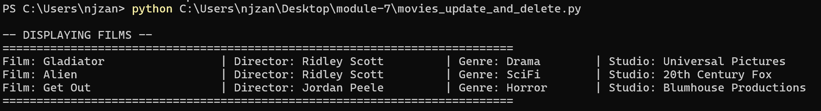
Description: PowerShell window displaying the baseline film records retrieved from the movies database using INNER JOINs prior to data modifications.
Figure 2: Film Records After INSERT
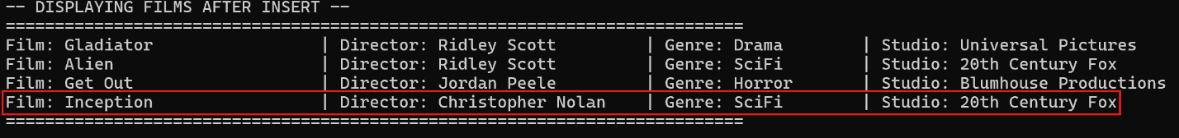
Description: Terminal output showing updated film records following the successful insertion of Inception into the database.
Figure 3: Film Records After UPDATE
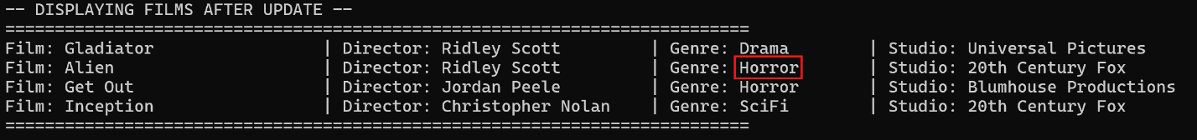
Description: Terminal output showing film records after executing the UPDATE query to set the genre of Alien to Horror.
Figure 4: Film Records After DELETE
Description: Terminal output showing final film records after executing the DELETE query to remove Gladiator from the database.

