Figure 1: Terminal Execution of movies_queries.py
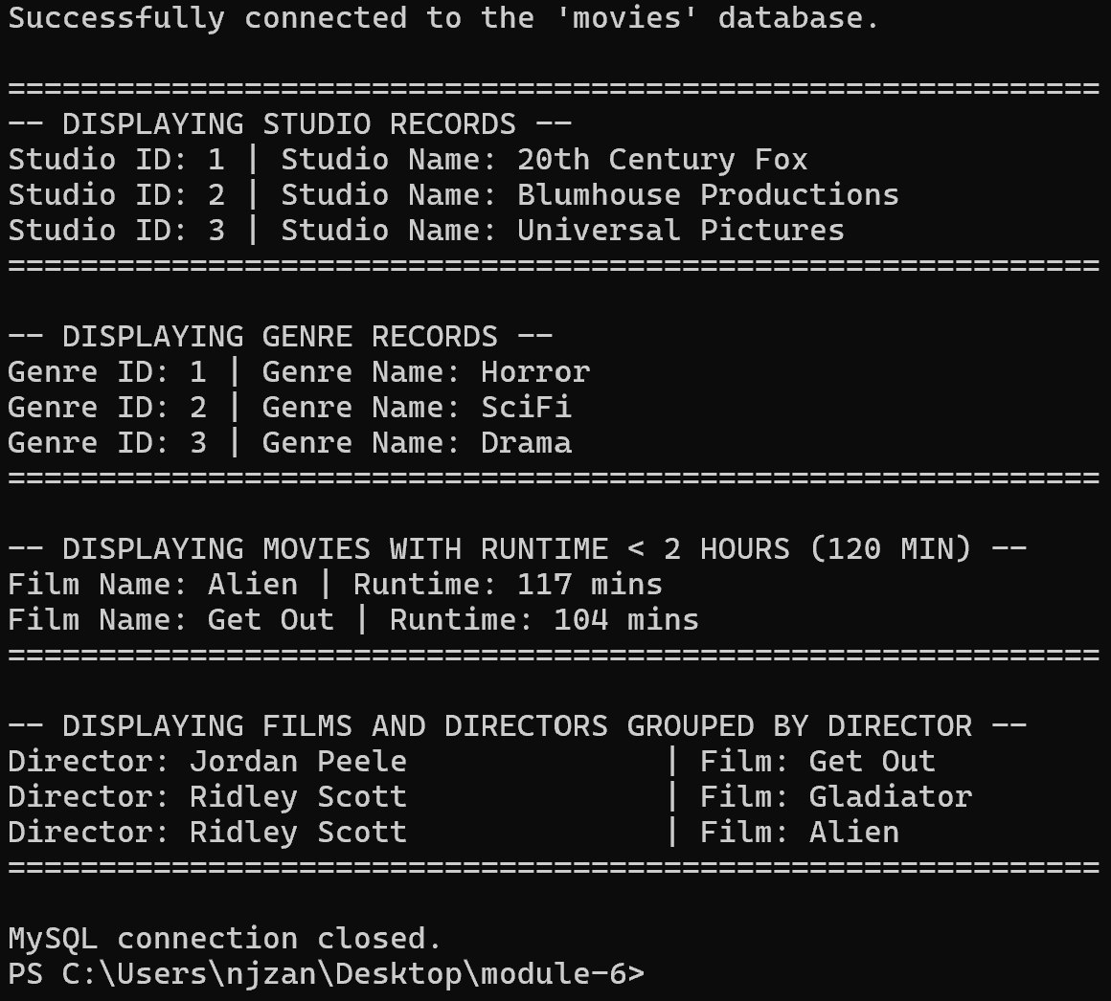
Description: PowerShell window showing output from movies_queries.py, including database connection confirmation, and retrieved records for studios, genres, short-runtime films, and directors.

