Figure 1: The original ERD
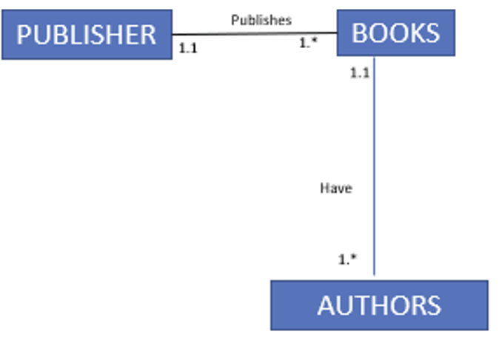
Figure 2: The recreated ERD using Visual Paradigm


