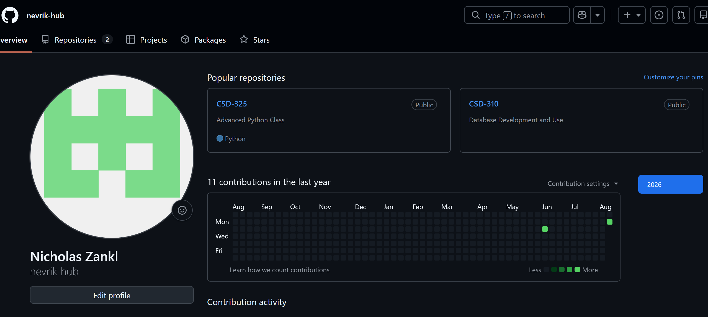
Figure 1: GitHub Profile Overview
Note on Workflow:
The local setup, directory creation (mkdir module-1), directory verification (dir), and initial repository checks (git status) were performed via the Command Line Interface in Windows PowerShell. Staging, committing, and pushing the files to GitHub were completed using GitHub Desktop rather than CLI commands.
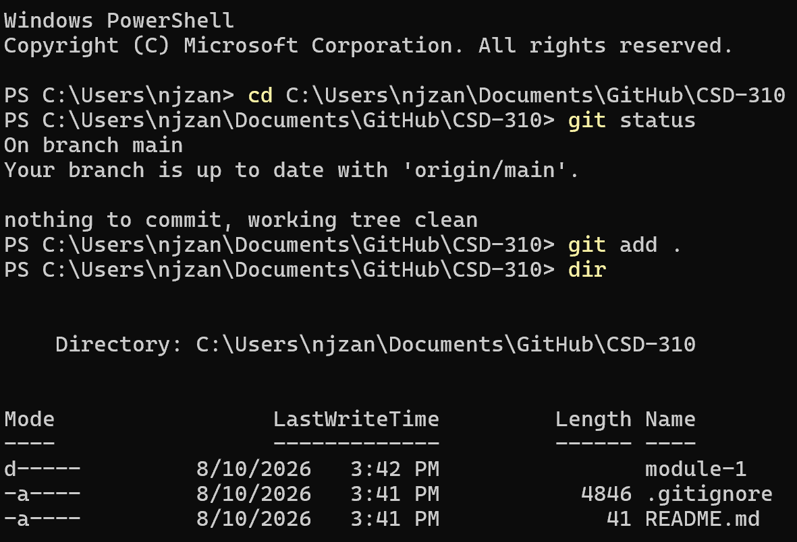
Figure 2: Local Directory Verification: Windows PowerShell navigated to C:\Users\njzan\Documents\GitHub\CSD-310. Running the dir command confirms that the local subfolder module-1 was successfully created inside the main repository folder.
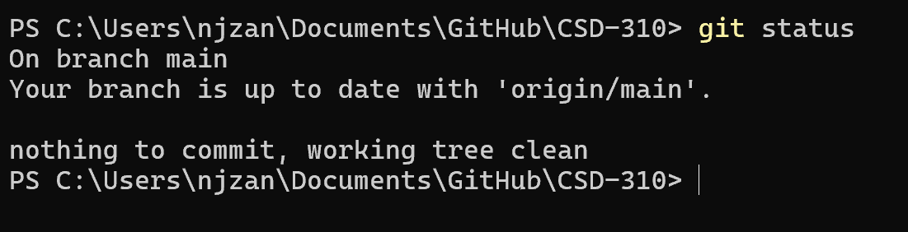
Figure 3: Local Repository Status: Windows PowerShell running git status inside the CSD-310 local repository. The output shows the local branch is up to date with origin/main.
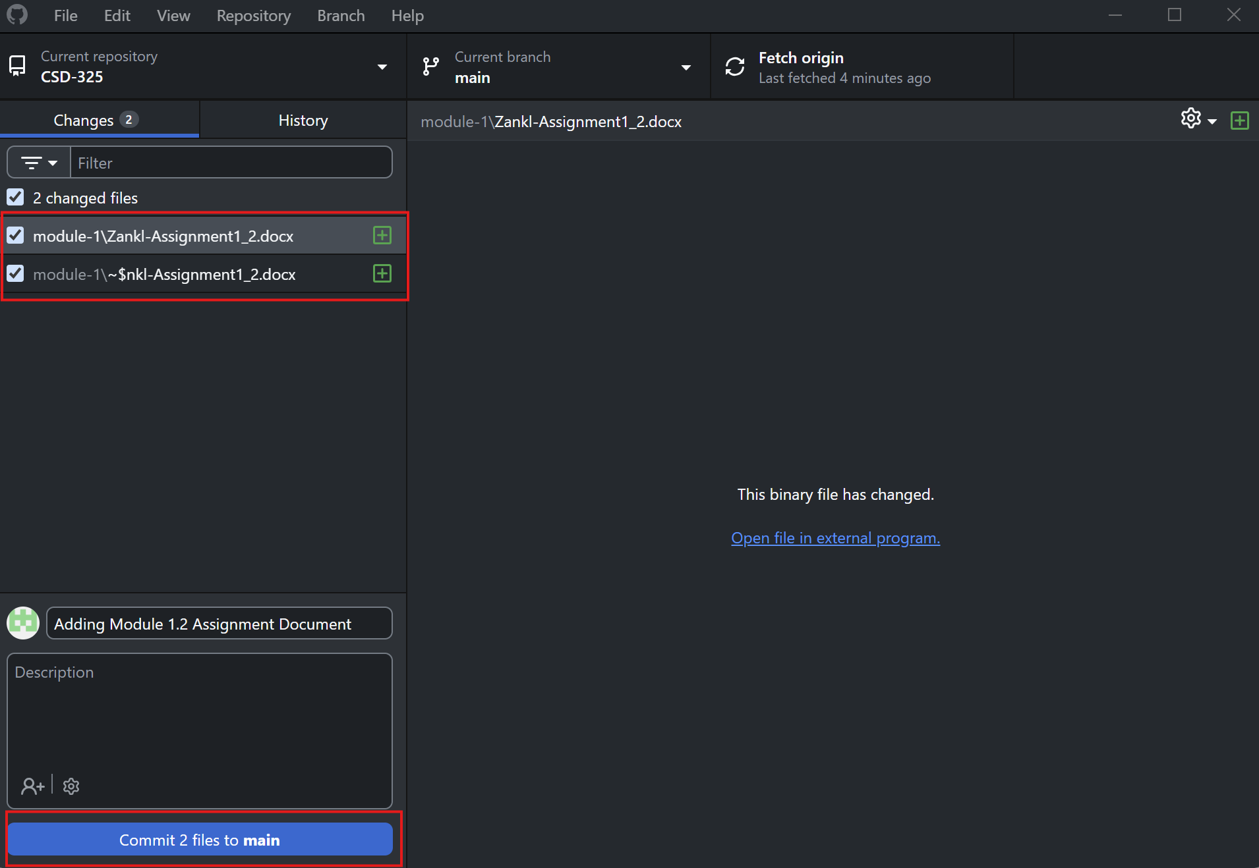
Figure 4: Staging and Committing via GitHub Desktop: This illustrates using the GitHub Desktop GUI application to stage local files and write a commit message prior to pushing the changes to GitHub.
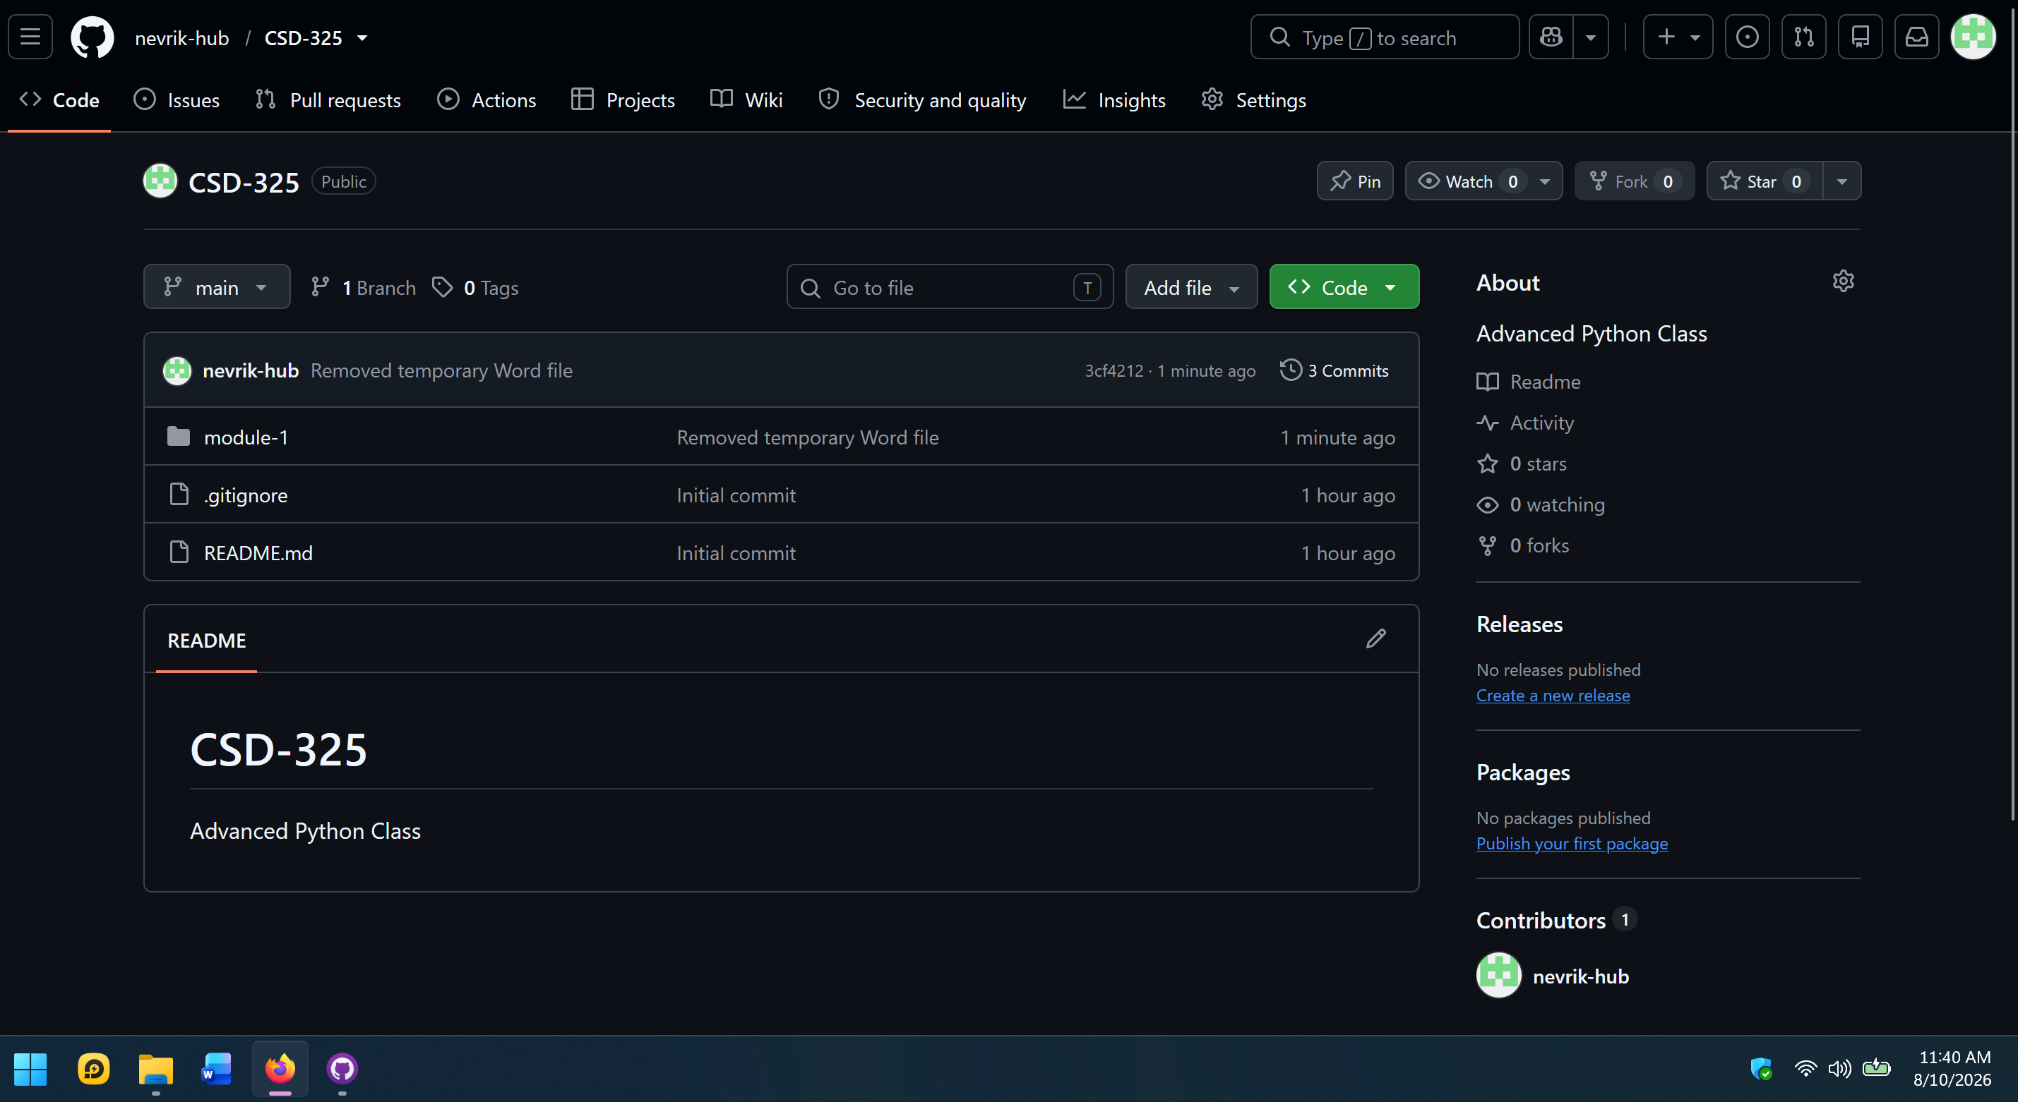
Figure 5: Cleaned Remote Repository View: This screenshot shows the live nevrik-hub/CSD-325 repository on GitHub.com. It reflects the latest commit ("Removed temporary Word file"), confirming that the module-1 directory is present on the remote main branch without any temporary lock files.

