Figure 1: Initial MySQL Database Connection
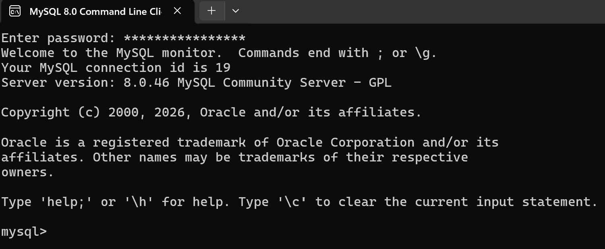
Description: Demonstrates successful authentication and local server connection via the MySQL Command Line Client, displaying the active mysql> prompt.

Figure 2: Database Creation Verification
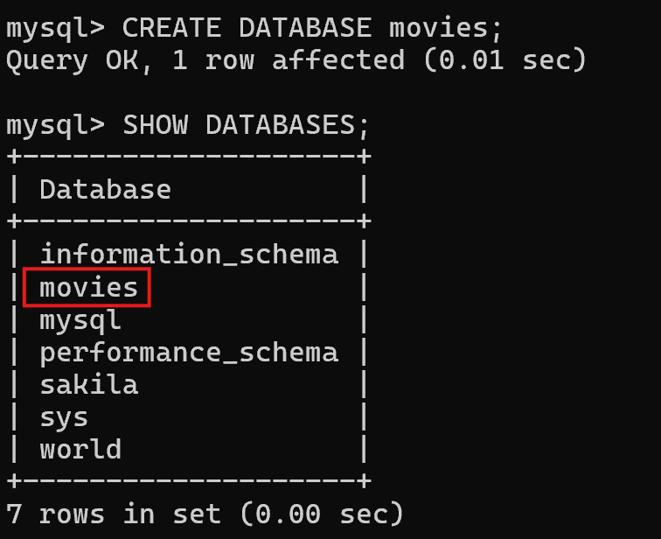
Description: Displays the output of the SHOW DATABASES; command, confirming that the new movies database was successfully created on the server.
Figure 3: String Normalization using UPPER()
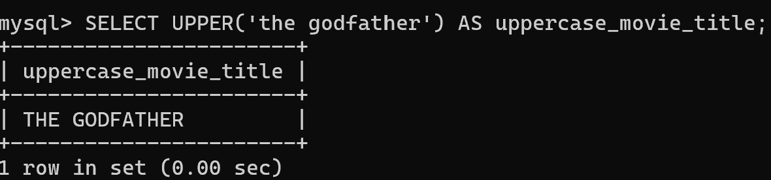
Description: Shows the execution of UPPER('the godfather') AS uppercase_movie_title;, converting lowercase text into uppercase to demonstrate string standardization.

Figure 4: System Timestamp Retrieval using NOW()
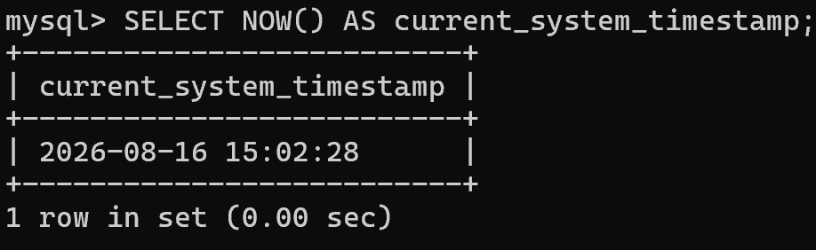
Description: Shows the execution of SELECT NOW() AS current_system_timestamp;, retrieving the current server date and time in YYYY-MM-DD HH:MM:SS format.

Figure 5: String Formatting using CONCAT()
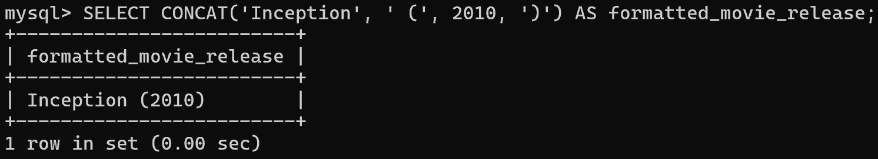
Description: Shows the execution of SELECT CONCAT('Inception', ' (', 2010, ')') AS formatted_movie_release;, merging title and year values into a single formatted result string.

