Figure 1: Movies Database Entity Relationship Diagram (ERD)
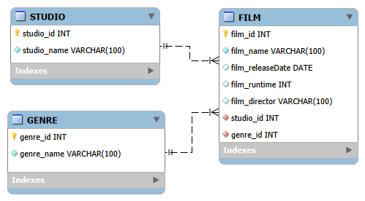
Description: Illustrates the conceptual data model for the Movies database, detailing the STUDIO, GENRE, and FILM entities, their respective primary/foreign key attributes, and the 1:N relationships linking studios and genres to films.

