1. Entity Relationship Diagram (Relational Data Model)
The Entity Relationship Diagram (ERD) below illustrates the normalized relational structure. A many-to-many relationship between USER and ROLE is resolved using the USER_ROLE junction table with a composite primary key. A one-to-many relationship links USER to DEPENDENT via the user_id foreign key.
Figure 1: Visual Paradigm Entity Relationship Diagram (ERD)
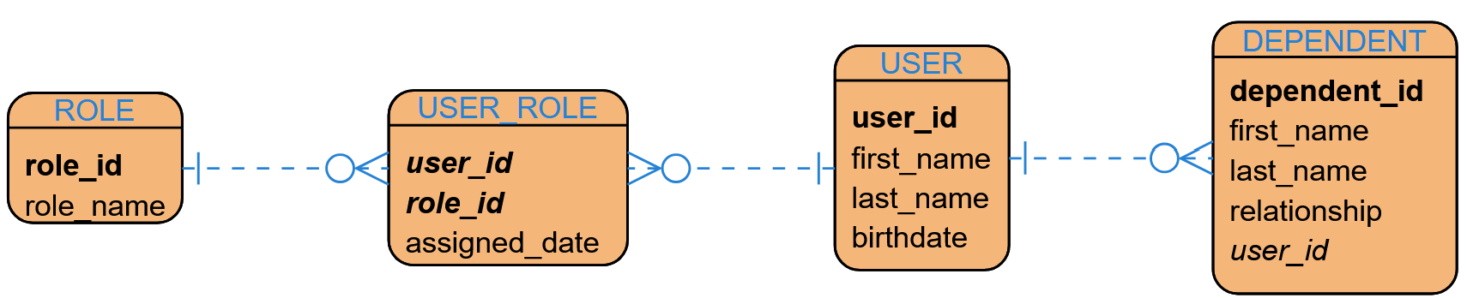
2. NoSQL Data Structure (Document Store)
In a document-oriented NoSQL database (such as MongoDB), relational entities are encapsulated directly within a single User document using embedded arrays. This eliminates the need for multi-table joins and allows all related roles and dependents to be retrieved in a single read operation.
Figure 2: JSON Document Representation of the NoSQL Data Structure
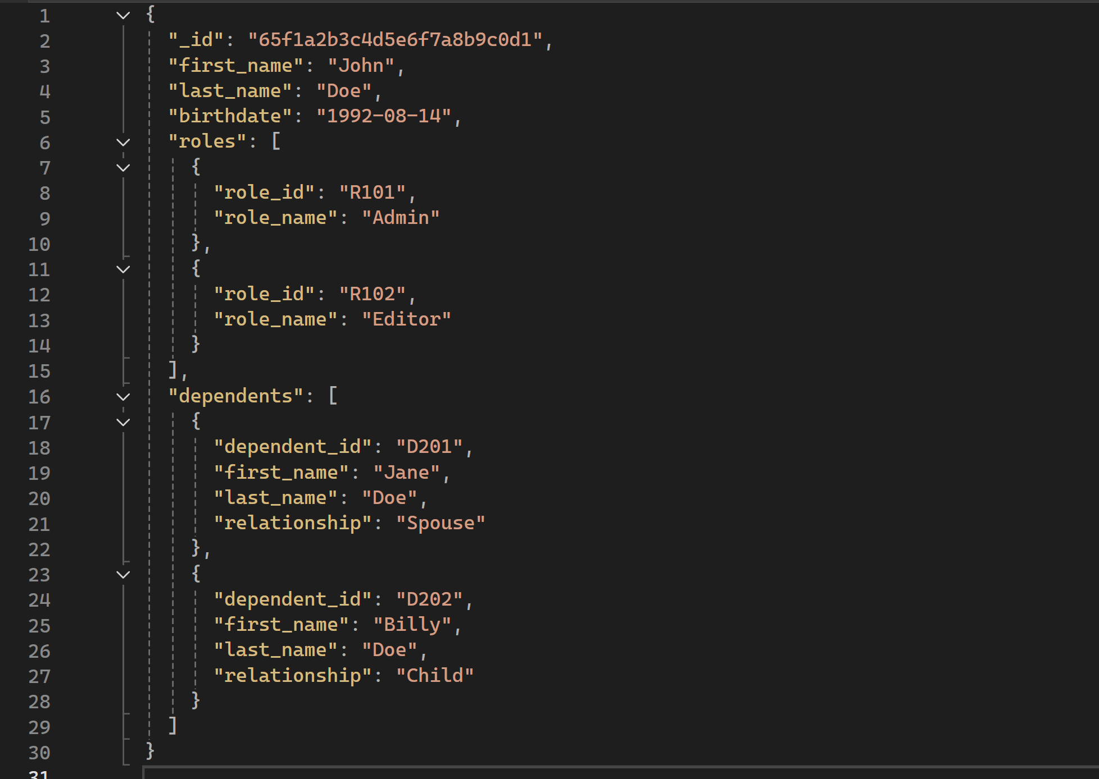
3. Model Comparison Summary
Table 1: Comparison of Relational and Document NoSQL Data Models
Feature | Relational Model (RDBMS) | Document NoSQL Model
Data Organization | Tables, columns, and rows with rigid schemas. | JSON/BSON documents with flexible schemas.
Relationships | Enforced via Primary Keys (PK) & Foreign Keys (FK). | Nested/embedded document collections.
Query Mechanism | SQL queries utilizing multi-table JOINs. | Key-value or single-document queries without JOINs.

