Figure 1: Program Execution & Subroutine Flowchart
Description: Visual model depicting the primary loop in main() alongside the standalone fahrenheit_to_celsius() subroutine logic using standard ANSI flowchart symbols.
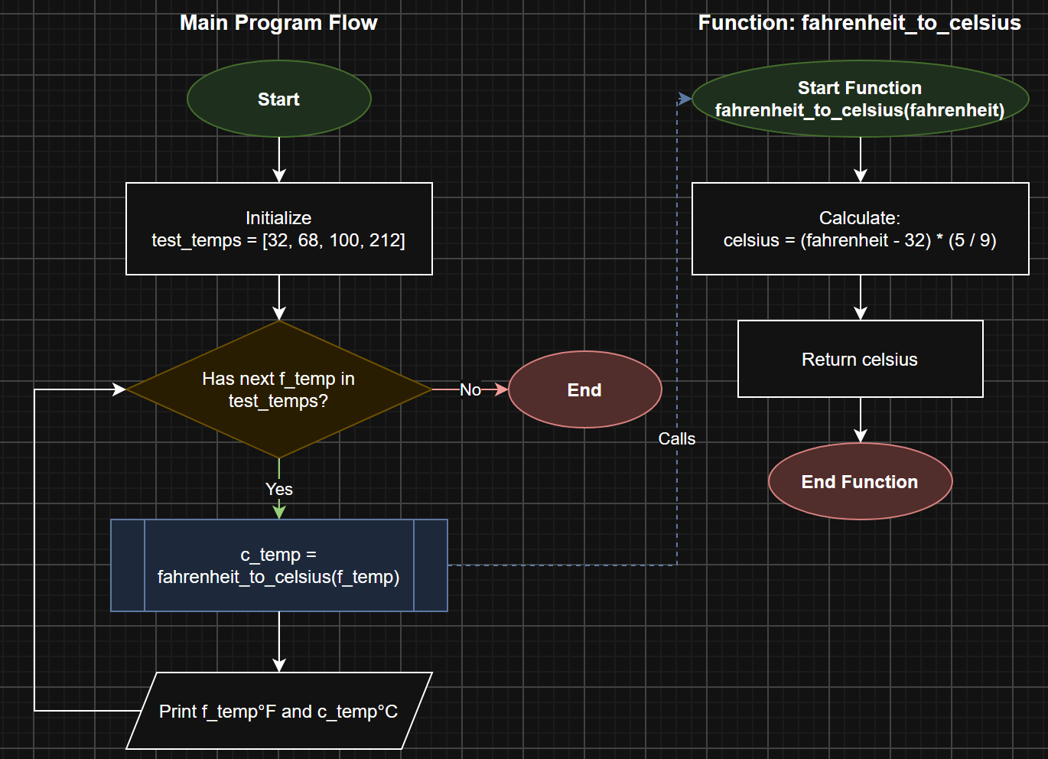

Figure 2: Breakpoint Initialization and Session Start
Description: Execution paused at the call site (c_temp = fahrenheit_to_celsius(f_temp)) in VS Code after setting a line breakpoint and launching the active debugging session
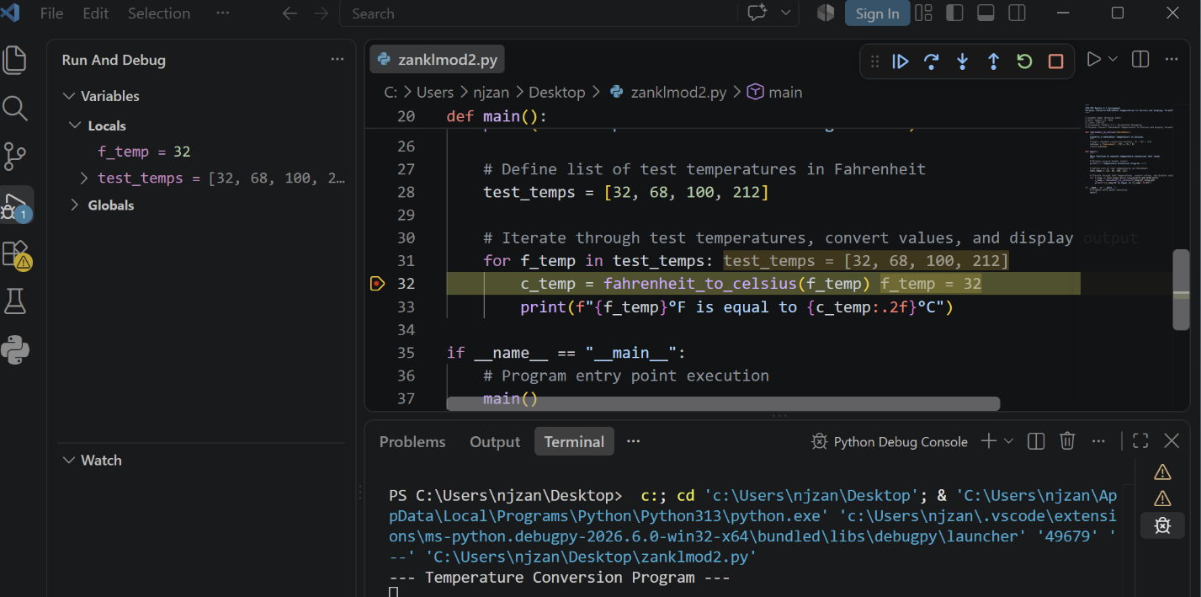
Figure 3: Stepping Into Function Definition
Description: Stepping into the function to transfer control flow inside fahrenheit_to_celsius(), displaying the parameter fahrenheit populated with its initial argument (32) in the variables panel.
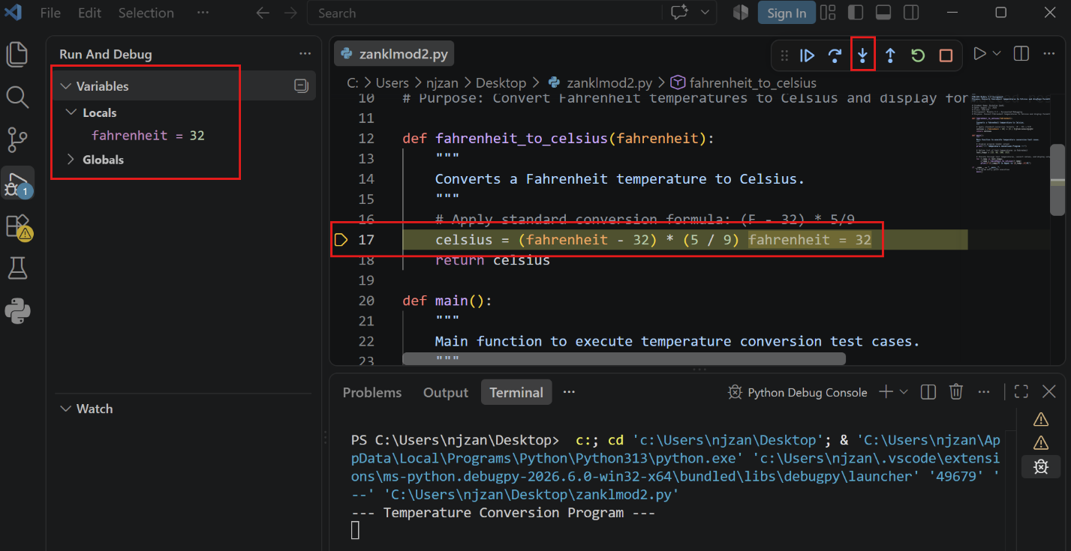
Figure 4: Stepping Over and Variable Inspection
Description: Advancing execution through the function using Step Over to calculate the return value, confirming Celsius evaluates to 0.0 before exiting back to main().
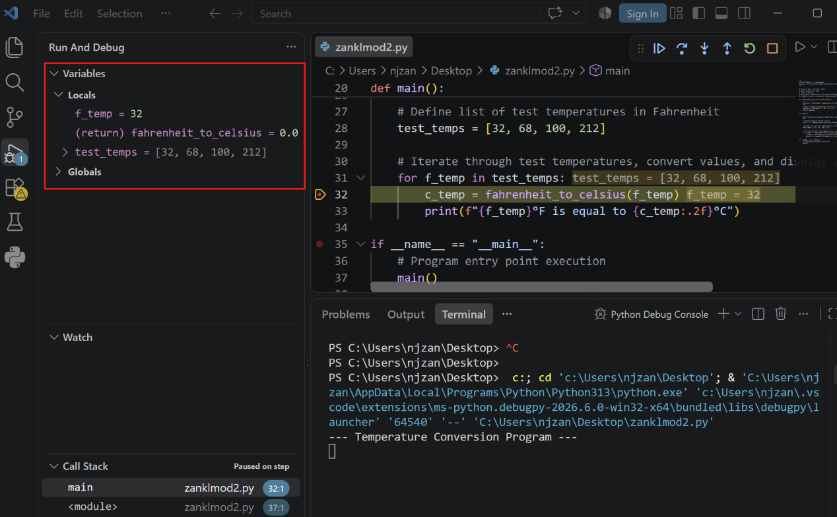
Figure 5: Program Execution & Terminal Output
Description: Continuing step-through execution back to the loop header, confirming the formatted string output printed to the debug console terminal.
