Project Overview

This project demonstrates the core fundamentals of web development using Python's Django web framework. The project highlights initializing a Django environment, running a local development server, configuring custom app-level routes, and serving dynamic HTTP responses. All application code and configurations are stored within the required directory structure under CSD-325/module-11/demo for GitHub version control.
Step 1: Initial Django Server Execution
After creating the demo Django project and initializing the application, the local development server was launched using python manage.py runserver. Navigating to [http://127.0.0.1:8000/](http://127.0.0.1:8000/) confirms the server is active, rendering the default Django installation landing page.
Figure 1: Initial Django Server Launch (127.0.0.1:8000)
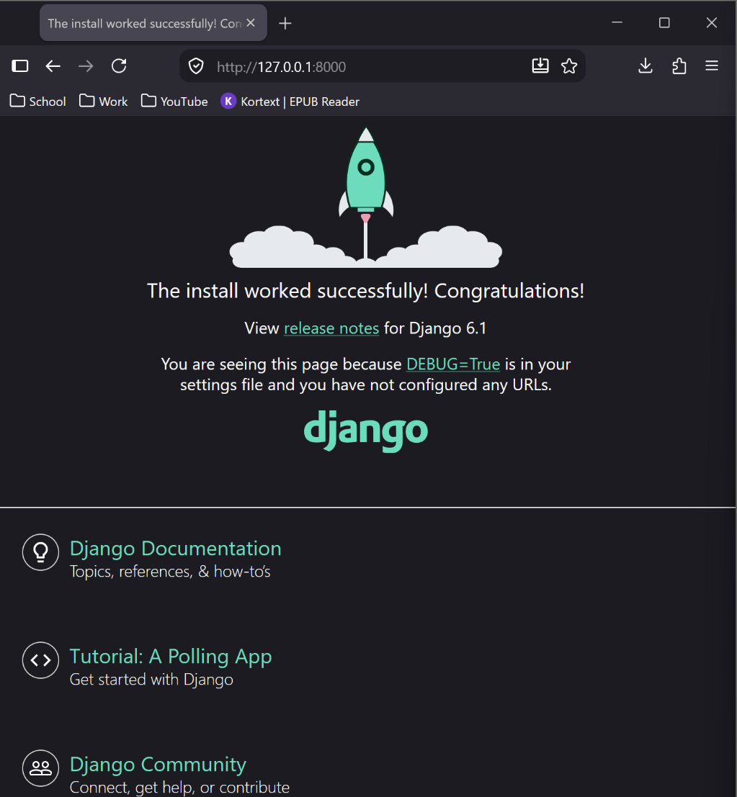
Step 2: Custom Application View Implementation
To fulfill the assignment specifications, a custom app (zankl) was added to the project, and its routing was wired into the project's primary urls.py configuration. The views.py file was modified to return a tailored HttpResponse displaying a personalized greeting.
- View Configuration (zankl/views.py): Configured an index view function returning an HttpResponse containing "Zankl says Hello!".
- URL Routing Setup (zankl/urls.py & demo/urls.py): Created app-level URL patterns and mapped the root path to target the custom zankl index view.
- Server Verification: Restarting the development server and refreshing [http://127.0.0.1:8000/](http://127.0.0.1:8000/) verifies that the custom HTTP response successfully overrides the default landing page.
Figure 2: Modified Django Web Page Displaying Custom Greeting
