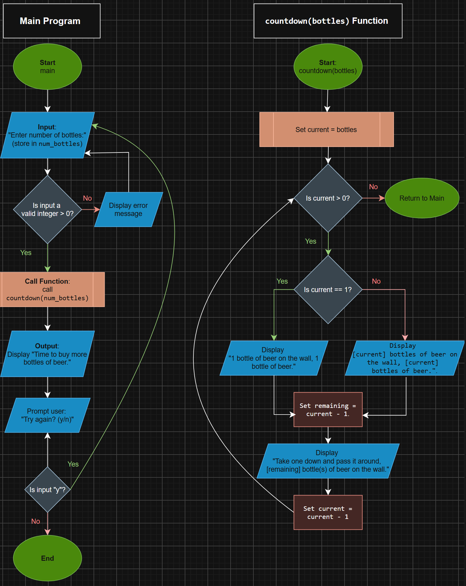
Figure 1: Program Logic and System Architecture
Program Flowcharts: Main Execution Flow (Left) and countdown() Function Logic (Right)
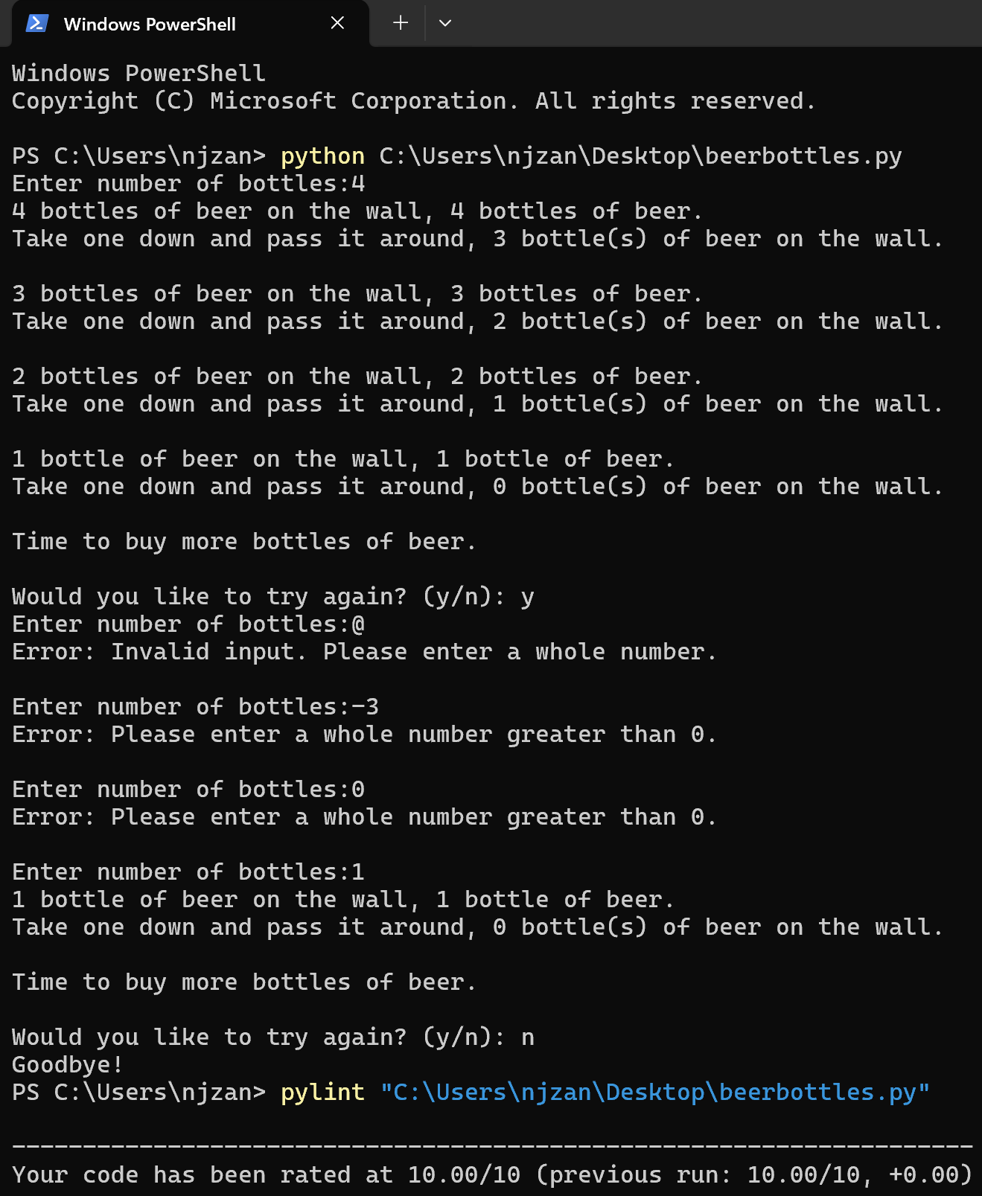
Figure 2: Program Execution and Static Analysis Output
Console output demonstrating program execution, input validation looping, clean program exit, and a 10.00/10 Pylint score.

