1. Completed HTML Document Source Code
Below is the complete HTML markup for Zankl_Mod1_3.html. It includes the required title tag, proper HTML5 doctype structure, h1 header, and location/weather line using the HTML degree entity (&deg;).
<!DOCTYPE html>
<html lang="en">
<head>
<meta charset="UTF-8">
<title>CSD 340 Web Development with HTML and CSS</title>
</head>
<body>
<h1>Assignment 1.3 – Building a Web Page Exercise, Part 1</h1>
<p>I am located in Godfrey, Illinois, and the weather today is partly cloudy and 68&deg;F.</p>
</body>
</html>

2. W3C Validation & Browser Verification Screenshots
Figure 1: Initial W3C HTML Direct Input Validation (With Starter Code Errors)
Initial markup check displaying validation errors present in starter code prior to corrections.
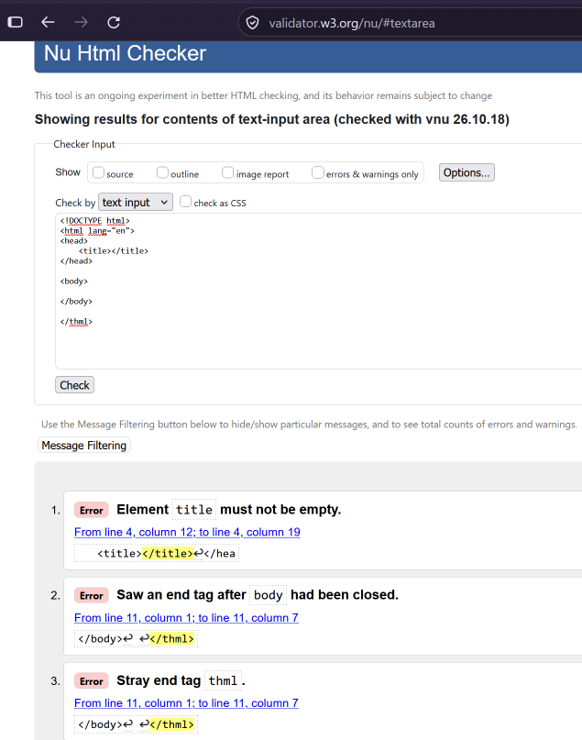
Figure 2: Re-validation Results After Error Corrections (0 Errors)
W3C validator output confirming 0 errors and 0 warnings following syntax corrections.
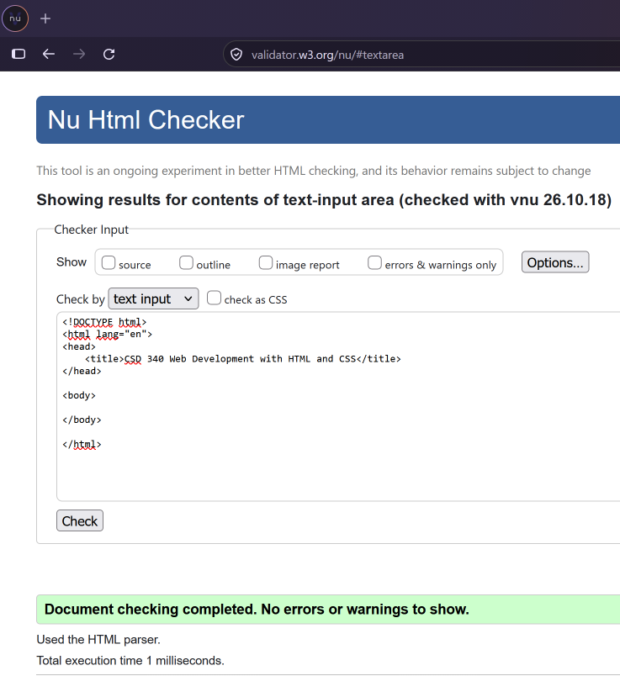

Figure 3: Final W3C HTML Validation (Title, H1 & Weather Content Added)
Final validation check confirming complete compliance for the fully updated document.
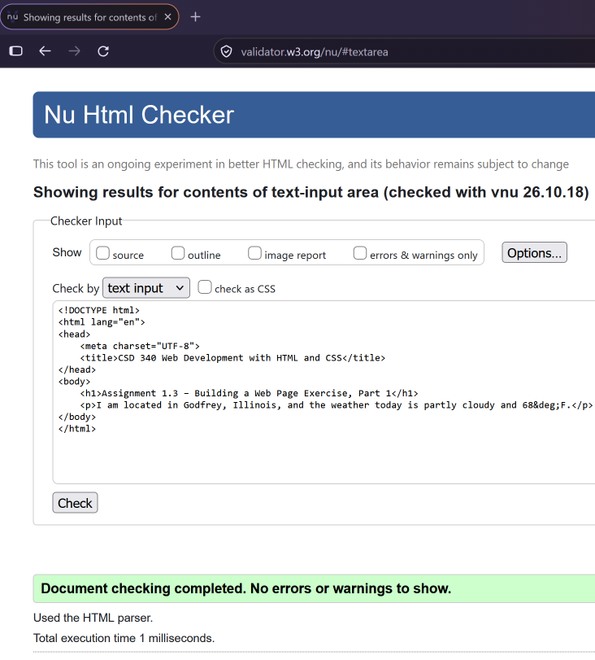

Figure 4: Web Page Rendered in Default Browser
Display of Zankl_Mod1_3.html rendered in web browser showing header, location, and weather information.
