1. System and Environment Setup Summary
The development environment was prepared by installing and configuring the Oracle Java SE Development Kit version 24.0.1. System environment variables including JAVA_HOME and System PATH were configured and verified via terminal command execution using java -version. Visual Studio Code was selected and configured as the primary Integrated Development Environment for compiling and executing Java application code. JavaFX module paths and required runtime dependencies were integrated into the environment build settings.
2. Program Overview and Logic
The program file WaterEnergyCalculator.java calculates the total thermal energy in Joules required to heat a specified mass of water across a temperature differential. The mathematical logic utilizes the thermodynamic formula where Q equals the mass of water in kilograms multiplied by the difference between the final and initial Celsius temperatures, multiplied by the specific heat capacity constant of 4184 Joules per kilogram degree Celsius. The program reads numeric user inputs for water mass, starting temperature, and target temperature using a Scanner object, computes the total energy transfer Q, and outputs the formatted result rounded to two decimal places.
3. Verification Screenshots
Screenshot 1: Java JDK Installation and Version
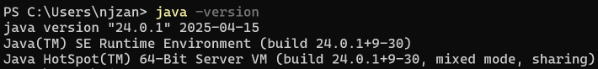
Screenshot 2: Program Execution and Calculation Output
