

**MIDDLE EAST TECHNICAL UNIVERSITY**

**DEPARTMENT OF ELECTRICAL AND ELECTRONICS ENGINEERING**

***EE463 – Project 1***

*Nevzat S. Şenyayla*

*2263796*

Table of Contents

A. INTRODUCTION 3

B. SINGLE-PHASE HALF BRIDGE RECTIFIER 4

1) Plotting the Output Voltage Waveform 5

2) Significance of the Sample Time 7

## INTRODUCTION

In today’s global world, electricity or electrical energy is the main component of all kinds of operations since almost all of the working fields are in need electricity in the struggle of civilization and making the lives of people more comfortable. Since, there is a big issue like “Global Warming” and exhaust gasses are one of the main reasons of that problem, both the environmentalists and the managers of the industrial world evolve into the idea that electricity is one of the best energy resource when compared by means of both power and the sludges. Due to that, at every moment of today’s daily lives, one can observe the result of that reality such as turbine generators located on highways, solar plants, electricity cars, and so on.

From this point of view, engineers -particularly Electrical and Electronics Engineers- dwell upon that issue in order to provide brand-new and efficient solutions to the human’s needs. The working field of Power Electronics is an essential one to accomplish that and provide new methods, solutions and products both to industry and the end-users to make them be able to take the advantage of this infinite energy source: Electricity.

Engineers should be able to convert the AC electrical energy that is being generated at Power Plants into more useful type since the electronic devices generally work with DC voltages and currents. In order to achieve that, power conversion principles should be applied, and the course of Static Power Conversion-I aims to teach the background information of all those methodologies by making the students fed with both theoretical knowledge and practical applications according to the syllabus of the course. The main ideology behind this course is to show students how power drawn from the grid can be converted into such form to both drive different kinds of materials like AC motors, DC motors, etc. and convert that energy into different types by using different topologies to drive all kinds of devices anywhere.

This report which is about the first simulation project of Static Power Conversion-I is concerned with the theoretical knowledge, mathematical approaches and practical applications of the first step of conversion which is rectification. Some given processes were investigated on rectifiers specifically the Diode Bridge Rectifiers and the fundamental theory of those topologies were examined according to analytical calculations and the comparisons of that calculations with the simulation results. The rectified voltage and current waveforms were analyzed and the details of those waveforms such as the maximum, minimum, peak-to-peak, mean, RMS values and the THD[1] information.

During the report one will be reading the details of three different topologies which are Single-Phase Half-Bridge Rectifier, Single-Phase Full-Bridge Rectifier and Three-Phase Full-Bridge Rectifier. One last note is in all the circuit schematics that are generalized by the usage of MATLAB-Simulink, generators represent the grid side of the network.

## SINGLE-PHASE HALF BRIDGE RECTIFIER

In practical applications, Single-Phase Half-Bridge Rectifiers are used in order to chop the negative component of the sinusoidal AC signal by usage of a diode that allows the current flow to the load in the positive cycles and block it in negative ones. By the reversing of the diode mounting direction, one can make the negative cycles pass and block the positive cycles. Since half of the signal is chopped due to the presence of the diode, there will not be a voltage on the load during the negative cycles -if diode is configured to pass the positive half ones-.

The AC source in the simulations are assumed as the Turkish grid which is 230 $V_{RMS}$ and 325 $V_{max}$ according to the equation of

*Figure 1: The Schematic, Input and Output Waveforms of SPHBR[2]*

As one can easily observe from the given figure above, the main application of SPHBRs are chopping the half cycles of the input signal. The same circuit schematic for SPHBR with a resistive load of 100Ohms is constructed at Simulink-Simscape and the related results asked in the project description are collected.

### Plotting the Output Voltage Waveform

If one tries to plot the output voltage waveform of a SPHBR, the expected result is a signal whose half cycles are chopped as explained earlier. The circuit schematic and the expected output voltage waveforms are given in the figures below:

*Figure 2: The Circuit Schematic of SPHBR*

*Figure 3: The Expected Output Waveform (Blue Trace) of Given Schematic*

#### Output Waveform for a Sample Time of 1ns

*Figure 4: The Output Voltage Waveform for a Step Time of 1ns*

#### Output Waveform for a Sample Time of 0.5ms

*Figure 5: The Output Voltage Waveform for a Step Time of 0.5ms*

#### Output Waveform for a Sample Time of 5ms

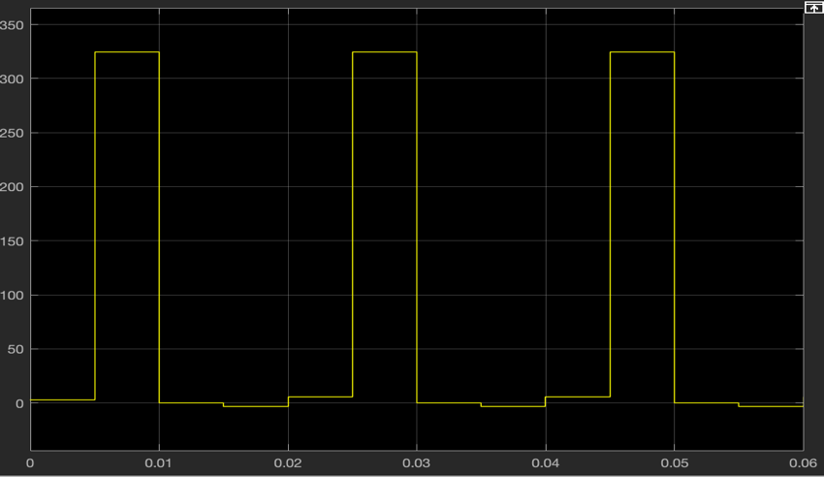

*Figure 6: The Output Voltage Waveform for a Step Time of 5ms*

### Significance of the Sample Time

Since the topology of the circuit has not change, the expected output voltage is the same, too. However, sample time can change the shape of the simulated signal.

1. Total Harmonic Distortion
2. Single-Phase Half-Bridge Rectifier