Zach Lindler
CPSC 1020 / 1021 - 002
Lab 1
01/15/2018

Screenshot 1

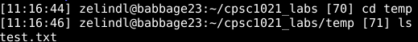
Screenshot 2

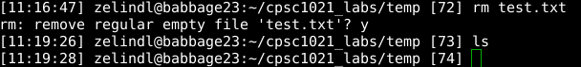
Screenshot 3

Screenshot 4

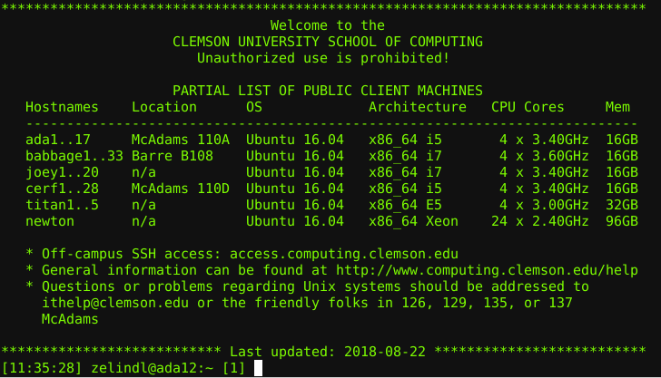
Screenshot 5

Screenshot 6

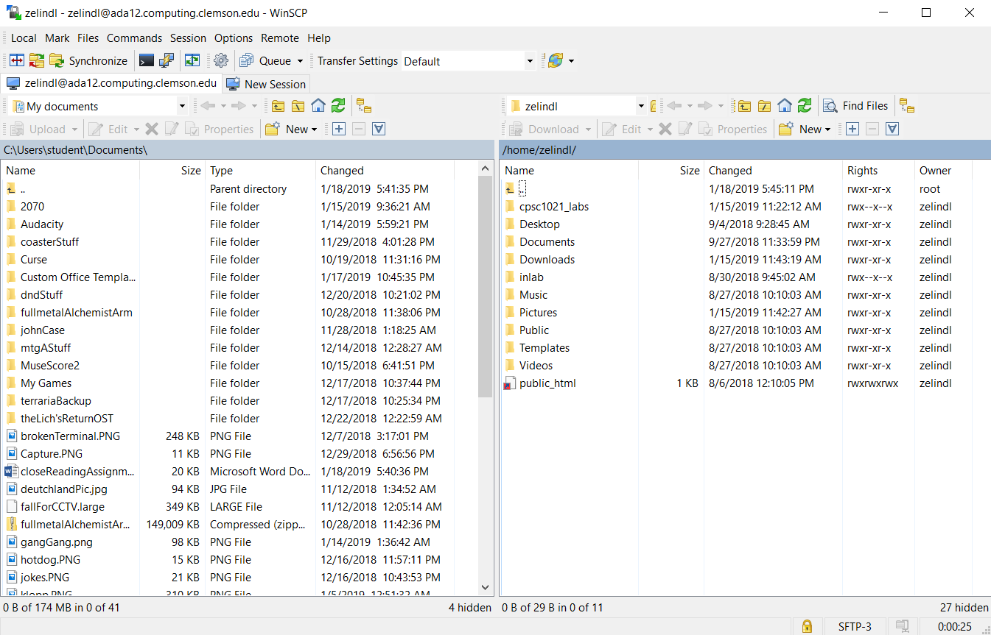
Screenshot 7

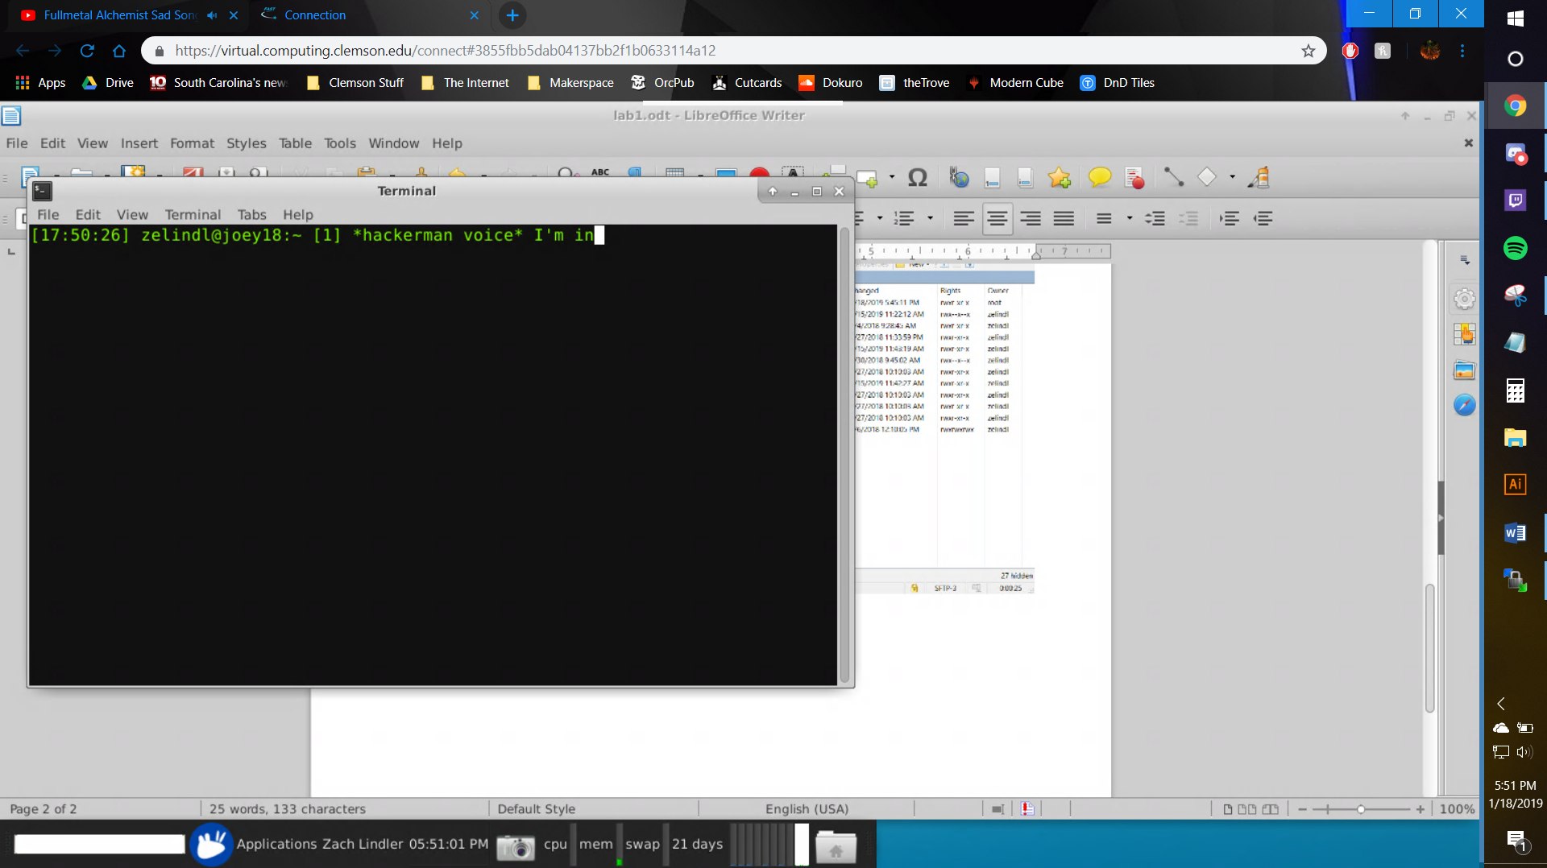
Screenshot 8

