# Apple Cider Braised Greens

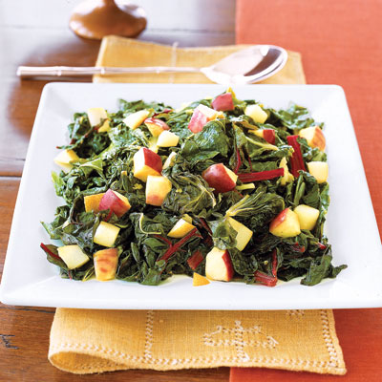

**SERVES:**16

Ingredients

* 1½ lb. mustard greens
* 1½ lb. collard greens
* 1½ lb. Swiss chard
* 2 tbsp. olive oil
* 3 large garlic cloves
* 1¼ c. apple cider
* 1 tbsp. cider vinegar
* salt
* 2 red cooking apples such as Gala or Rome Beauty

**Directions**

1. Remove stems from mustard greens; discard stems. Trim stem ends from collard greens and Swiss chard; remove stems from leaves. Cut stems into 1-inch pieces; cut leaves into 2-inch pieces. Rinse leaves and stems; drain well.
2. In 8-quart saucepot, heat oil over high heat until hot. Add garlic and cook 30 seconds to 1 minute or until golden, stirring constantly. Add as many leaves and stems as possible, cider, vinegar, and 11/2 teaspoons salt, stirring to wilt greens. Add remaining greens in batches.
3. Reduce heat to medium. Cover saucepot and cook greens 15 minutes. Stir in apples; cook, partially covered, 10 minutes longer or until stems are very tender and most of liquid evaporates, stirring occasionally. With slotted spoon, transfer to serving bowl.

http://www.goodhousekeeping.com/food-recipes/a6489/apple-cider-greens-4152/