**BEETS**

**Beet Lentil & Quinoa Burgers with Creamy Horseradish Sauce**

Bring on the burgers! These Beet Lentil & Quinoa Burgers are big, hearty & flavorful. A dollop of creamy horseradish sauce complements the earthy beets perfectly & provides a veggie burger taste sensation!

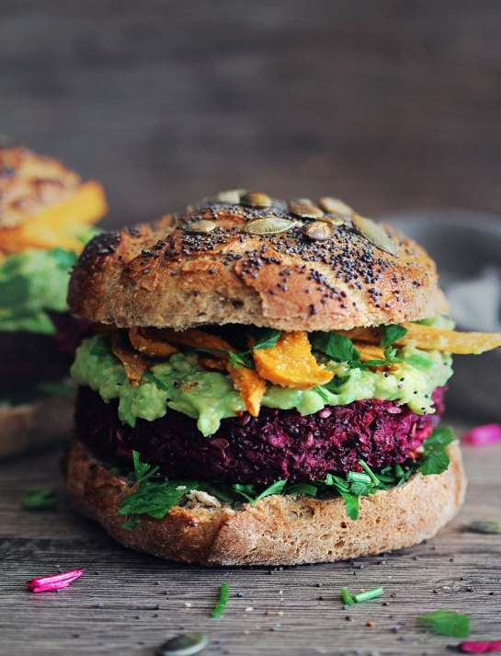Servings 5 large burgers

**Ingredients**

* **For the burgers**
* 1 packed cup grated beetroot (I used a food processor to grate mine)
* 1 cup cooked green lentils
* 1 cup breadcrumbs (use gluten free breadcrumbs if necessary)
* 1 cup quinoa , cooked
* 1 small onion grated (I used a food processor to grate mine)
* 2 cloves garlic , grated or chopped very finely, (you can sub this for 1 tablespoon of garlic salt)
* 4 tablespoons | 1/4 cup cashew butter (substitution almond)
* 2 teaspoons ground fennel
* 1.5 teaspoons salt
* 1.5 teaspoons pepper
* For the horseradish sauce
* 1/2 cup raw cashew nuts
* 2 tablespoons horseradish sauce
* 1/2 cup non-dairy milk
* 1/4 teaspoon salt

**Instructions**

**For the burgers**

1. Add the lentils, beetroot & onion to a food processor and pulse together. You want it all in small pieces not a puree.
2. Tip out into a large bowl.
3. Add all of the other burger ingredients and mix very well. I find my hands the best tool for this if you don't mind stained fingers! You need to make sure everything is mixed really well and that the nut butter is distributed evenly and not in clumps.
4. Take out tennis ball sized lumps of mixture and squeeze and press together really well in your hands making ball shapes.
5. Place on a baking sheet and press down the tops with the palm of your hand to flatten into burger shapes. I made mine about 1 inch thick but you can make yours the thickness you prefer.
6. Put the tray in the fridge for at least half an hour. Anything up to overnight is fine.
7. Heat a fry pan over a medium heat. If you use some oil if you like but if you have a non stick pan you don't need to.
8. Cook each burger until a golden crust forms then flip and cook again until a crust forms on the other side. If your burgers are quite thin then cook them for 5 - 6 minutes in the pan. If they are thicker like mine, once you have a nice crust on each side put them on a tray and finish them off in the oven on 350°F for 20 - 25 minutes. Because of the thickness it it’s hard to cook them all the way through in the fry pan.
9. If you prefer you can omit the fry pan step and just bake them in the oven for 30 mins but they really are better if you get that nice crust to develop first.

**For the sauce**

1. Soak the cashew nuts in boiling water for 20 mins.
2. 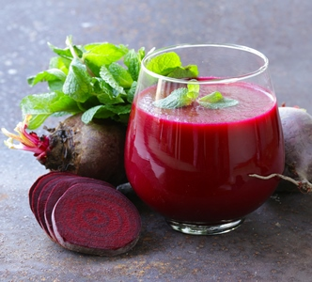Drain then put in a food processor or blender with the other ingredients and blitz until very smooth. https://avirtualvegan.com/wprm_print/10005/

**Beet Juice**

* 1 small beet
* 1 large apple
* 2 celery stalks
* 1-2 carrots
* ½ lemon or lime
* ½ inch small piece of ginger, peeled

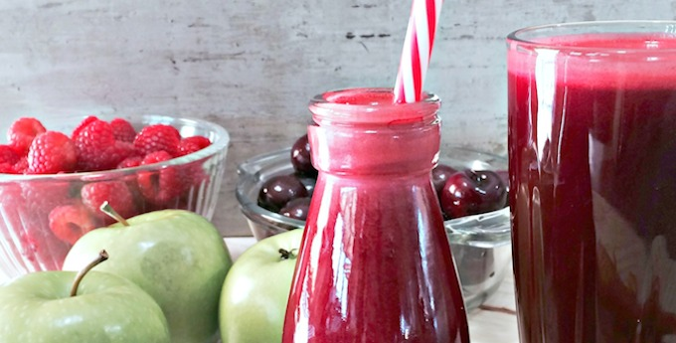Wash and juice all the ingredients except the lemon or lime. Add to juice separately after all fruits and veggies are juiced.

**Beet Blend Juice by Kris Carr**

* 2 beets
* 6 carrots
* 2 apples
* 1 cup of raspberries
* Small knob of ginger

http://kriscarr.com/recipe/beet-blend

**Beet, Date & Celery Salad**

* 1 pound of beets, shredded
* 3 stalks celery, chopped
* ½ cup pitted dried dates, chopped
* 3 Tablespoons lemon juice
* ¼ teaspoon salt and pepper

Directions: Mix ingredients together and add lemon juice to taste. Serve immediately.

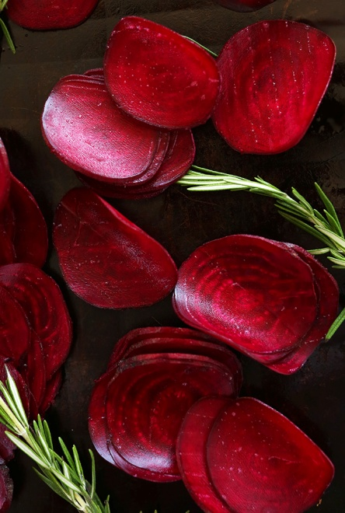**Baked Rosemary Beet Chips**

**Ingredients**

* 3 medium-large beets, rinsed and scrubbed
* Olive or canola oil
* Sea Salt + Black Pepper
* 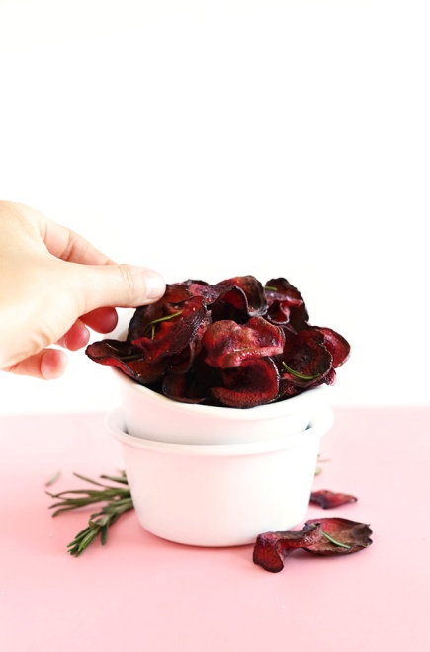2-3 sprigs rosemary, roughly chopped

**Instructions**

1. Preheat oven to 375 degrees F and place oven rack in the center of the oven.
2. Thinly slice beets with a mandolin (or a sharp knife), getting them as consistently thin as possible. They should curl a little when cut. This will ensure even baking and crispiness.
3. Divide between two baking sheets and spray or very lightly drizzle with olive oil. Add a pinch of salt and the rosemary. Toss to coat, then arrange in a single layer, making sure the slices aren’t touching.
4. Bake for 15-20 minutes or until crispy and slightly brown. Be sure to watch closely past the 15 minute mark as they can burn quickly.
5. 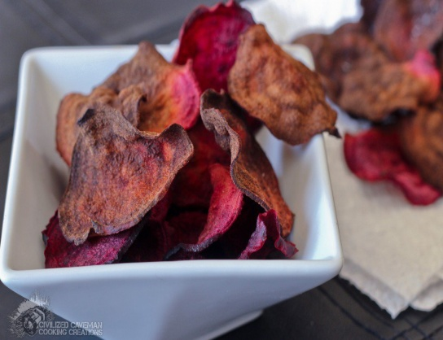Remove from oven, let cool. Then serve.

https://minimalistbaker.com/baked-rosemary-beet-chips/

**Oven Roasted Beet Chips**

**Ingredients**

* 2 medium beets
* 1 tsp [extra-virgin olive oil **or** coconut oil melted](http://www.kasandrinos.com/)

**Instructions**

1. Preheat your oven to 350 degrees F
2. Peel your beets and slice 1/16th of an inch thick using a mandolin
3. In a [mixing bowl](http://www.amazon.com/gp/product/B001715PN8/ref=as_li_ss_tl?ie=UTF8&camp=1789&creative=390957&creativeASIN=B001715PN8&linkCode=as2&tag=civilcavemcoo-20) toss your beets with either your olive oil or coconut oil. Use 4 rimmed baking sheets or bake in 2 batches. Line two of your baking sheets with parchment paper and then arrange beets in a single layer
4. Stack a baking sheet on top of your beets holding them flat
5. Bake them for ~20 Minutes or until the edges of your beets start to dry out
6. Remove the second baking sheets holding your beets down and rotate your baking sheets
7. Bake for an additional 10-20 minutes ensuring you remove the beets as they become lighter in color
8. Transfer to a wire rack and let cool, the chips will get crispy when cold
9. Serve with a side of your choice. [Mango Guacamole](http://civilizedcavemancooking.com/sidessoupsdrinks/mango-guacamole/) adds a sweet touch