**Braised Greens & Cannellini Bean Panini**

A creamy spread of cannellini beans cooked with onion, garlic and white wine is the perfect match for tender braised greens. Press the two between pieces of crusty whole-wheat bread and you have an outstanding vegan panini.

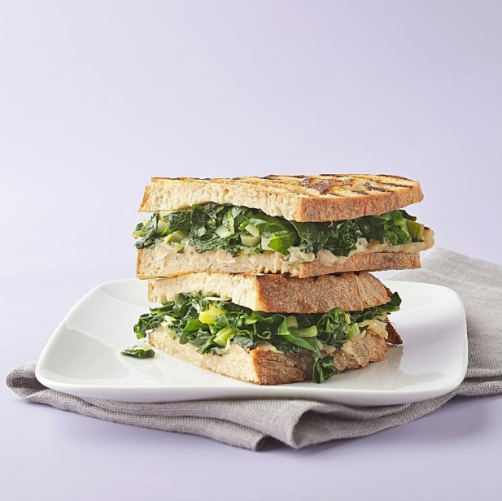**Ingredients**

***Braised Greens***

* 1½ pounds (about 2 bunches) hearty greens, such as kale or collards
* 3 tablespoons extra-virgin olive oil
* 2 large leeks, sliced ¼-inch thick (see Tips), white and light green parts only
* ¼ teaspoon salt
* ¼ teaspoon freshly ground pepper
* ¼ teaspoon crushed red pepper
* 1 cup vegetable broth

***White Bean Spread***

* 2 tablespoons extra-virgin olive oil
* 3 spring onion bulbs or 3 shallots, thinly sliced
* 2 cloves garlic, thinly sliced
* ½ cup dry white wine
* 1½ cups cooked cannellini beans or one 15-ounce can, rinsed
* ⅛ teaspoon salt
* ⅛ teaspoon freshly ground pepper
* 12 slices crusty whole-wheat bread
* Olive oil cooking spray

**Preparation**

Makes 6 servings

1. To prepare braised greens: Strip leaves from stalks. Stack and slice the leaves into 1-inch strips. Thinly slice the stems into ¼-inch pieces. Keep leaves and stems separate.
2. Heat 3 tablespoons oil in a large Dutch oven over medium heat. Add leeks and the chopped stems and cook, stirring, until softened, 4 to 5 minutes. Stir in ¼ teaspoon each salt, pepper and crushed red pepper. Add the sliced greens and broth. Reduce heat to low, cover and cook, stirring occasionally, until the greens are very tender, 20 to 25 minutes. Uncover. If there's any liquid left in the pan, continue cooking for another minute or two until it is nearly gone.
3. To prepare bean spread: Meanwhile, heat 2 tablespoons oil in a medium saucepan over medium heat. Add onions (or shallots) and garlic and cook, stirring occasionally, until tender, 2 to 3 minutes. Add wine and cook until most of it is evaporated, 3 to 6 minutes. Stir in beans and ⅛ teaspoon each salt and pepper; cook until heated through, 1 to 2 minutes. Puree the bean mixture in a food processor until almost smooth. (Use caution when pureeing hot foods.)
4. To prepare panini: Coat one side of each slice of bread with cooking spray. With the sprayed side down, spread equal portions of the bean puree on 6 slices of bread. Top each with equal portions of the braised greens. Top with the remaining pieces of bread, sprayed-side up. Press in a panini maker until hot and crispy. (Don't have a panini maker? See Tips.)
5. Make Ahead Tip: Cover and refrigerate braised greens and bean spread in separate containers for up to 3 days.
6. Tips: To clean leeks, trim and discard green tops and white roots. Split leeks lengthwise and place in plenty of water. Swish the leeks in the water to release any sand or soil. Drain. Repeat until no grit remains.

http://www.eatingwell.com/recipe/250439/braised-greens-cannellini-bean-panini/