**Cabbage Rolls *from Leslie Susralski’s Mom***

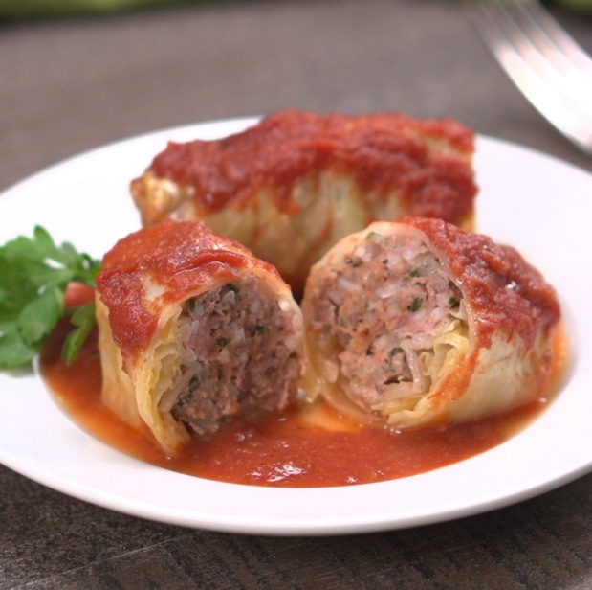**Ingredients**

* 1 head of cabbage
* 2 lbs organic ground turkey
* 1 large onion diced
* 1 large green pepper diced
* 2 eggs
* 3 slices of a multi grain bread
* 1 cup uncooked rice
* 3 garlic gloves diced
* 2 32 ounce cans organic crushed tomatoes
* 2 tablespoons Mrs. Dash seasoning

**Directions**

Cut the center core out of the cabbage and place in a large pot of water. Boil the cabbage and as the leaves parboil pull them off and put on a plate to cool.

Mix the turkey, onion, 2 cloves of garlic, 1 tablespoon of Mrs Dash seasoning, 3 slices of bread..run the bread under water so it is soft and add 2 eggs and rice. Mix together and form small balls. Place balls in the center of a cabbage leaf and fold the sides in and roll

Up. Layer the rolls in your crockpot.

Sauce is 2 32 ounce cans organic crushed tomatoes, 2 32 ounce cans of water, garlic clove, chopped green pepper and tablespoon of Mrs Dash. Mix together and pour over the cabbage rolls.

Cook in the crockpot for 6 hours or overnight. If the sauce becomes too thick add more water.