**Cancer Fighting Kitchen Thai it Up Chicken Soup Recipe**

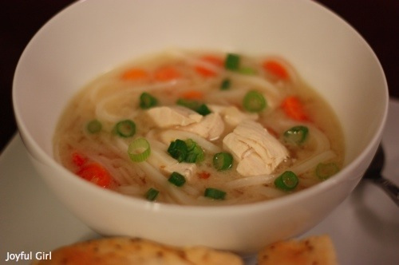

Thai it Up Chicken Soup

**Ingredients**

* 2 peeled shallots or 1 small red onion
* 6 1 inch pieces unpeeled fresh ginger
* 1 stalk lemon grass, cut into chunks
* 2 kaffir lime leaves or 1 tsp lime zest
* 1 15 ounce coconut milk
* 3 1/2 ounces rice noodles broken in pieces
* 1 cup peeled diced carrots
* pinch of cayenne (optional 1 organic chicken breast half cut in chunks
* 2 tbsp freshly squeezed lime juice
* 1/4 cup chopped fresh cilantro
* 2 tbsp sliced scallions (optional)
* salt

**Directions**

1. Combine all the ingredients from broth thru lime zest. Add 1/4 tsp salt in a soup pot, bring to a boil. Lower the heat to med-low and simmer 20 minutes.
2. Using a slotted spoon remove solids and discard. Stir in coconut milk and continue to simmer 10 minutes.
3. Meanwhile, put the rice noodles into a bowl of hot water and soak 10 minutes. Drain and set aside.
4. Stir the carrots and cayenne pepper into the soup, simmer 3 minutes then add chicken and simmer 7 minutes or until chicken is cooked through. Stir in noodles, lime juice, 1/4 tsp salt. Check for seasoning. Serve. Top with cilantro and scallions.

https://www.familycookbookproject.com/recipe/3388560/cancer-fighting-kitchen-thai-it-up-chicken-soup.html