Chia, Lemon & Strawberry Zucchini Muffins

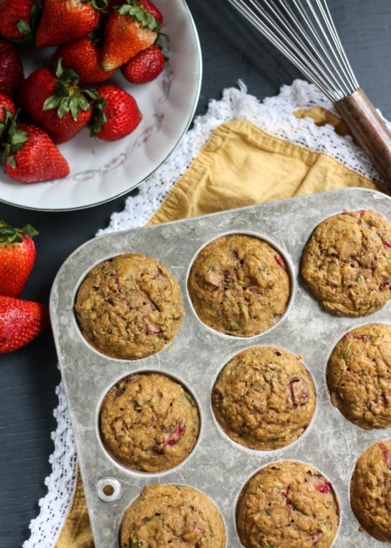

Nutritious and healthy whole grain strawberry zucchini muffins with a hint of lemon and a little crunch from chia seeds. Naturally sweetened and amazingly delicious!

**INGREDIENTS**

* 1 1/2 cups white whole wheat flour, whole wheat pastry flour or all purpose gluten-free flour
* 1 teaspoon baking soda
* 1/4 teaspoon salt
* 1 cup shredded zucchini (about 1 medium zucchini)
* 1/3 cup pure Grade B maple syrup or honey
* 2 tablespoons lemon zest (not juice!)
* 1 1/2 tablespoons coconut oil, melted and cooled
* 1/3 cup unsweetened applesauce
* 1 egg
* 1/4 cup unsweetened vanilla almond milk
* 3/4 cup ripe diced strawberries
* 2 tablespoons chia seeds

**INSTRUCTIONS**

~Preheat oven to 350 degrees F. Line a 12 cup muffin pan with nonstick cooking spray or line with muffin liners. Either way I recommend using nonstick cooking spray. This guarantees that they muffins will not stick to the liners or the pan.

~In a large bowl combine the dry ingredients: flour, baking soda and salt; set aside.

~Squeeze the shredded zucchini of excess moisture with a paper towel then add to another large bowl with the other following wet ingredients: maple syrup, lemon zest, coconut oil, applesauce, egg and milk.

~Add to dry ingredients and stir until just combined. Gently fold in strawberries and chia seeds.

~Even distribute batter among muffin tins, filling about 3/4 of the way full. Bake for 20-22 minutes or until toothpick inserted into the middle of the muffin comes out clean. Cool on wire rack for 10 minutes then remove muffins and transfer to wire rack to finish cooling.

Makes 12 muffins.

**NOTES**

If you'd like, you can skip the lemon and add chocolate chips or carob chips for a delicious treat.  
  
To make vegan: Use a flax egg instead of a regular egg. The recipe should work out just fine!  
  
To make gluten free: Use an all purpose gluten free flour that replaces regular flour 1:1.