**Moroccan Lentil Soup Recipe from The Abundance Diet.** Author: Somer McCowan

**Ingredients**

* 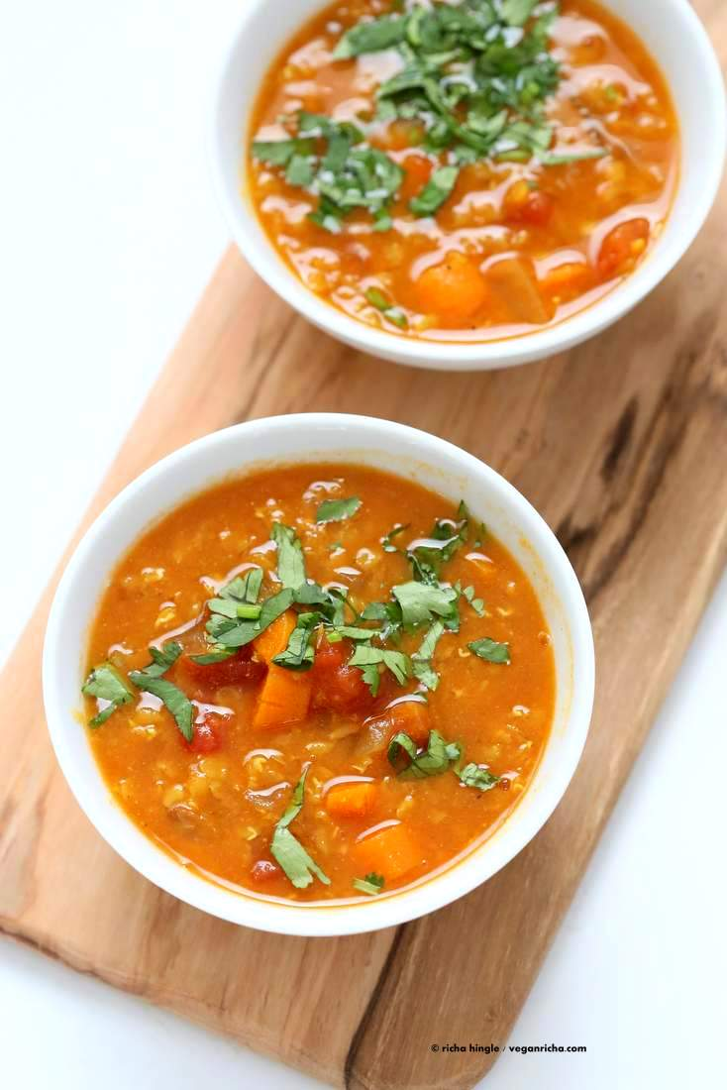6 cups vegetable broth
* 2 cups onions chopped into 1/4-inch dice
* 2 medium carrots sliced into 1/4-inch rounds
* 2 large cloves garlic minced or pressed
* 1 teaspoon [ground coriander](https://www.amazon.com/gp/product/B000WS1KI6/ref=as_li_tl?ie=UTF8&camp=1789&creative=390957&creativeASIN=B000WS1KI6&linkCode=as2&tag=vegric-20&linkId=HCNVTXTMFDRKRAJM)
* 1 1/2 heaped teaspoons ground cumin
* 3/4 teaspoon ground turmeric
* 3/4 teaspoon smoked paprika
* 3/4 teaspoon ground cinnamon
* 3/4 teaspoon ground ginger
* 28 oz can crushed tomatoes
* 1 1/2 cups split dry red lentils picked over and rinsed
* 1/3 cup chopped parsley
* 1/3 cup chopped cilantro
* Juice of 1 large lemon
* 1 teaspoon sea salt or to taste
* 1/3 teaspoon ground black pepper

**Instructions**

1. Heat 1/4 cup of the vegetable broth in a large soup pot over medium-high heat.
2. Add the onion, carrot, and garlic and sauté, adding additional broth as necessary to keep the vegetables from burning. Sauté until the onions are softened and translucent, about 5 minutes.
3. Add the coriander, cumin, turmeric, smoked paprika, cinnamon, and ground ginger. Sauté the vegetables and seasonings for 1 to 2 minutes to allow the flavors to bloom. Add the remaining vegetable broth, crushed tomatoes, and lentils and bring to a boil.
4. Cover the pot and reduce the heat to a simmer. Cook for 30 minutes or until the lentils are fully cooked.
5. Add the parsley, cilantro, and lemon juice and stir to combine. Season with the salt and pepper.
6. For texture variation you can pulse the soup a few times with an immersion blender. For extra brightness, squeeze an additional slice of lemon over each bowl.

https://www.veganricha.com/2015/06/moroccan-lentil-soup-recipe-from-the-abundance-diet.html