**Raw Avocado Pesto Zucchini Noodles**

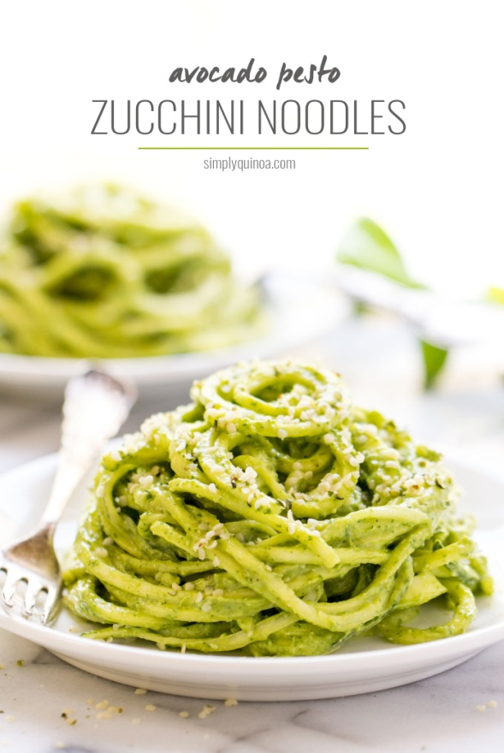

**Ingredients**

* 3 – 4 medium zucchinis
* 2 avoados
* 2 cups fresh basil
* 3 – 4 cloves garlic
* Juice of 1 lemon
* 1/4 cup [hemp seeds](http://www.bobsredmill.com/hulled-hemp-seed.html) (or pine nuts)
* [Sea salt](http://edisongrainery.com/store/super-foods/76-himalayan-pink-salt.html) + red pepper flakes to taste

**Instructions**

Spiralize the zucchinis and break/cut the noodles into smaller strands. Put them in a large bowl and set aside.

Add remaining ingredients to a food processor and blend on high until smooth and creamy. Pour pesto over zucchini noodles and toss to combine.

Serve immediately or store in the fridge until ready to serve.

Enjoy with a sprinkling more of hemp seeds and/or nutritional yeast and enjoy!

https://www.simplyquinoa.com/raw-avocado-pesto-zucchini-noodles/