**No-Cook Summer Recipes**

**Arugula, Watermelon and Feta Salad**

# http://food.fnr.sndimg.com/content/dam/images/food/fullset/2010/3/17/1/BX0218_arugula-watermelon-and-feta-salad_s4x3.jpg.rend.hgtvcom.966.725.jpegIngredients

* 1/4 cup freshly squeezed orange juice
* 1/4 cup freshly squeezed lemon juice (2 lemons)
* 1/4 cup minced shallots (1 large)
* 1 tablespoon honey
* 1/2 cup good olive oil
* 1 teaspoon kosher salt
* 1/2 teaspoon freshly ground black pepper
* 6 cups baby arugula, washed and spun dry
* 1/8th seedless watermelon, rind removed, and cut in 1-inch cubes
* 12 ounces good feta cheese, 1/2-inch diced
* 1 cup (4 ounces) whole fresh mint leaves, julienned

### Directions

Whisk together the orange juice, lemon juice, shallots, honey, salt, and pepper. Slowly pour in the olive oil, whisking constantly, to form an emulsion. If not using within an hour, store the vinaigrette covered in the refrigerator.

Place the arugula, watermelon, feta, and mint in a large bowl. Drizzle with enough vinaigrette to coat the greens lightly and toss well. Taste for seasonings and serve immediately.

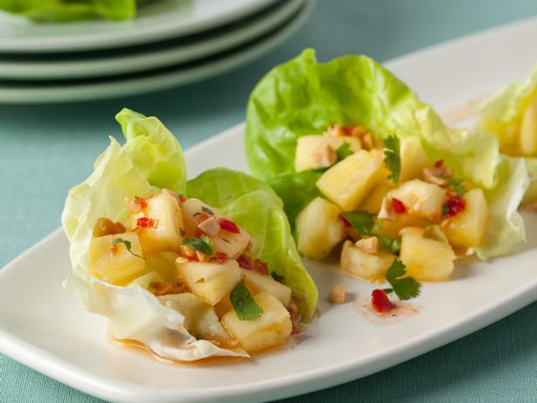**Spicy Thai-Style Pineapple Wraps**

**Ingredients**

* Juice of 2 limes (about 14 cup)
* 2 teaspoons sugar
* 2 teaspoons chile paste, such as sambal oelek
* 2 teaspoons fish sauce
* 2 cups roasted peanuts or cashews, roughly chopped
* 23 cup roughly chopped fresh cilantro (leaves and stems)
* 12 Bibb lettuce leaves (about 1 head)
* Half a medium fresh pineapple, peeled, cored, and cut into bite-size chunks (about 3 cups)
* Kosher salt

### Directions

Whisk the lime juice, sugar, chile paste, and fish sauce in a bowl until the sugar dissolves. Add the peanuts and cilantro and stir until evenly dressed with the sauce.

When ready to serve, arrange the lettuce leaves on a large platter. Put about 1/4 cup of pineapple in each leaf and season with salt to taste. Top the pineapple with the nut mixture. Serve, letting your guests wrap (or fold) each lettuce leaf to enclose the filling.

**Veggie Pita Pockets**

**Ingredients**

* 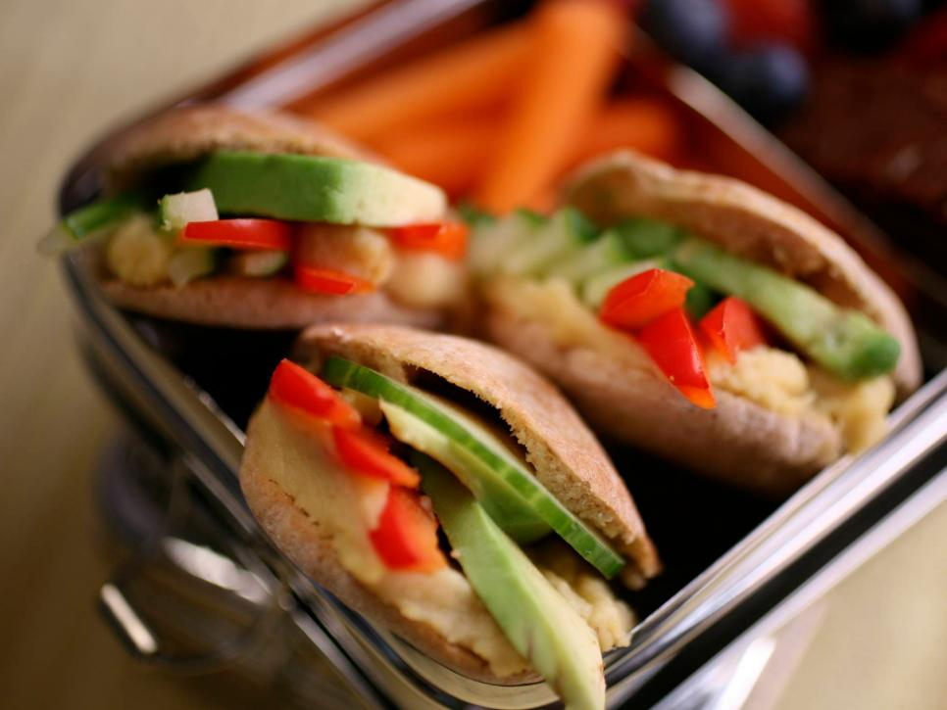1 (15-ounce) can chickpeas or white beans, rinsed and drained
* 1 to 2 tablespoons water
* 1/4 cup grated manchego or pecorino romano cheese
* 2 teaspoons freshly squeezed lemon juice
* 1 teaspoon kosher salt, plus more for seasoning
* Pinch red pepper flakes
* 1/4 cup extra-virgin olive oil
* Freshly ground black pepper
* 1/2 ripe Hass avocado, pitted and sliced
* 1 small cucumber, sliced or 1/2 bell pepper, seeded and sliced
* 10 to 12 whole-wheat pita minis (3 inches), lightly toasted

### Directions

Combine the chickpeas, water, cheese, lemon juice, salt and red pepper flakes in a food processor and puree until completely smooth, about 5 minutes. While the motor is running, pour in the olive oil and process until fully incorporated and velvety. Season with pepper, to taste.

Spoon a scant tablespoon bean spread into toasted pitas. (Put remaining bean spread in an air-tight container.) Add avocado and cucumber slices, or other vegetables of choice and season, to taste, with salt and pepper. Wrap in parchment or butcher paper, and pack in a plastic container to keep from getting squished. Pack in a lunch box and send to school.

##### Cook's Note

Remaining bean spread becomes a dip for vegetables or pita chips, or as another dimension layered in your child's favorite cold cut sandwich.

### Cucumber Salad

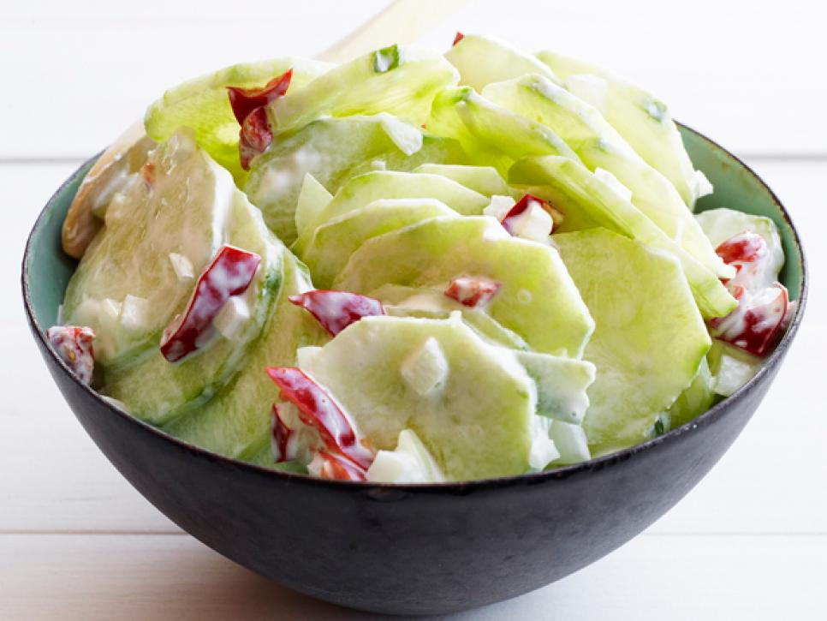

### Ingredients & Directions

* Toss 3 peeled and thinly sliced cucumbers with 1 tablespoon salt in a bowl. Chill 1 hour, then drain and pat dry.
* Meanwhile, soak 3 tablespoons minced onion in cold water 15 minutes; drain.
* Mix 1 1/2 cups sour cream and 1 1/2 teaspoons sugar in a large bowl, then stir in the cucumbers, onion, some black pepper and 1/2 cup chopped pickled cherry peppers.

# http://food.fnr.sndimg.com/content/dam/images/food/fullset/2009/1/16/0/GH0106_Watermelon-Pops.jpg.rend.hgtvcom.966.725.jpegSpiked Watermelon Pops

**Ingredients**

* 1/2 (3 pounds) large watermelon, peeled and cut into 1-inch chunks
* 1/4 cup sugar
* 3/4 cup watermelon flavored 70 proof vodka (recommended: Smirnoff Twist of Watermelon)* see Cook's Note
* 1/2 cup chopped fresh mint leaves

**Directions**

* Special equipment: 16 (1/4 cup) ice pop molds, 16 wooden pop sticks or wooden coffee stirrers at least 2-inches longer than the molds.
* In a blender, combine the watermelon, sugar, and vodka. Blend until the mixture is smooth. Add the mint and pulse once to combine. Pour the mixture into the pop molds. Insert the wooden sticks all the way down the inside the molds. Freeze for at least 10 hours or preferably overnight.
* To unfreeze the ice pops, insert the molds in hot water for 5 to 10 seconds. Serve immediately.

**Cook's Note**

**\*For nonalcoholic Watermelon Pops, substitute 3/4 cup orange juice for the vodka.**

# [Papaya-Banana Smoothie](http://www.foodnetwork.com/recipes/bobby-flay/papaya-banana-smoothie-recipe-1948862#lightbox-recipe-video)

# Papaya-Banana Smoothie

**Ingredients**

* 1 cup milk
* 1/4 cup Greek yogurt
* 1 teaspoon pure vanilla extract
* 1 small ripe banana, peeled and sliced
* 1/2 large, ripe papaya, peeled, seeded and chopped
* 1 cup ice cubes

<http://www.foodnetwork.com/recipes/photos/no-cook-summer-recipes>

<http://www.marksdailyapple.com/top-10-summer-vegetables/>