**Spicy Roasted Cabbage Wedges**

34.8K7914[Mail](mailto:?subject=Spicy%20Roasted%20Cabbage%20Wedges&body=https%3A%2F%2Fskinnyms.com%2Fspicy-roasted-cabbage-wedges-recipe%2F)

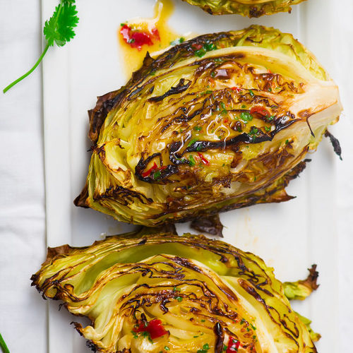Even if you’re not a cabbage fanatic, you’ll love these scrumptious cabbage wedges! Before now, your relationship with cabbage might’ve been limited to chopping the vegetable and tossing it in a salad. Here at SkinnyMs., we’ve discovered a mouthwatering cabbage-prep method that’ll blow your taste buds away – roasting! Cabbage turns brown and fork tender when you use your oven to transform an ordinary vegetable into something deliciously extraordinary.

Vegan and gluten-free, this foolproof recipe calls for just a few wholesome ingredients, including cabbage, olive oil, sun-dried tomatoes, Dijon mustard, and some spices. Red pepper flakes give each wedge a zesty kick, while black pepper adds a bold finish. These roasted beauties make a unique, tasty side dish to any main meal. With minimal prep time and simple instructions, these spicy roasted cabbage wedges come together in a matter of minutes!

**Spicy Roasted Cabbage Wedges**

**Ingredients**

* 1 medium head green cabbage, cut into 8 wedges
* 2 tablespoons extra-virgin olive oil
* 1/2 teaspoon kosher or sea salt
* 1/2 teaspoon black pepper
* 1/4 teaspoon red pepper flakes
* 1/4 teaspoon garlic powder
* 1 tablespoon Dijon mustard
* 2 tablespoons chopped sun-dried tomatoes
* 1 tablespoon chopped cilantro, optional

**Directions**

Preheat oven to 400 degrees.

In a small bowl, whisk together oil, salt, pepper, garlic powder, red pepper flakes, Dijon mustard, and sun-dried tomatoes.

Brush all sides of cabbage wedges with oil mixture. Place wedges on a large baking sheet. Cover wedges with foil and roast 45 minutes, remove foil and roast an additional 10 minutes or until golden and fork tender. If desired, garnish with chopped cilantro. Serve immediately. Enjoy!

https://skinnyms.com/spicy-roasted-cabbage-wedges-recipe/