# Sweet Cabbage Salad

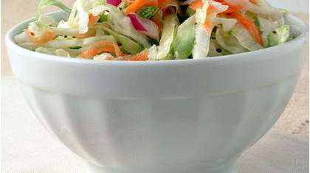

"I developed this recipe after my mom made a similar version. I changed a couple of her items and ended up with this sweet-tangy [salad](http://www.myrecipes.com/salad-recipes/)." -Jenn Sitts, Oneonta, NY

Serve this light, crisp side dish to complement barbecue food or other summer dishes. It's a healthy, low-fat version of cole slaw.

**Ingredients**

* 6 cups shredded cabbage (about 1/2 head)
* 1 cup shredded carrot (about 1 medium)
* 1 cup chopped green bell pepper (about 1 medium)
* 1/2 cup chopped red onion
* 1/2 cup sugar
* 1/2 cup white wine vinegar
* 2 tablespoons olive oil
* 1 teaspoon dry mustard
* 1/2 teaspoon celery seeds
* 1/2 teaspoon salt

Directions: Combine first 4 ingredients in a large bowl; toss well. Combine sugar and remaining ingredients in a small bowl, stirring with a whisk. Pour vinegar mixture over cabbage mixture, tossing gently to combine. Cover; chill 1 hour.

http://www.health.com/health/recipe/0,,10000001197207,00.html