**Sweet Potato Rice Pudding**

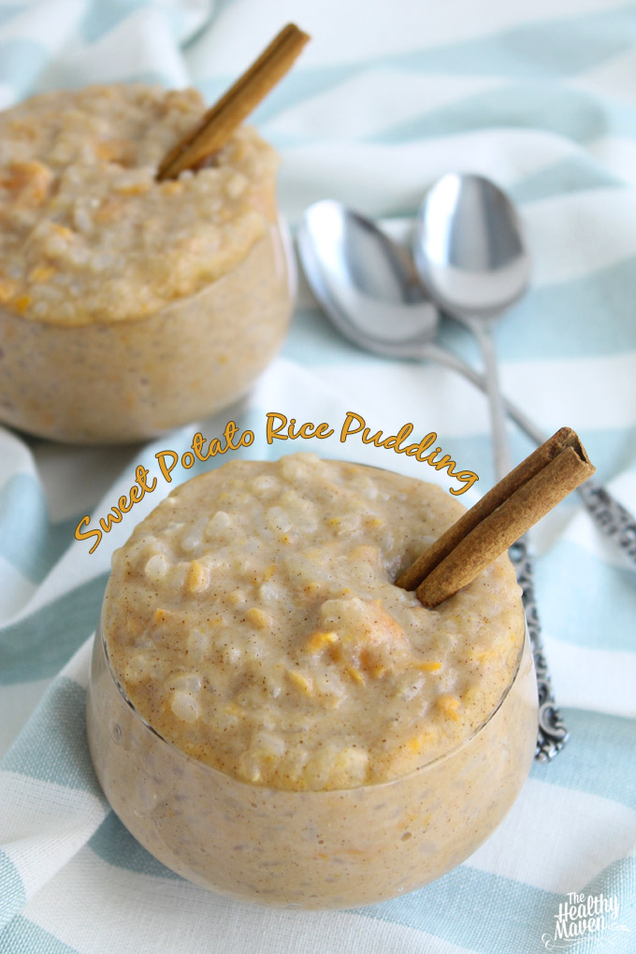

**Ingredients**

* 1/2 cup brown rice (I used short grain)
* 4 cups unsweetened non-dairy milk (I used a mix of coconut and almond milk)
* 2 T honey (or agave for vegans)
* 1 1/2 tsp vanilla extract
* ½ tsp ground cinnamon
* 1 cup mashed sweet potato (about 1 medium)

**Instructions**

1. If roasting sweet potato preheat oven to 400 degrees F. and roast for 40-50 mins in tinfoil. Remove from oven and let cool before cutting open and scooping out 1 cup. OR microwave on high for 4-5 mins on a paper towel or microwave safe dish. Let cool and cut open to scoop out 1 cup.
2. In a large saucepan add rice and non-dairy milk.
3. Bring to a boil before decreasing heat to a simmer.
4. Let simmer for 40-50 mins, stirring occasionally.
5. Once all liquid has been absorbed and reached pudding consistency add honey,vanilla, mashed sweet potato and cinnamon.
6. Add additional milk if pudding is too thick.
7. Remove from heat and serve.
8. Will keep in refrigerator for several days in an airtight container.

http://www.thehealthymaven.com/2014/02/sweet-potato-rice-pudding.html