How to Make Turmeric Spiced Cabbage Soup

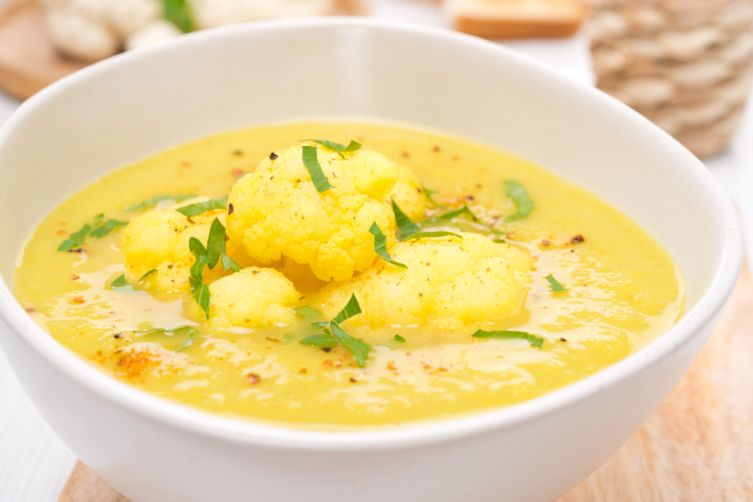

**Ingredients**

* 1 small head of white cabbage, finely chopped
* ½ head cauliflower
* 2 garlic cloves, minced
* 2 tsp [turmeric powder](https://www.amazon.com/gp/product/B00W4AY9BA/ref=as_li_qf_sp_asin_il_tl?ie=UTF8&tag=organifi00f-20&camp=1789&creative=9325&linkCode=as2&creativeASIN=B00W4AY9BA&linkId=fd35fdc6f546fa586d935ae3a7af3269)
* 1 tsp [cumin powder](https://www.amazon.com/gp/product/B000WS3AJS/ref=as_li_qf_sp_asin_il_tl?ie=UTF8&tag=organifi00f-20&camp=1789&creative=9325&linkCode=as2&creativeASIN=B000WS3AJS&linkId=028ba4d1cd4ce879145669967e3c156d)
* ¼ cup [coconut milk](https://www.amazon.com/gp/product/B001HTJ2BQ/ref=as_li_qf_sp_asin_il_tl?ie=UTF8&tag=organifi00f-20&camp=1789&creative=9325&linkCode=as2&creativeASIN=B001HTJ2BQ&linkId=f58b25ad15495485c6f23c6d47c2eab3)
* 3 cups [vegetable stock](https://www.amazon.com/gp/product/B009S4PM34/ref=as_li_qf_sp_asin_il_tl?ie=UTF8&tag=organifi00f-20&camp=1789&creative=9325&linkCode=as2&creativeASIN=B009S4PM34&linkId=a22e61f4cf7c0464d9e5a539054d932a)
* 2 tbsp [coconut oil](https://www.amazon.com/gp/product/B00DS842HS/ref=as_li_qf_sp_asin_il_tl?ie=UTF8&tag=organifi00f-20&camp=1789&creative=9325&linkCode=as2&creativeASIN=B00DS842HS&linkId=5d7a84e690076ddbaddd6fe13932d846)
* ½ tsp [sea salt](https://www.amazon.com/gp/product/B0034TY0A0/ref=as_li_qf_sp_asin_il_tl?ie=UTF8&tag=organifi00f-20&camp=1789&creative=9325&linkCode=as2&creativeASIN=B0034TY0A0&linkId=dd28ad70a1ae17d1f7a9cc152bd794bd)
* ½ tsp [pepper](https://www.amazon.com/gp/product/B010BUF0VM/ref=as_li_qf_sp_asin_il_tl?ie=UTF8&tag=organifi00f-20&camp=1789&creative=9325&linkCode=as2&creativeASIN=B010BUF0VM&linkId=ff1167fab2b7d37a7c458cdda34069b3)

**Instructions**

1. In a saucepan on medium heat, heat the oil and then add the garlic, cabbage and cauliflower.
2. Saute for 10 minutes until cabbage is soft.
3. Add vegetable stock.
4. Bring to a boil, cover and allow simmering for 20 minutes.
5. Remove from heat and add the coconut milk and spices.
6. Pour the soup into a blender and process until smooth.
7. Add salt and pepper to desired taste.

http://fitlife.tv/reduce-inflammation-purify-your-body-with-turmeric-spiced-cabbage-soup_original/

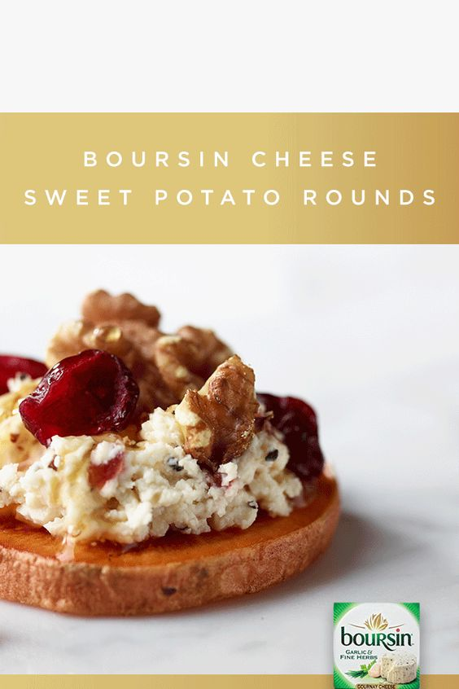

**Ingredients:**

* Sweet potato
* Olive oil
* Boursin cheese
* Dried cranberries

**Directions:**

~Slice uniform sweet potato slices. Spray with oil on both sides.

~Bake until soft but not mushy.  Allow potatoes to cool.

~Add some Boursin Shallot and Chive cheese on the cooled sweet potato, top with dried cranberries, chopped walnuts and right before serving a drizzle of honey.

**Sweet Potato Rounds with Goat Cheese Appetizer**

A Festive Appetizer: Sweet Potato Rounds with Goat Cheese, Cranberries & Honey Balsamic Glaze, finished with a blood orange infused olive oil and fresh basil!

**Ingredients**

* 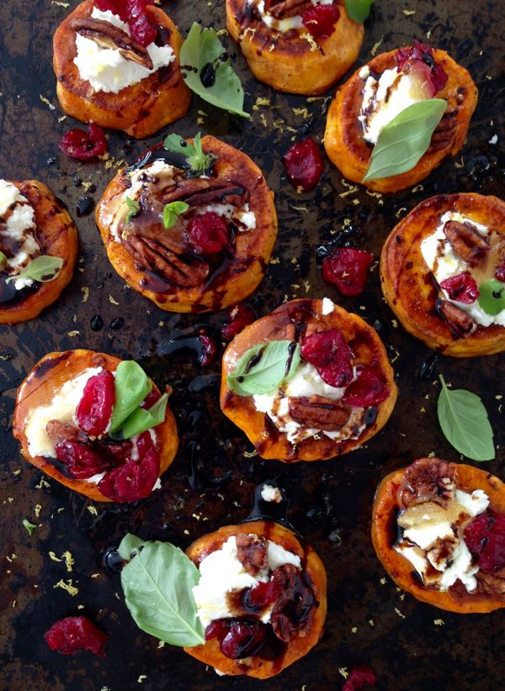2 sweet potatoes large
* 5 oz goat cheese
* 1/3 c candied walnuts or pecans
* 1/3 c cranberries dried
* 2 tbsp balsamic reduction
* 1 tsp sea salt + more to taste
* 1/2 tsp paprika sweet
* 2 tbsp olive oil + more as needed
* 1 tbsp blood orange olive oil
* 3 tbsp wild honey
* Zest from 1 lemon
* 15 leaves basil small, for garnish

**Instructions**

~Preheat your oven to 500”F

~In a small bowl combine the olive oil, sea salt and paprika.

~Peel and cut the sweet potatoes into 1 inch thick rounds.

~Take each sweet potato round and coat it in the olive oil mixture all over. Place them on a large baking tray without touching each other.

~Bake the sweet potato rounds for 8 to 10 minutes on each side until golden.

~Transfer to a serving tray and top with the goat cheese, candied walnuts, and cranberries. Spoon a little bit of wild honey on top of each potato round and sprinkle with the lemon zest.

~Just before serving finish with a light drizzle of orange infused olive oil, the balsamic glaze and garnish with the fresh basil leaves. https://ciaoflorentina.com/sweet-potato-rounds-recipe-goat-cheese-cranberries-balsamic-glaze/

**How To Make A Green Tea Mango Smoothie**

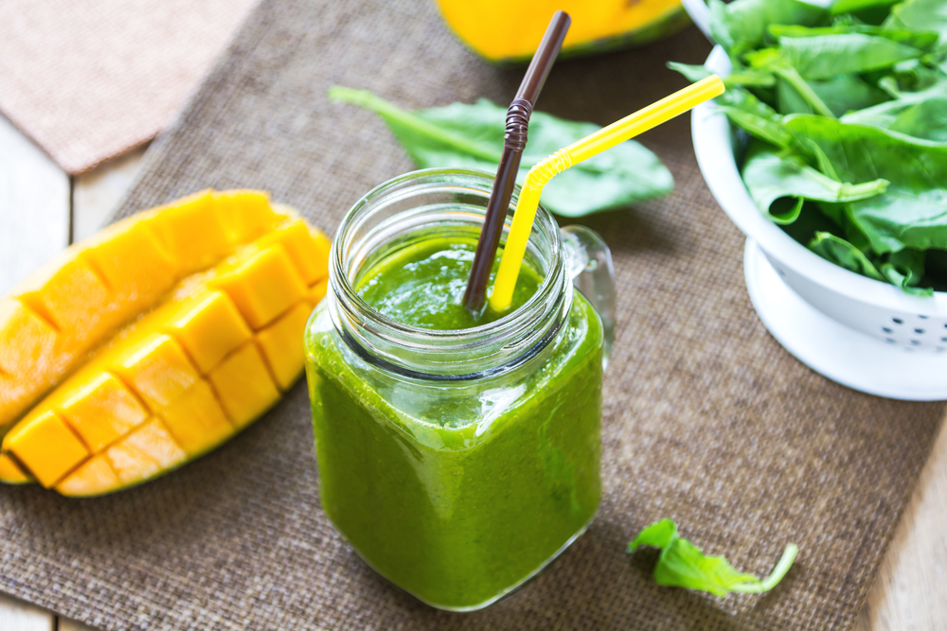

**Ingredients**

* 1 ½ cups brewed green tea, chilled
* 1 ½ cups frozen mango, cubed
* 2 bananas, frozen and cut into pieces
* 1 cup fresh spinach
* 1 cup fresh kale
* 1 tbsp lemon juice
* 1 tbsp [chia seeds](https://www.amazon.com/gp/product/B009AH7OU8/ref=as_li_qf_sp_asin_il_tl?ie=UTF8&tag=organifi00f-20&camp=1789&creative=9325&linkCode=as2&creativeASIN=B009AH7OU8&linkId=8c679e4cdc3bfe17f12f8492479c3f73)
* ¼ tsp [turmeric](https://www.amazon.com/gp/product/B000WR4LMY/ref=as_li_qf_sp_asin_il_tl?ie=UTF8&tag=organifi00f-20&camp=1789&creative=9325&linkCode=as2&creativeASIN=B000WR4LMY&linkId=c764b6db35fba4685f894935144171e7)
* 1 tsp [raw honey](https://www.amazon.com/gp/product/B00CMQD3VS/ref=as_li_qf_sp_asin_il_tl?ie=UTF8&tag=organifi00f-20&camp=1789&creative=9325&linkCode=as2&creativeASIN=B00CMQD3VS&linkId=8211e097530a9268fc55843dce9e6585) (optional)

**Instructions**

1. Place all of the ingredients in a blender and process until smooth. Push down the sides as needed to ensure everything is well combined, smooth and creamy.