**[Cranberry & Thyme Vegan Cheese Ball](http://itdoesnttastelikechicken.com/2015/12/22/cranberry-thyme-vegan-cheese-ball/)**

**[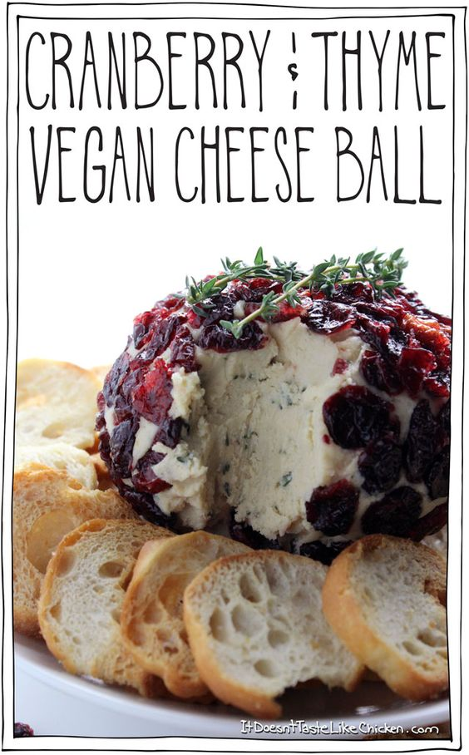](http://itdoesnttastelikechicken.com/2015/12/22/cranberry-thyme-vegan-cheese-ball/)**

**Ingredients**

* 1/2 cup Cranberries, dried
* 1 clove Garlic
* 1 tbsp Thyme, fresh leaves
* 2 tbsp Lemon juice
* 2 tsp White miso paste
* 2 tbsp Nutritional yeast
* 1/4 tsp Salt
* Oils & Vinegars
* 2 tbsp Coconut oil
* Nuts & Seeds
* 1 cup Cashews, raw

**Instructions**

1. You can either boil or soak the cashews. **To boil the cashews:** add the cashews to a small pot, cover with water, and boil for about 10 minutes until the cashews are very tender. **To soak the cashews:** add the cashews to a bowl, and cover with water. Let soak for 4 hours or longer until tender.
2. Drain the cashews and add to a food processor along with the lemon juice, nutritional yeast, coconut oil, white miso paste, garlic, and salt. Blend until very smooth and creamy, stopping to scrape down the sides as needed. Add the thyme leaves to the food processor and blend to combine.
3. Line a small bowl with plastic wrap, and scoop the cheese mixture into the bowl. Gather up the sides of the plastic wrap and twist to form a ball. Let the cheese ball firm up in the freezer for about an hour, or for a couple of hours in the fridge.
4. Remove the now firm cheese ball from the plastic wrap, and press the cranberries onto the outside of the ball. You can also lightly press the ball to get a rounder shape if desired. You can serve it right away, or keep the cheese ball covered in the fridge until you are ready to serve. Garnish with thyme sprigs and serve with crackers.

Recipe from itdoesnttastelikechicken.com

##### Vegan Parmesan Cheese

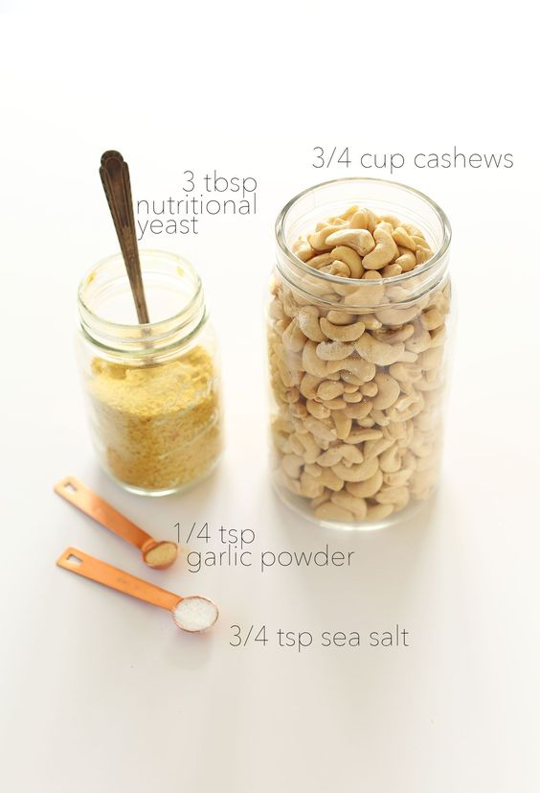

Easy, 4 ingredient vegan parmesan cheese that's perfect on top of pastas, pizza and anywhere you'd usually use parmesan cheese! (Vegan, Gluten free)

##### Ingredients

* 1/4 tsp Garlic powder
* 3 tbsp Nutritional yeast
* 3/4 tsp Sea salt

Recipe from minimalistbaker.com