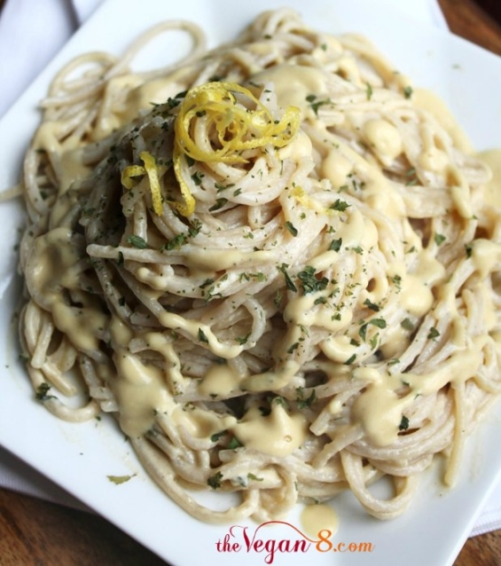Vegan Garlic Alfredo Sauce

Yields 2 cups

Healthy vegan garlic alfredo sauce that tastes like the guilty version. Lots of onion is the secret to this easy, low ingredient and rich dairy-free and oil-free alfredo sauce. You will be shocked there is not an ounce of dairy in it!

**INGREDIENTS**

* 1 medium white onion, chopped (MAKE SURE to measure out 1 1/2 cups (200g b/c this is where lots of flavor comes)
* 1-2 cups low sodium vegetable broth, separated (240-480 mL)
* 1/2 teaspoon (3g) fine sea salt
* 1/4-1/2 teaspoon ground black pepper
* 4 EXTRA LARGE garlic cloves, minced (15g) (don't skimp because hey, flavor! You should NOT need to be adding extra garlic if you use the correct amount listed. If your cloves are small, add more.)
* 1/2 heaping cup raw, unsalted cashews (75 g, 2.6 oz) (soaked overnight in hot water if you don't have a high powered blender, otherwise your result will be gritty and NOT creamy)
* 1-2 tablespoons lemon juice (don't omit, as this omits any cashew flavor!)
* 1/4 cup nutritional yeast (25 g, more or less if preferred. I used an extra tablespoon. Make sure to use a non-synthetic version so it doesn't leave a nasty vitamin taste. I highly recommend [Sari brand](http://thevegan8.com/goto/http:/amzn.to/2eFS96c))

**Note**

* It is not recommended to sub or eliminate any of these ingredients, as I cannot vouch for the results if any are changed. The lemon juice is crucial, as it eliminates any cashew flavor.
* Also, if you don't have a high powered blender like a Vitamix, it is crucial to pre-soak the cashews so they soften and the sauce ends up smooth and creamy, and not gritty. Drain them and rinse after soaking.

**INSTRUCTIONS**

1. Add the onion and **ONLY** 1 cup of the broth to a large pan over medium heat. Cook for about 8 minutes until the onion is very tender. (Add a tiny bit more broth if it is cooking too fast or turn the heat down, so the onions don't burn) After several minutes, add the garlic and cook a couple of minutes more. All of the broth should have evaporated by now. If not, keep letting it cook until the broth is GONE. You don't want any more liquid once it's done cooking, so the end result is thick and creamy.
2. Add the cooked veggies (the onion and garlic) to a blender. Start out by just adding 1/2 cup more of the remaining broth and add the remaining ingredients (salt, pepper, cashews, lemon juice, nutritional yeast). Blend on high for a couple of minutes until very creamy and smooth. Add any more broth to reach desired consistency, if necessary. Taste and add any more salt & pepper, if desired.
3. Serve over preferred pasta. *Note:* When preparing your pasta, make sure to salt your water well, so your pasta has flavor and isn't bland, which can affect the end flavor result of the dish. I add around a tablespoon to a large pot of boiling water. Garnish with parsley, lemon zest and salt & pepper, if desired. Add any veggies you like. I like to add broccoli or even peas. Store leftovers in the fridge. The sauce will thicken up even more overnight, which you can thin out a little with a touch of broth when reheating, if necessary.

**http://thevegan8.com/2013/12/28/vegan-garlic-alfredo-sauce/**