# Vegan Sweet Potato Veggie Burgers

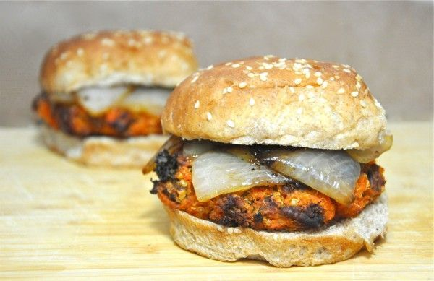

This is not your average veggie burger recipe - it's a sweet potato burger! A sweet potato veggie burger, that is. Packed full of lots of healthy ingredients, these sweet potato burgers are truly inspired by Southern cooking - they're made from sweet potatoes, quinoa, maple syrup, pecans and kale. This is a good one to bookmark if you need an idea to use up some [leftover cooked or mashed sweet potatoes,](https://www.thespruce.com/what-to-do-with-leftover-potatoes-3376635) or even if you have [leftover cooked quinoa](https://www.thespruce.com/what-to-do-with-leftover-quinoa-3378671) on hand.

These award-winning Southern-inspired vegetarian and vegan sweet potato burgers made with [quinoa](https://www.thespruce.com/what-is-quinoa-3376836) were developed by Tolerant Vegan blogger Nikki Haney and courtesy of the [North Carolina Sweet Potato Commission](http://www.ncsweetpotatoes.com/). ( https://www.thespruce.com/vegan-sweet-potato-veggie-burgers-3377361)

**Ingredients:**

* 3 medium sweet potatoes (about 1 1/2 pounds)
* 1/4 cup quinoa, uncooked
* 2 tablespoons vegan butter substitute, or butter
* 2 tablespoons maple syrup
* 1/8 teaspoon cayenne pepper
* 1 cup chopped kale
* 1/2 cup dry roasted pecans, chopped
* Salt
* 1 small sweet onion, very coarsely chopped
* Freshly ground black pepper
* 4 hamburger buns

**Directions:**

1. Preheat oven to 400°F. Pierce sweet potatoes and microwave together until soft, 4 to 6 minutes. Mash firmly into measuring cups to make 2 cups; transfer to a medium mixing bowl.
2. Meanwhile, in a small saucepan, bring 3/4 cup water and the quinoa to a boil. Reduce to a low simmer and cover, until the water is nearly absorbed and the quinoa appears transparent, about 8 to 10 minutes. Remove quinoa from the stove; allow to sit covered, for 5 minutes.
3. In a separate saucepan, melt 1 tablespoon of the vegan butter substitute or butter. Stir in 1 tablespoon of maple syrup and the cayenne pepper. Add mixture to the mashed sweet potatoes along with the kale, cooked quinoa, pecans and 1/2 teaspoon salt; mix well.
4. Form the mixture into four patties; place on a well-oiled baking sheet. Bake for 35 minutes, turning once at the halfway point.
5. When the burgers have around 15 minutes left to bake, make the onion topping. In a small skillet over medium heat, melt the remaining 1 tablespoon vegan butter substitute. Add the onion; sprinkle with salt and fresh ground black pepper to taste. Cook and stir for 12 minutes. Reduce heat to low; add remaining 1 tablespoon of maple syrup. Cook and stir until onions are slightly brown, about 3 more minutes; remove from heat.
6. Transfer burgers to buns and top each with onion mixture. Makes four sweet potato veggie patties.