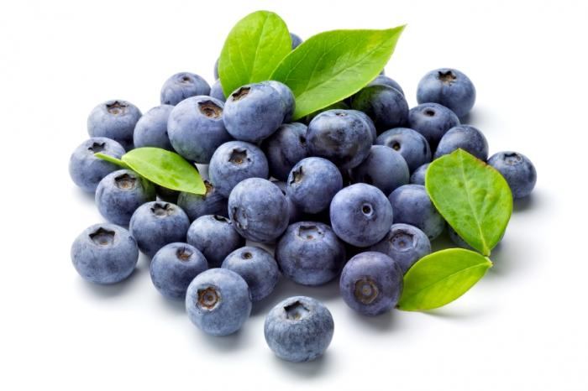***Blueberries***

**Blueberry-Lemon Iced Tea**

*Ingredients*

* 16-oz. blueberries
* 1/2 cup fresh lemon juice
* 4 cups water
* 3 family-size tea bags
* 3/4 cup sugar (optional)

*Directions:*

1. Bring blueberries and 1/2 cup fresh lemon juice to a boil in a large saucepan over medium heat. Cook, stirring occasionally, 5 minutes. Remove from heat, and pour through a fine wire-mesh strainer into a bowl, using back of a spoon to squeeze out juice. Discard solids. Wipe saucepan clean.
2. Bring 4 cups water to a boil in same saucepan; add 3 family-size tea bags, and let stand 5 minutes. Remove and discard tea bags. Stir in 3/4 cup sugar and blueberry juice mixture. Pour into a pitcher; cover and chill 1 hour. Serve over ice.

**Peach and Blueberry Greek Yogurt Cake**

*Ingredients*

* 1 and 1/2 cups all-purpose flour
* 1 teaspoon baking powder
* 1/2 teaspoon baking soda
* 1/2 stick butter, softened
* 1 cup sugar
* 2 eggs
* 1/2 teaspoon vanilla
* 1/2 cup Greek yogurt
* 2 peaches, sliced into wedges
* 6 oz blueberries
* 1 teaspoon granulated sugar

*Directions:*

1. Preheat oven to 350°F with rack in middle. Grease the side and the bottom of the pan with butter or cooking spray.
2. Sift flour, baking powder, baking soda, together into a medium bowl.
3. In a separate bowl, beat butter, sugar, and 2 eggs until very light in color and fluffy, 2-3 minutes on high speed. Add vanilla and Greek yogurt and continue beating until very creamy and light in color, for about 1 more minute.
4. Keeping the mixer speed low, mix in the flour mix until combined. Do not over mix.
5. Transfer the cake batter to the ‘springform’ pan. Top with sliced peaches, and scatter blueberries evenly on top in the spaces between the peach slices. Sprinkle the fruit with 1 teaspoon granulated sugar.
6. Bake until cake turns golden, and the tester comes out clean in the center, about 1 hour, depending on your oven. Midway through baking, Add some extra peach slices and extra blueberries on top of the cake for prettiness, and return cake to baking.
7. When the cake is done baking, let it cool (still in the baking pan) on a wire rack. After cake has cooled for about 40 minutes, release the cake from the ‘springform’ pan. At this point, if the cake is cool enough, you can slide your hand under the cake, between the parchment paper and the bottom portion of the ‘springform’ pan and move the cake onto a cake plate.

**Savory Blueberry and Brie Grilled Cheese**

[Ingredients](https://www.driscolls.com/recipe/Savory-Blueberry-and-Brie-Grilled-Cheese#collapse-EF7A7AEA609C4C018D232165C7079FD6)

* Package Butter
* (Use savory blueberry sauce from recipe below)
* 4 Ounces Brie
* 4 Ounces mascarpone cheese (or if would like to make your own, mix 4 ounces full fat cream cheese, 1 to 2 T yogurt and a touch of either half & half or heavy cream)
* 1 Cup baby arugula

[Directions](https://www.driscolls.com/recipe/Savory-Blueberry-and-Brie-Grilled-Cheese#collapse-ADE0658D294C4304B5040BC5BA6EF8D6)

1. Follow Savory Blueberry sauce recipe below.  Remove from heat and let cool 15 minutes.
2. Preheat oven to 375°F.
3. Butter 1 side of each bread slice and place butter side down on an ungreased cookie sheet. On the other side spread a thin layer of mascarpone cheese and top each with about 2 tablespoons blueberry spread. Thinly sliced Brie, keeping rind on if preferred, and evenly divide, placing on top of blueberry spread. Cook sandwiches about 10 minutes or until cheese is melted. Remove from heat and transfer to serving dishes. Top each with about 1/4 cup arugula and serve immediately.

**Grilled Salmon Steaks with Savory Blueberry Sauce;** *Salmon and blueberries deliciously combine in this summer dish.*

*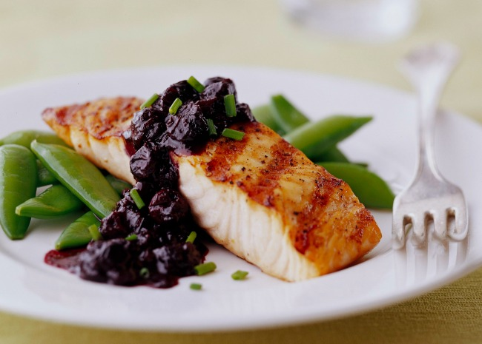Ingredients*

* 1/2 cup chicken stock
* 1/4 cup balsamic vinegar
* 1/4 cup lemon juice
* 1 teaspoon honey
* 1 tablespoon cornstarch
* 1/4 cup chicken stock
* 1 cup fresh blueberries
* 2 teaspoons chopped fresh chives
* fresh thyme
* 4 (6 ounce) salmon steaks
* 2 tablespoons olive oil salt and pepper to taste

*Directions*

1. Pour 1/2 cup chicken stock, vinegar, lemon juice, and honey into a saucepan. Bring to a boil over high heat, then reduce heat to medium. Dissolve cornstarch in 1/4 cup of chicken stock, and stir into the simmering sauce. Cook and stir until the sauce thickens and turns clear, 1 to 2 minutes. Stir in the blueberries and chives, and keep warm over low heat.
2. Preheat grill to medium high-heat.
3. Brush salmon with oil, and season to taste with salt and pepper. Grill until the fish flakes easily with a fork, about 3 to 4 minutes per side. Serve with blueberry sauce.

**Blueberry Chicken Salad**  
makes 3 - 4 sandwiches

*Ingredients*

* 16 ounces chicken breasts or rotisserie chicken breast
* sea salt and fresh ground pepper, to taste
* ¼ cup chicken broth or stock
* ¼ cup blueberries
* ¾ cup mayonnaise
* ¼ cup celery, diced
* 1 Tablespoon shallot, diced
* ⅛ cup walnuts
* mixed spring greens
* 3-4 croissants

*Directions*

1. Lightly season the chicken breasts with sea salt and pepper, then place in a skillet with chicken broth or stock.
2. Bring the stock to a simmer, cover the skillet and cook for 10 - 15 minutes on medium-low or until the internal temperature of the chicken reaches 160°F (or use rotisserie chicken breast)
3. Dice chicken and add blueberries. Once the chicken has cooled add mayonnaise, celery, shallot, and walnuts. Mix well, then refrigerate overnight.
4. Serve on a croissant topped with mixed spring greens. Enjoy!