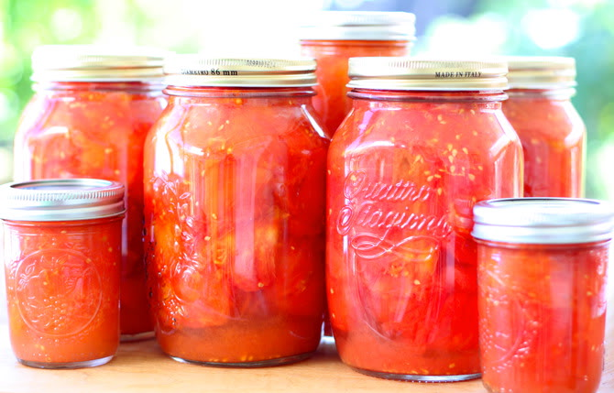Canning Tomatoes

**Preserving Method:** Water Bath Canning

Makes about 2-3/4 lbs tomatoes for each quart jar

**YOU WILL NEED**

·       2-3/4 lbs tomatoes per quart jar

·       ½ tsp [Ball® Citric Acid](http://www.freshpreserving.com/ball-citric-acid-for-preserving-tomatoes-7.5-oz.-1034059.html) or 2 Tbsp bottled lemon juice to each hot quart jar or ¼ tsp[Ball® Citric Acid](http://www.freshpreserving.com/ball-citric-acid-for-preserving-tomatoes-7.5-oz.-1034059.html)or 1 Tbsp bottled lemon juice to each hot pint jar

·       Salt, 1 tsp salt to each quart jar or 1/2 tsp salt to each pint jar (if desired)

**DIRECTIONS**

1. PREPARE boiling water canner. Heat jars in simmering water until ready for use. Do not boil.  Wash lids in warm soapy water and set bands aside.
2. WASH tomatoes. Dip in boiling water 30 to 60 seconds. Immediately dip in cold water. Slip off skins. Trim away any green areas and cut out core. Leave tomatoes whole or cut into halves or quarters.
3. CUT tomatoes into quarters to measure about 2 cups. Transfer to a large stainless steel saucepan and bring to a boil over medium-high heat. Using a potato masher, crush tomatoes to release juices. While maintaining a gentle boil and stirring to prevent scorching, quarter additional tomatoes and add to the saucepan as you work. The remaining tomatoes do not need to be crushed, as they will soften with heating and stirring. Continue until all tomatoes are added, then boil gently for 5 minutes.
4. ADD ½ tsp Ball® Citric Acid or 2 Tbsp bottled lemon juice to each hot quart jar. Add ¼ tsp Ball®Citric Acid or 1 Tbsp bottled lemon juice to each hot pint jar.
5. PACK hot tomatoes into hot jars to within a generous 1/2 inch of top of jar. Press tomatoes into the jar until the spaces between them fill with juice, leaving 1/2 inch headspace. Add 1 teaspoon salt to each quart jar, 1/2 teaspoon to each pint jar, if desired. Remove air bubbles and adjust headspace, if necessary, by adding hot tomatoes. Wipe rim. Center hot lid on jar. Apply band and adjust until fit is fingertip tight.Place jar in boiling water canner. Repeat until all jars are filled.
6. PROCESS filled jars in a boiling water canner for 35 minutes for pints and 45 minutes for quarts, adjusting for altitude. Remove jars and cool. Check lids for seal after 24 hours. Lid should not flex up and down when center is pressed

**Canning tips**

➢ Can’t re-use lids, rubber sealing compound is compromised. If bands show signs of rust, discard.

➢ Scald jars, to bring up to temp. No need to sterilize if processing for more than 10 minutes.

➢ Place lids and bands in hot water, not boiling to soften rubber seal.

➢ Brine should be about 180 degrees when poured.

➢ Leave ½” space between food and top of jar for pint jars.

➢ Remove air bubbles & Clean rim of jar on outside or jar

➢ Fingertip tight: Hold lid in place with other thumb or hand and screw on ban “fingertip” tight.

➢ Start timer when water comes to a boil with 1” water of jars

➢ Turn off water and let sit 5 minutes, temperature change could force liquid out.

➢ Should hear a popping sound. Let jars sit and press on lid should hear no sound, or lids should not be able to be depressed.

➢ Once a seal is formed, you may remove bands. For more information, [www.freshpreserving.com](http://www.freshpreserving.com)

**Tomato Basil soup**

* 2 quarts fresh canned tomatoes
* TT kosher salt and black pepper
* Olive oil as needed
* ¼ c olive oil
* 1 c onions, diced
* 1 Tb garlic, minced
* Roasted tomatoes and reserved juice
* 3 c water or chicken stock
* 1 bay leaf
* ¼ tsp dried thyme
* 2 Tb fresh basil, chiffonade
* TT kosher salt and black pepper

 2 quarts canned fresh tomatoes. Heat oil in a medium saucepan over low-medium heat, add onions and garlic and let cook until onions are soft and translucent.

Add tomato, juice, stock and herbs, bring to a boil and let simmer for 20 minutes, remove bay leaf and puree until smooth. Season with salt and pepper

**Grown up grilled cheese recipe**

Gruyere Grilled cheese with tomato, basil, arugula and crusty bread