***Quinoa***

***Quinoa Stuffed peppers***

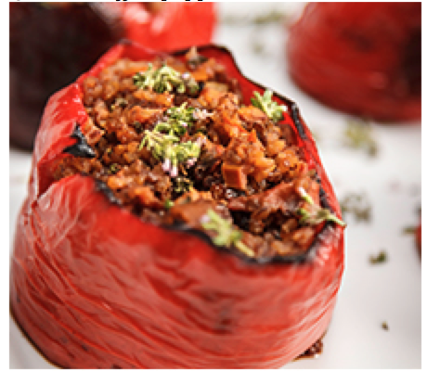

**Ingredients**

* 2 large bell peppers, cut in half
* 1 cup uncooked quinoa
* 1 tablespoon olive oil
* 1 cup chopped zucchini
* 6 Roma tomatoes, chopped
* 1/2 cup chopped onion
* 1 stalk celery, chopped
* 2 tablespoons chopped walnuts
* 3 garlic cloves, chopped
* 2 teaspoons chopped fresh thyme
* 1 teaspoon salt
* 1/2 teaspoon ground black pepper
* 1/2 teaspoon Parmesan cheese

**Directions**

1. Heat the oven to 350 F. Cook quinoa according to package directions. Set aside.
2. Heat a large sauté pan to medium-high heat. Add oil, zucchini, tomatoes, onion, celery, walnuts, garlic and thyme. Reduce heat to medium after 2 minutes.
3. Once vegetables are tender, add cooked quinoa, salt, pepper and cheese. Place the pepper halves on a baking sheet. Place 1/2 cup of the quinoa and vegetable mixture into each pepper half.
4. Cover with foil and bake for 15 to 20 minutes. Uncover and bake for an additional 5 minutes until peppers are cooked to desired doneness.

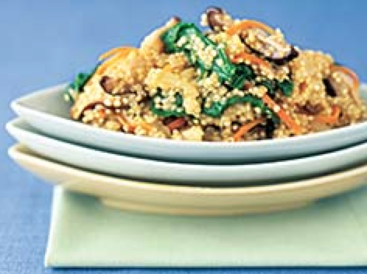[***Quinoa risotto with arugula and Parmesan***](https://www.mayoclinic.org/healthy-lifestyle/recipes/quinoa-risotto-with-arugula-and-parmesan/rcp-20049874)

**Ingredient**

* 1 tablespoon olive oil
* 1/2 yellow onion, chopped (about 1/2 cup)
* 1 garlic clove, minced
* 1 cup quinoa, well rinsed
* 2 1/4 cups low-sodium vegetable stock or broth
* 2 cups chopped, stemmed arugula (rocket)
* 1 small carrot, peeled and finely shredded
* 1/2 cup thinly sliced fresh shiitake mushrooms
* 1/4 cup grated Parmesan cheese
* 1/4 teaspoon salt
* 1/4 teaspoon freshly ground black pepper

**Directions**

1. In a large saucepan, heat the olive oil over medium heat. Add the onion and sauté until soft and translucent, about 4 minutes. Add the garlic and quinoa and cook for about 1 minute, stirring occasionally. Don't let the garlic brown.
2. Add the stock and bring to a boil. Reduce the heat to low and simmer until the quinoa is almost tender to the bite but slightly hard in the center, about 12 minutes. The mixture will be brothy.
3. Stir in the arugula, carrot and mushrooms and simmer until the quinoa grains have turned from white to translucent, about 2 minutes longer.
4. Stir in the cheese and season with the salt and pepper. Serve immediately.

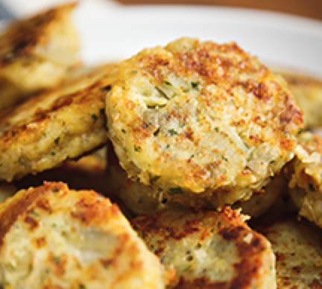***Quinoa  Cakes***

**Ingredients**

* 3 sweet potatoes, peeled and cut into spears
* 1 cup uncooked quinoa
* 2 eggs
* 3 cloves garlic, minced
* 6 ounces Gruyere or Parmesan cheese, shredded
* 2 tablespoons finely chopped fresh parsley
* 1 teaspoon salt
* 1/4 teaspoon ground black pepper
* 1/4 teaspoon nutmeg
* 2 tablespoons olive oil

**Directions**

1. Heat oven to 375 F. Place the potatoes on a greased baking sheet. Bake for 45 minutes or until potatoes are completely soft. Meanwhile, cook quinoa according to package directions; set aside to cool.
2. In a large bowl, combine cooked potatoes, cooked quinoa, eggs, garlic, cheese, parsley, salt, pepper and nutmeg.
3. Heat 1 tablespoon of olive oil in a large saucepan. Form half of the quinoa mixture into 1/4-cup patties and place in the pan; cook until cakes are golden brown.
4. Place cooked patties on a baking sheet. Repeat process with remaining oil and quinoa mixture. Bake cakes in the oven for 5 minutes to ensure they are heated through.

**Avocado Quinoa Salad**

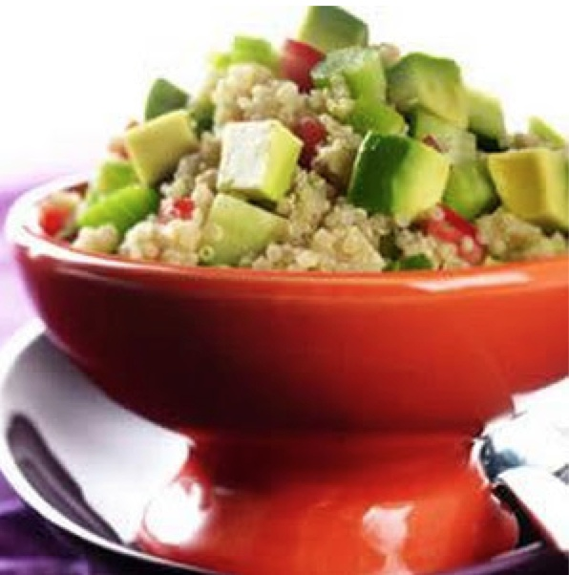

**Ingredient**

* 1 cup quinoa
* 2 cups chicken broth
* 2 hass avocado
* 2 tablespoons lemon juice
* 1 tomatoes (large, diced)
* 1/2 cucumber (diced)
* 2 stalks celery (diced)
* dressing
* fresh Cilantro torn
* Cumin and coriander
* Cider vinegar
* Olive oil
* salt
* pepper

**Directions**

1. In medium saucepan, cook quinoa according to package directions, using chicken broth in place of water. Let cool. Cut avocados in half, remove pit and peel.
2. Cut into chunks. Toss with lemon juice. Add avocado and all remaining ingredients to quinoa and toss with vinaigrette gently to mix. Chill until ready to serve.