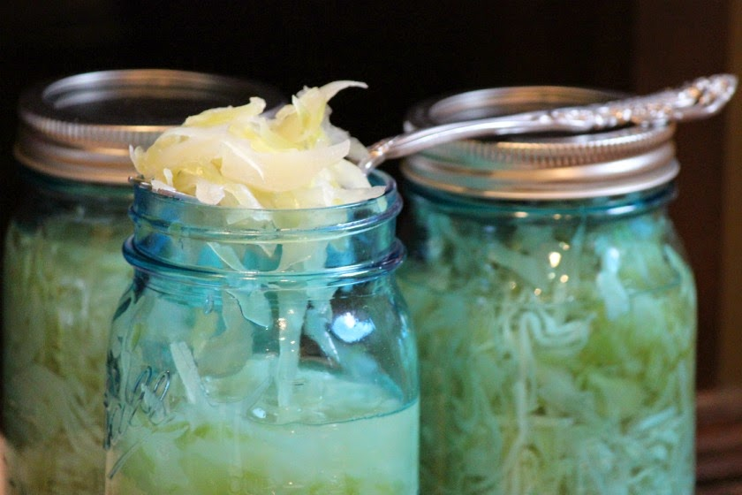**Sauerkraut**

**Ingredients:**

* 5 pounds of cabbage (regular green or red)
* 3 level Tablespoons sea salt (not additives or iodine, high quality sea salt)

**Directions:**

* Shred cabbage very fine. Weight the cabbage close to exact. Use a scale for accuracy.
* Mix cabbage with salt and massage cabbage for approx. 5 minutes until liquid forms.
* Fill cabbage to the top of jar and add remaining liquid to the top. (It is important to have liquid remain above the cabbage).
* Place fermenting lid on jar and leave outside of refrigerator for approx. 2 weeks to 4 weeks. (Without fermenting lid, place cabbage in bowl submerged in liquid and places a clean plate on top to help keep cabbage below liquid. Place something heavy like a few rocks on top of plate to help keep cabbage pressed down.)
* If there is not enough brine(liquid) for the sauerkraut to be covered by an inch, make extra brine by dissolving 1 1/2 tablespoons of salt per quart of heated water. Let cool before adding.



**Kimchee Recipe**

* 2 pounds of Napa cabbage
* Daikon radish
* ¼ cup of sea salt (non-iodized without fillers or additives)

Cut Napa cabbage into approx. 1 inch squares. Place in bowel and add salt. Massage gently for just a minute or two and add water to cover. Set aside for approx. one hour.

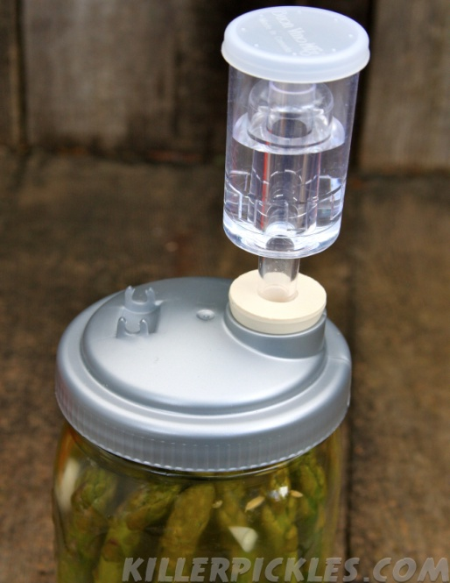Drain water and ***rinse 3 times with clean water***. Place in colander for approx. ½ hour. When ready to put into jar, squeeze the majority of the liquid from the cabbage. Then mix thoroughly with porridge and rest of ingredients. Then fill jar to the top.

**Porridge for Kimchee**

**Ingredients:**

* 1 cup water
* 2T sweet rice flour

**FERMENTING LID**

**Directions:**

Using 1 cup of water, simmer ¾ of the water on low heat. Add remaining ¼ cup water to 2 tablespoons of sweet rice flour. Mix the solution into the simmering water; constantly whisking (much like gravy) Cook on low heat for a minute or two and then place in cool, ice bath. (Can do this step ahead of time).

**Ingredients for remaining porridge:**

* 1 carrot, cut into matchsticks
* 8 ounce daikon radishes cut into matchsticks
* 1 T graded or pasted garlic (between 4 or 6 cloves)
* 1 t grated fresh ginger
* 4 scallions; trimmed and cut into 1 inch pieces
* 1 to 5 T Korean chili flake (no substitute is available). Add to taste (3T for average, 2 T for mild and 5 T for spicy)
* 1 T fermented chili paste (optional; for added flavor and spiciness)

**Directions:**

Place all the ingredients into a bowl. Add ¼ the portage (already made) and mix.

***To make seafood version*:** add 2 to 3 T of fish sauce or/and salted shrimp (usually whole, salted. Need to chop fine or place in food processor)

***To make vegan version*:** add 3 T water and ¾ teaspoon of kelp powder (provides a rich flavor. Alternative or in addition to: mushroom powder)

Mix porridge to cabbage, add cabbage to jar and top with liquid. Place fermenting lid on and leave, outside of the refrigerator in room temperature for *four to five days*. Then it can be loosely caped and put in the refrigerator for up to a year.  Long term cool fermentation develops the flavor.

**NOTES:**