Root Vegetables

***Tacos with Roasted Winter Vegetables and Red Cabbage Slaw***

* 5 cups (3/4-inch-diced) mixed vegetables (see Notes)
* 1 red onion, cut into eighths
* 3 tablespoons extra virgin olive oil, divided
* 1 teaspoon dried Mexican oregano (can substitute Mediterranean oregano, marjoram, or omit)
* 1/2 teaspoon chile powder
* 1/2 teaspoon ground cumin
* Kosher salt
* Freshly ground black pepper
* 2 cups shredded red cabbage (about 1/2 small head)
* Juice of 1 lime
* 1/4 cup coarsely chopped cilantro
* 8 corn tortillas
* 2 tablespoons toasted pumpkin seeds

Directions:

1. Preheat oven to 400°F.
2. Toss the vegetables and onion with 2 tablespoons olive oil, oregano, chile powder, cumin, a pinch of salt and freshly ground black pepper. Spread evenly on a baking sheet and roast, stirring occasionally, for 30-40 minutes or until all the vegetables are tender.
3. At least 15 minutes before serving, toss the shredded cabbage with the remaining tablespoon of olive oil, lime juice, cilantro, and 1/4 teaspoon salt. Cover and refrigerate. (Can make up to a day ahead.)
4. To assemble, [warm the tortillas](https://www.thekitchn.com/ready-to-eat-three-ways-to-war-117346), fill them with roasted vegetables, and top with cabbage slaw. Garnish with pumpkin seeds.

**Recipe Notes:**

• Use any combination of root vegetables and winter squash, such as beets, butternut squash, carrots, celeriac, parsnips, turnips, and sweet potatoes. Fennel bulbs also make a good addition. • For a non-vegan version, you might garnish the tacos with queso fresco or goat cheese.

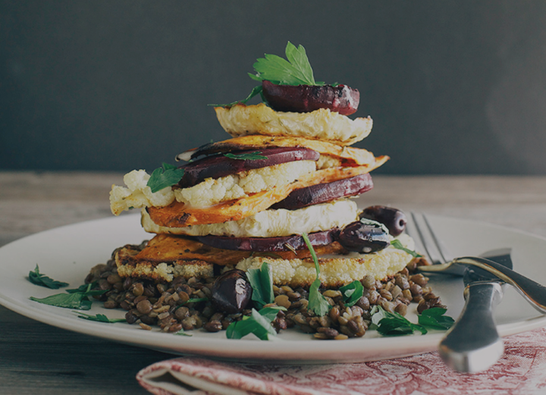***Lemon rosemary vegetable stacks w/ lentils + creamy horseradish vinaigrette***  
**notes:**  Remember to cover the beets for two thirds of the cooking process because they can shrivel up. These components can be made ahead of time and just re-warmed before serving, making meal time a little quicker and less harried.

**Vegetables:**

* 2 sprigs of rosemary, leaves removed + chopped
* juice of 1 lemon
* 3 tbsp grapeseed oil
* 1 small celery root, peeled
* 1 fat sweet potato, peeled1
* large beet, peeled
* 1 head of cauliflower, trimmed

**Lentils:**

* 2 tsp grapeseed oil
* 1 shallot, diced fine
* 1/2 cup lentils (I used a mix of French + brown), rinsed
* 1 cup water + extra
* salt to taste

***horseradish + maple vinaigrette:***

* 1/4 cup apple cider vinegar
* splash of water
* 1 tsp dijon mustard
* 1.5 tbsp maple syrup
* horseradish to taste (I used 2 heaped tsp of fresh grated horseradish root)
* salt + pepper
* heavy 1/3 cup grapeseed or olive oil
* Garnish with black olives and very roughly chopped parsley

1. Preheat the oven to 400 degrees F. Line 2 medium-large baking sheets with parchment + 1 extra, smaller baking sheet. Set aside.

2. Combine the rosemary, lemon juice and oil in a small bowl. Set aside. Slice the celery root + sweet potato about an inch thick across. You want to cut them so that you get a large cross section for stacking. Lay the celery root + sweet potato slices on one of the medium-large baking sheets. Brush both sides of all vegetables with the rosemary and lemon oil, season with salt and pepper, and slide baking sheet into the oven. These should take about 35-40 minutes to brown up and soften. Remove and set aside.

3. Slice the beets about 1/4-1/2 inch thick. Lay the slices on the smaller sheet. Brush with the lemon, rosemary and oil mixture, season with salt and pepper. Cover baking sheet with foil and place in the oven. Slide baking sheet into the oven. Roast for 20 minutes covered. Remove the foil and roast for another 10-15 minutes. Remove and set aside.

Slice the cauliflower into 1 inch thick cross sections with the core intact. Lay the slices on the last baking sheet and brush with the rosemary + lemon oil on both sides. Season with salt and pepper and slide into the oven. The cauliflower should take about 20-25 minutes, so make sure you prep this one last. Remove and set aside.

4. While the vegetables are roasting, **start the** **lentils**. Heat the 2 tsp grapeseed oil over medium heat. Add the diced shallots. Stir them around until they become translucent and soft, about 3 minutes. Add the rinsed lentils to the pan and stir them around in the oil and shallots. Add the water to the pan. Bring lentils to a very faint simmer, like just a couple bubbles coming to the surface here and there. Cook until the lentils are soft with a tiny bit of bite intact, topping up the pot with more water as necessary, about 25-30 minutes. Season lentils with salt and stir in a glug of olive oil to keep the lentils individual.

**Make the vinaigrette:** Combine all of the vinaigrette ingredients in a blender and blend on medium-high until mixture is creamy and incorporated. Check for seasoning, adjust to your liking and set aside.

To serve, divide the warm lentils among 2 dinner plates, pressing down on them with the back of a spoon to make a flat surface. Stack the roasted vegetables on top of the flattened lentils. Drizzle the whole thing with horseradish vinaigrette. Garnish with olives and chopped parsley. Serve warm.

***Spiced winter root vegetable soup***

* 1 onion, roughly chopped
* 2 garlic, cloves, roughly chopped
* 1 tablespoon of olive oil
* 1 butternut squash, peeled + roughly chopped (about 3 cups)
* 1 sweet potato, peeled + roughly chopped
* 2 carrots, peeled + chopped roughly
* 5 cups vegetable stock
* 1 teaspoon each of cumin + coriander
* 1/2 teaspoon each of cinnamon, nutmeg + cayenne
* 1 cup almond milk
* salt + pepper to taste

**Directions**

1. Heat the oil over a low heat + add the onion + garlic. Gently fry until translucent.  
2. Add the remaining ingredients + bring to a low boil. Simmer for 30 minutes.  
3. Blend the soup until smooth + adjust seasoning to taste. Be careful of blending the soup whilst it is still very hot. Always allow to cool off before doing so. Freeze on the day, refrigerate for up to 4 days or eat straight away to keep warm!