**Soups**

**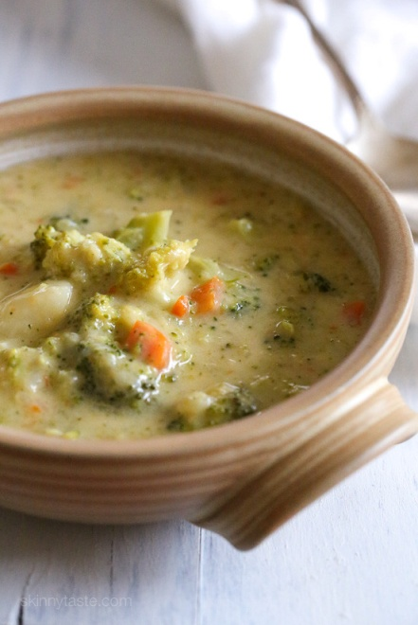 Broccoli Cheese and Potato Soup**

**Ingredients**

* 1 tablespoon butter
* 1 medium yellow onion, chopped
* 3 large white potatoes, cubed, about 4 cups
* 5 cups chicken broth
* ½ teaspoon kosher salt
* 6 cups broccoli florets
* 2 cups whole milk
* 3 cups shredded medium cheddar cheese
* 1 teaspoon freshly ground black pepper

**Instructions**

Melt the butter in a large dutch oven over medium heat. Add the onion and cook for 4-5 minutes, until softened, stirring occasionally. Add the cubed potatoes, chicken broth and the kosher salt and bring to a boil, then reduce the heat to a rolling simmer and cook the potatoes for about 8 minutes or until soft and easily pierced with a fork. Add the broccoli florets and the milk and bring to a boil, then reduce to a simmer, cooking for 5-7 minutes or until the broccoli is al denté. Blend half of the soup till a smooth consistency and add back into the rest of the soup.

Add the cheese to the soup 1 cup at a time, stirring until melted before adding the next batch of cheese. Season with black pepper and more salt to taste.

**Curried Cauliflower Soup**

 **Ingredients**

* 1 large head of cauliflower, broken into small florets, stems chopped
* ¼ cup melted coconut oil or olive oil
* 1 medium yellow onion, diced
* 2 to 3 tbsp Thai red curry paste
* ½ cup white wine
* 1 sm lemon, zested
* 3 cups vegetable stoke
* 1 can coconut milk
* ½ tsp sugar
* 1 tbsp rice vinegar
* salt and pepper
* green onion chopped

**Instructions**

Preheat oven 400 degrees. Toss cauliflower with melted coconut oil to lightly coat. Spread cauliflower in a single layer on a large baking sheet and roast until the tips of the cauliflower are golden brown, about 25 min.

In a stockpot, sweat the onions in 1 tbsp coconut oil and add curry paste and lemon zest and stir. Add the wine and cook until most of the wine has evaporated.

Add all the roasted cauliflower stems and half of the florets to the pot. Add the vegetable stock, coconut milk and sugar. Cook stirring occasionally until the soup is warmed through. Remove from heat add vinegar. Blend soup in a blender or use an immersion blender until smooth. Salt and pepper to taste. Ladle soup into bowls and top with remaining cauliflower florets and green onions.

**Chicken Tortilla Soup**

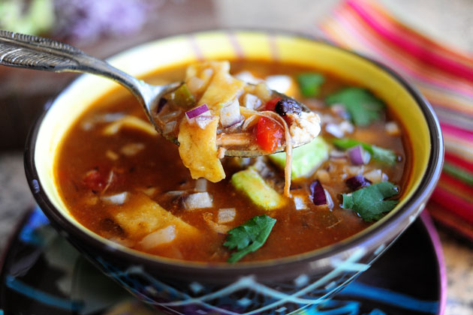 **Ingredients**

* 1 onion diced
* 3 cloves of garlic minced
* 1 tbsp olive oil
* 2 tsp chili powder
* 1 tsp dried oregano
* 1 can crushed tomatoes
* 2 quarts chicken stock
* 1 cup corn
* 1 cup white hominy
* 1 4 oz can chopped green chili peppers
* 1 can black beans drained and rinsed
* ¼ cup chopped cilantro
* 2 boneless chicken breasts, cooked and cut into bite size pieces
* crushed tortilla chips
* black pepper
* Monterey jack cheese
* Chopped green onions

**Instructions**

In a stockpot, heat oil, sauté onion and garlic in oil until soft. Stir in chili powder, oregano, tomatoes, and stock. Bring to a boil, and simmer 5 to 10 min.

Stir in corn, hominy, chilies, beans, cilantro, and chicken. Simmer 10 min.

Serve with crushed tortilla chips, cheese and green onions.