***Squash recipes***

***Asparagus and Mushroom Pesto Spaghetti Squash***

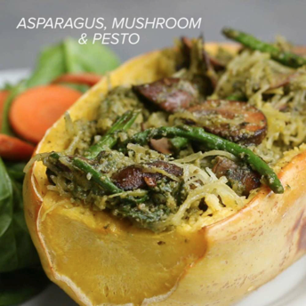 **Ingredients**

* 1 spaghetti squash
* 2 tablespoons olive oil
* 1 teaspoon salt
* 1 teaspoon pepper
* PESTO
* 2 cups fresh basil
* ½ cup extra virgin olive oil, divided
* ½ cup grated parmesan cheese
* 2 cloves garlic
* ¼ cup pine nut
* ½ teaspoon salt

FILLING

* 1 tablespoon oil
* 1 lb mushroom, sliced
* 1 cup asparagus, cut in half
* 1 tablespoon garlic, minced
* 1 teaspoon salt
* 1 teaspoon pepper

**Preparation**

* Preheat oven to 400ºF (200ºC).
* With a sharp knife, slice the squash in half. If the squash is too tough, puncture in several places forming a dotted line around the squash. Microwave for 3-5 minutes to soften. Allow to cool before cutting in half. Scoop out the seeds, brush with oil, and sprinkle with salt, and pepper. Bake for 40-45 minutes, or until a fork can easily pierce the skin.
* Meanwhile, in a blender combine basil, olive oil, vegetarian Parmesan cheese, garlic, pine nuts, and salt. Set aside.
* In a pan add the olive oil and garlic over medium-high heat, sautè 30 seconds-1 minute, add in mushrooms and cook for 3 minutes. Add asparagus and stir until cooked.
* Remove squash from the oven, with a fork pull at the edges to produce that stringy “spaghetti” quality until you’ve completed both of them.
* In the mushroom and asparagus pan combine “spaghetti” and pesto and mix. Return to the squash and serve with or without plates. Garnish with parmesan.

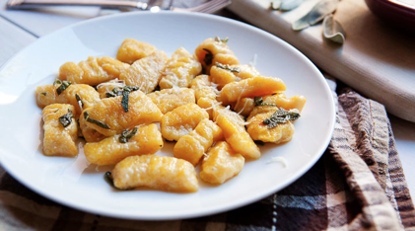**Butternut Squash Gnocchi**

Fluffy homemade gnocchi made with roasted butternut squash and served with a simple and delicious butter and sage sauce.

**Ingredients**

* 1 1/2 cups roasted butternut squash, mashed
* 1 1/2 cups Russet potatoes, mashed
* 1 large egg
* 1/2 cup Parmesan cheese, grated
* 3/4 teaspoon kosher salt
* 1/2 teaspoon ground nutmeg
* 1/2 teaspoon ground black pepper
* 1 1/2 cups all-purpose flour, plus extra for shaping Sage Butter sauce:
* 1/2 cup unsalted butter
* 4-6 leaves fresh sage
* Pasta water
* Parmesan cheese, for garnish

**Directions**

1) Preheat oven to 350 degrees F. Cut squash in half down the middle. Roast the squash, cut-side up, for 50-60 minutes until the flesh is fork tender.

2) When squash is roasted, remove from oven and let cool briefly. Then scrape out flesh with a fork and measure out amount for recipe and place in a bowl. Mash the squash well.

3) Meanwhile, peel and chop 2 Russet potatoes. Boil the potatoes in salted water for 10-12 minutes until they are really tender. Then mash the potatoes and measure out amount for recipe. Add to the bowl with the squash.

4) Let the squash and potato mixture cool for a few minutes and then stir in egg, seasonings, cheese, and flour last. Mix dough with your hands until it’s combined, but not sticky. Depending on how moist the squash and potato was, you might need to add more flour.

5) Cut dough into quarters and roll out a quarter at a time on a floured, clean surface. Roll it out into a long rope about 1/2-inch in diameter. Then cut the gnocchi into 1/2 inch dumplings. Use a fork to press some depressions into each gnocchi. Then add the shaped gnocchi to a baking sheet covered with flour. Repeat with all the dough until your gnocchi are done.

6) At this point you can freeze the gnocchi on the baking sheet and then transfer them to a freezer-safe bag or cook them immediately in salted, simmering water for 5-6 minutes. The gnocchi might not be cooked through even after floating.

7) To make sauce for one serving of gnocchi (one quarter of the dough), add two tablespoons of butter to a small skillet over medium heat with about a teaspoon of minced sage (one big leaf). Let the butter melt and bubble for a minute or two. Then add boiled gnocchi to the skillet. Let cook, undisturbed for a few minutes until gnocchi start to crisp.

8) Add 1-2 tablespoons of pasta cooking water to the skillet to form a light sauce. Swirl to combine butter, pasta water, and pasta. 9) Serve gnocchi right away garnished with Parmesan cheese.

**FRUITY ACORN SQUASH RECIPE**

# Inline image 1INGREDIENTS

* 1 small acorn squash (about 1-1/4 pounds)
* 1 mediumt tart apple, peeled and chopped
* 1/4 cup chopped celery
* 2 tablespoons raisins
* 1 tablespoon brown sugar
* 1/4 teaspoon pumpkin pie spice

#### DIRECTIONS

Cut acorn squash in half lengthwise; remove and discard seeds and membranes. Place squash cut side down in a greased 11-in. x 7-in. microwave-safe dish. Microwave, uncovered, on high for 6-8 minutes or until almost tender.

Meanwhile, in a bowl, combine the apple, celery, raisins, brown sugar and pumpkin pie spice. Turn squash over; fill centers with apple mixture. Cover and microwave 4-5 minutes longer or until squash and apple filling are tender. Let stand for 3 minutes before serving. **Yield:**2 servings.