**TOMATOES, BASIL AND CORN**

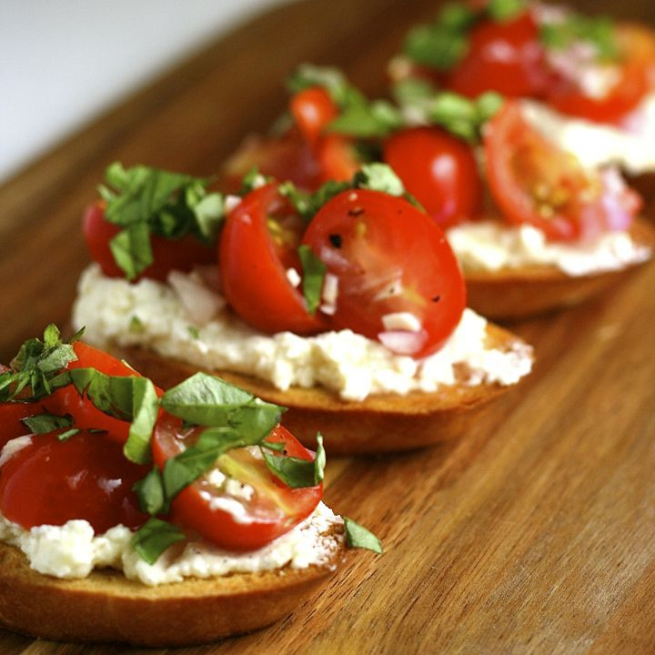***Tomato, Mozzarella and Basil Bruschetta***

**Ingredients**

* 1 (32-ounce) can whole tomatoes, drained or fresh
* 1 cup fresh basil leaves, washed and spun dry
* 4 tablespoons extra-virgin olive oil
* 6 cloves garlic, peeled
* Kosher salt and freshly ground black pepper
* 2 large French baquettes, sliced 1-inch thick (about 36 slices)
* 1 1/2 pounds fresh mozzarella cheese, sliced 1/4-inch thick

**Directions**

1. Preheat oven to 375 degrees F.
2. In the bowl of a food processor, add drained tomatoes, 1 cup basil leaves, olive oil and 2 cloves garlic. Pulse until smooth, but somewhat chunky. Season with salt and pepper.
3. On a baking sheet, line up baguette slices. Toast in oven for about 3 minutes or until light golden brown. Working quickly, rub the remaining garlic on the toasted side of each slice and then lay a piece of mozzarella cheese on top. Place bread back in oven and melt cheese slightly, about 45 seconds. Remove from oven and spread one tablespoon of the tomato mixture on each piece.
4. Place bruschetta on decorative platter and garnish with basil leaves.

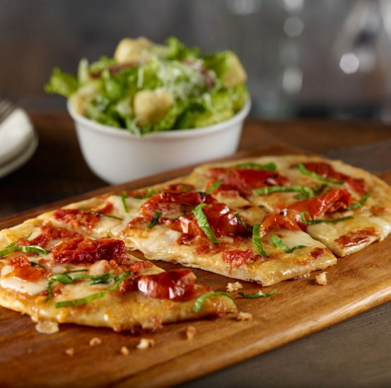 ***Tomato Flatbread***

* 2 1/2 pounds firm medium (2 1/2-inch) tomatoes, cored and sliced 1/4 inch thick
* 1 cup whole fresh parsley leaves, lightly packed
* 1/2 cup coarsely chopped fresh basil leaves, lightly packed
* 3 large garlic cloves
* 1 tablespoon fresh thyme leaves
* Kosher salt and freshly ground black pepper
* 1/2 cup good olive oil
* 6 tablespoons Dijon mustard
* 1/2 cup plus 2 tablespoons freshly grated Italian Parmesan cheese
* flat bread

**Directions**

1. Place the tomatoes in a large bowl. Put the parsley, basil, garlic, thyme, 1 teaspoon salt, and 1 teaspoon pepper in the bowl of a food processor fitted with the steel blade and process until finely minced. With the processor running, pour the olive oil down the feed tube and process until combined. Pour the mixture over the tomatoes and toss gently. Set aside.
2. Brush the mustard on the crust with a pastry brush. Sprinkle with the 1/2 cup of Parmesan. Place overlapping tomatoes in rows on top. If there is a little garlic and herb mixture in the bowl, sprinkle it over the tomatoes, but if there is liquid in the bowl, strain it through a very-fine-mesh strainer, discard the liquid, and sprinkle the garlic and herb mixture on the tomatoes. Sprinkle the remaining 2 tablespoons of Parmesan on top. Bake for 30 minutes.
3. Cool slightly, cut into squares, and serve warm or at room temperature.

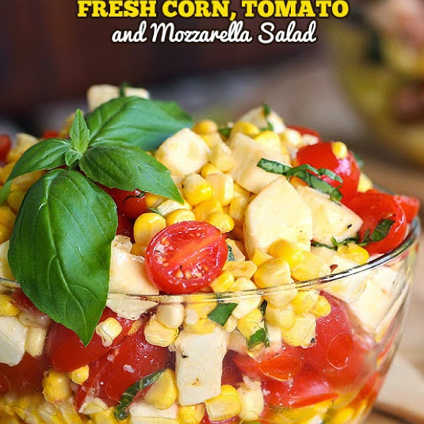 ***Fresh Corn Tomato Salad***

**Ingredients**

* 3 tablespoons white wine vinegar
* Kosher salt and freshly ground black pepper
* 1/4 cup extra-virgin olive oil
* 6 ears fresh corn
* 2 cups grape tomatoes, halved
* 8 ounces fresh mozzarella, cut into small cubes
* 1 bunch scallions (white and green), thinly sliced
* 1 1/2 cups fresh basil leaves
* Garlic
* shallots
* Dijon mustard

**Directions**

~Whisk together the vinegar, 2 teaspoons salt and some pepper in a small bowl. Gradually whisk in the oil, starting with a few drops and then adding the rest in a steady stream, to make a smooth dressing.

~Shear off the corn kernels with a sharp knife over a bowl (you should have about 4 cups). Toss in the tomatoes, mozzarella and scallions. Pour the vinaigrette over the salad and toss to coat. Cover and let stand for at least 15 minutes and up to 2 hours. Before serving, tear the basil over the salad and stir.

***Tomato and Lentil Salad***

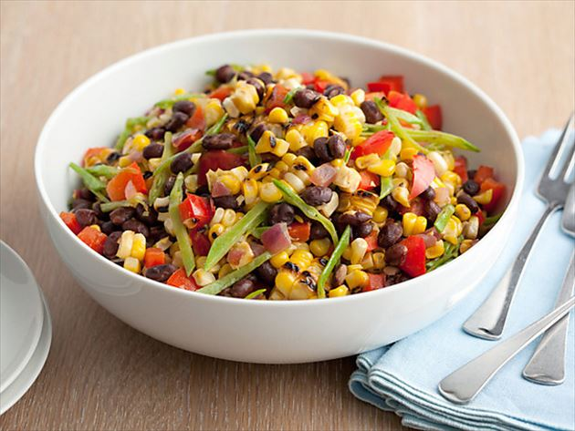**Ingredients**

* 1 cup small green lentils
* 2 cloves garlic, peeled
* 2 teaspoons lemon zest plus 1/4 cup freshly squeezed lemon juice
* 2 tablespoons olive oil
* 2 cups cherry tomatoes, quartered
* 3/4 cup sliced scallions (use pale green and white parts only)
* 1/4 cup fresh basil, chopped
* 1/4 cup fresh dill, chopped
* 1 ear fresh corn, kernels cut off the cob
* Salt and freshly ground black pepper

**Directions**

1. Combine the lentils, garlic and 4 cups water in a large heavy pot. Bring to a boil and reduce to a simmer. Simmer until the lentils are soft, about 15 minutes. Drain the lentils, discarding the garlic cloves, and set aside to cool to room temperature.
2. In a mixing bowl, whisk together the lemon juice and olive oil until combined. Add the tomatoes, scallions, basil, dill, corn and cooled lentils. Season with salt and pepper. Add the lemon zest and toss to combine; making sure everything is evenly incorporated.
3. Serve cold or at room temperature.