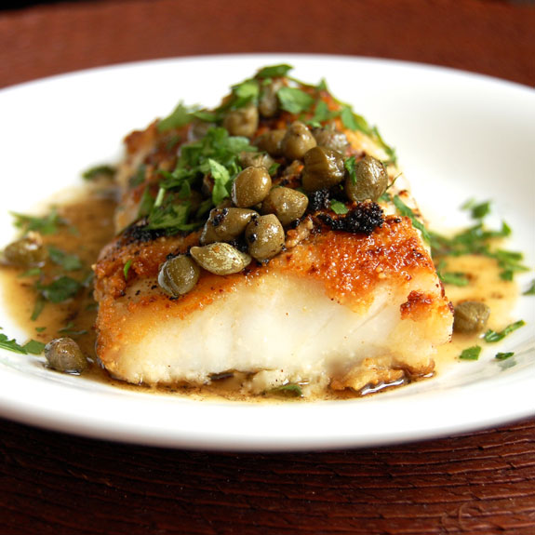***White Fish***

**Fillet of Sole with Capers**

A fish cooked ***en papillote*** is wrapped in parchment paper, and baked in a medium oven so it gently steams in its own juices. Aromatics, such as dill, sliced onions, and olives, are also enclosed in the package to flavor the fish.

**Ingredients**

* 1 tablespoon capers
* 1 teaspoon ground peppercorns
* 2 tablespoons fresh lemon juice
* 1 fennel bulb, (about 1 pound), sliced crosswise as thinly as possible
* 1/3 cup finely chopped fresh dill
* 2 6-ounce portions sole, flounder, or striped bass
* Salt

**Directions**

1. Heat oven to 400 degrees. Combine capers, peppercorns, and lemon juice in a small bowl. Set aside.
2. Fold two 24-inch lengths of parchment paper in half crosswise, cut into a half-heart shape, and open. On one half of one piece, arrange a quarter of the fennel slices 2 to 3 inches from the fold. Sprinkle a quarter of the peppercorn mixture and a quarter of the chopped dill on top; place one piece of fish over the fennel, and sprinkle with salt. Layer with another quarter of fennel slices, peppercorn mixture, and chopped dill.
3. Fold the other half of parchment along the crease, covering the ingredients. Make small overlapping folds to seal the edges, starting at the top of the heart.
4. Two inches from the end, twist the parchment twice, gently but firmly, to seal. The paper will puff during cooking, so make sure the seams are tightly sealed. Repeat process to make the second packet.
5. Place packets on a baking sheet; bake for 12 to 15 minutes. Remove from oven, open packets, and serve immediately.

**Crispy Baked Cod**

**Ingredients**

* 1 cup panko breadcrumbs
* 2 tablespoons chopped fresh parsley
* 2 teaspoons grated lemon rind
* 1 teaspoon minced garlic
* 6 (6-oz.) cod fillets
* 1 teaspoon salt
* 2 tablespoons butter, melted

**Directions:** Combine first 4 ingredients in a small bowl. Place fillets on a lightly greased wire rack in a baking pan; sprinkle evenly with salt. Spoon the breadcrumb mixture evenly onto fillets, pressing down gently. Drizzle evenly with 2 Tbsp. melted butter. Bake at 400° for 17 minutes or until breadcrumbs are golden and fish flakes with a fork.

**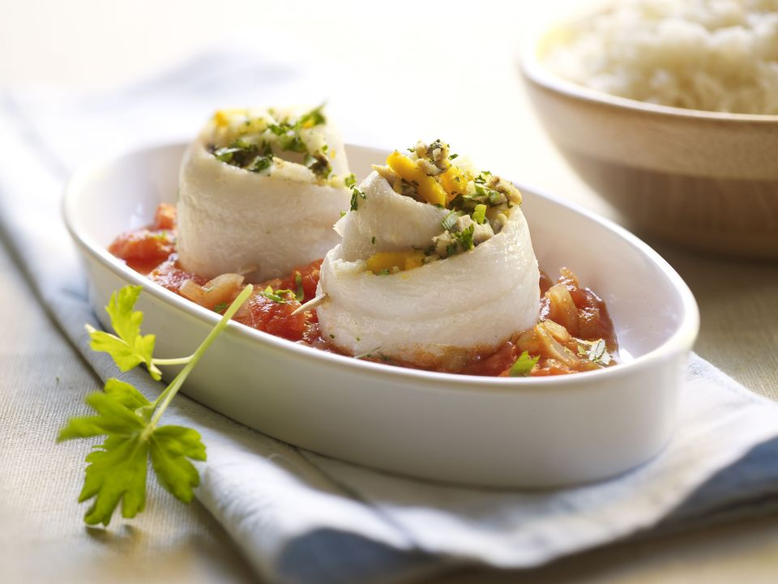 Spinach Stuffed Flounder with Fresh Tomato Sauce**

**Ingredients**

* 2 tablespoons butter, divided
* 1 cup finely chopped onion
* 1/2 cup diced yellow or red bell pepper
* 1 clove garlic, minced
* 1 pound fresh spinach, chopped
* 2 pounds flounder fillets
* 2 cups diced tomatoes with juice or 1 can (14.5 ounces) petite diced tomatoes
* 1/4 teaspoon dried leaf basil
* salt and pepper, to taste

**Directions**

1. Preheat oven to 350 F.
2. Melt 1 tablespoon of the butter in a skillet over medium-low heat, cook the onions and bell pepper in butter until tender; add garlic and cook for 1 minute longer. Remove the onion and garlic to a plate.
3. Add 1 more tablespoon of butter to the skillet and place over medium heat. Add the spinach, a little at a time, until wilted. Cover and cook for 4 to 5 minutes. Drain well.
4. Place a fish fillet on a plate; spread with the cooked spinach and sprinkle with some of the cooked onion and garlic mixture. Roll up and place in a shallow lightly buttered baking dish, seam-side down. Repeat with remaining fillets.
5. Combine the diced tomatoes with the basil and remaining onion and garlic mixture; taste and add salt and pepper, as needed.
6. Spoon the tomato mixture over and around the stuffed fillets.
7. Bake in the preheated oven for about 20 minutes or until fish flakes easily with a fork.

**Corn stew**

**Ingredients**

* 1 pint grape tomatoes halved
* olive oil
* 4 corn on the cob
* small onion diced
* leaks  sliced
* garlic diced
* 1 oz white wine
* 2-3 oz cream
* lemon juice

**Directions**

Coat tomatoes with olive oil and roast. Cut corn off the cob, sweat onions, leaks and garlic, add white wine and reduce. Add corn, salt and pepper and cream, reduce. Add lemon.