AVOCADO BASIL DRESSING

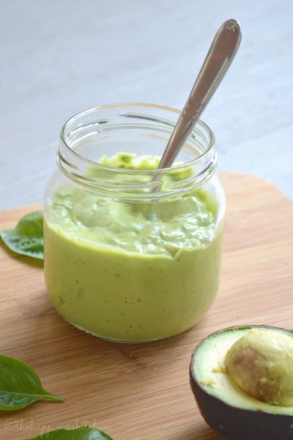

This avocado basil dressing is incredibly flavourful and creamy and can be used on salads, in sandwiches, and as a dip.

INGREDIENTS

* 1 ripe avocado
* ½ cup packed fresh basil leaves, washed
* 1 clove of garlic
* 2-3 tsp lemon juice
* ¼ cup extra-virgin olive oil
* ½ tsp pink Himalayan salt (or to taste)
* ¼ tsp pepper
* water (optional)

INSTRUCTIONS

1. Slice avocados in half and remove outer skin and seed.
2. Place in a blender or food processor with remaining ingredients.
3. Add one tablespoon of water at a time until desired consistency is reached. No water is recommended if planning on using in sandwiches or as a dip.
4. Keep in a covered, airtight container for 3 days.

http://thehappinesskitchen.com/5-minute-avocado-basil-dressing/