**Homemade Bar Soap**

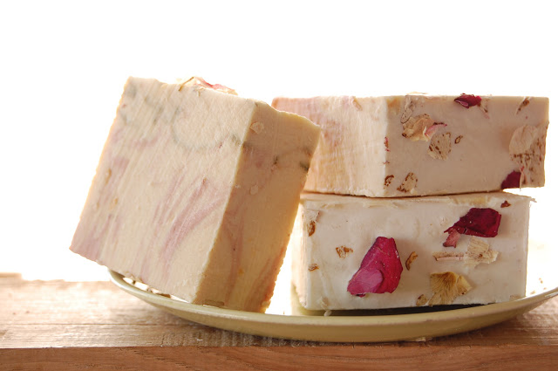

**Ingredients**

* 1/2 cup Oatmeal
* 2 teaspoons Honey
* 2 LB Melt and Pour Organic Goats Milk Soap Base.
* Essential oils (vanilla bean) 20 drops.
* Alcohol in a spray bottle.

Ingredients

* Heat pot of water, Cut the lines of the soap and put the wax cubes into double boiler. Heat until melted.
* Cut the lines of the soap and put into glass bowl. Microwave on high for 2 minutes until completely melted and no chunks. Took about 4 or 5 times.
* Once done stir in oatmeal, honey and essential oils.
* Pour into a soap mold, spray alcohol on any air bubbles.
* Let set for a few hours, overnight is best. Then pop them right out and enjoy!

**Alternative Recipe**

**Ingredients**

* 2 LB Melt and Pour Organic Goats Milk Soap Base.
* 3 tablespoons of jojoba or organic almond oil.
* essential oils (of your choice) 30 drops max.
* Himalaya salt.
* Alcohol in a spray bottle.

**Directions**

* Heat pot of water, Cut the lines of the soap and put the wax cubes into double boiler. Heat until melted.
* Cut the lines of the soap and put into glass bowl. Microwave on high for 2 minutes until completely melted and no chunks. Took about about 4 or 5 times.
* Once done stir in jojoba oil and essential oils.
* Sprinkle some salt on bottom of molds.
* Pour into a soap mold, spray alcohol on any air bubbles and sprinkle with salt.
* Let set for a few hours, overnight is best. Then pop them right out and enjoy!