**Eco-Friendly Citrus Clean Travel & Home Surface Spray (disinfectant), Natural Hand Soup & Summertime Treats**

**Citrus Clean Travel & Home Surface Spray (disinfectant)**

**Ingredients**

* 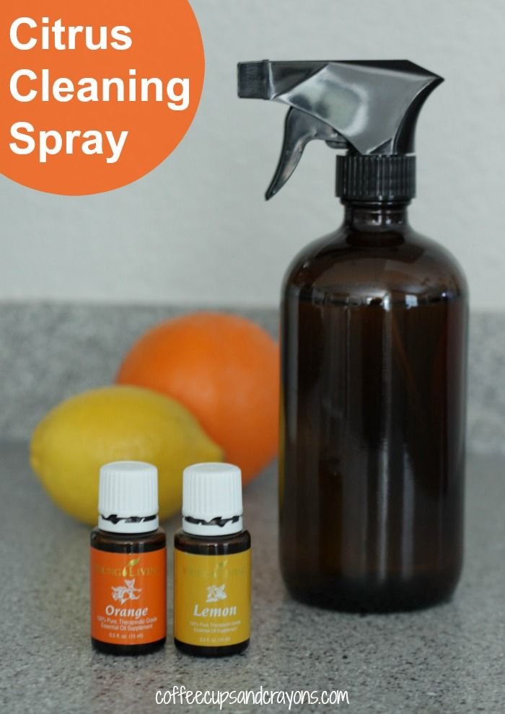3 drops Lemon
* 3drops lime
* 3 drops wild orange
* 3 drops thieves
* 1 oz Epson salt

**Directions:** Pour all ingredients into spray bottle and gently shake.

**Hand Soap**

* 3 Tablespoons of Liquid Castile Soap (Dr. Bronner’s Soap)
* 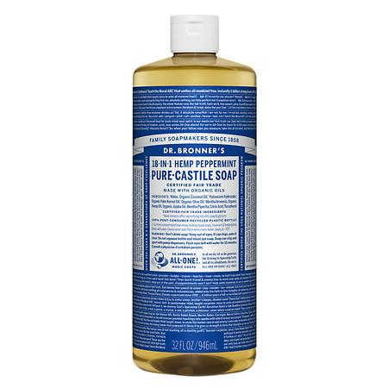¼ tsp or 1/2 dropper full of vitamin E oil
* 6 drops of your favorite essential oil

**Directions**

Add ingredients to container and fill remaining container with water (leave room for lid). Gently shake to combine all ingredients.