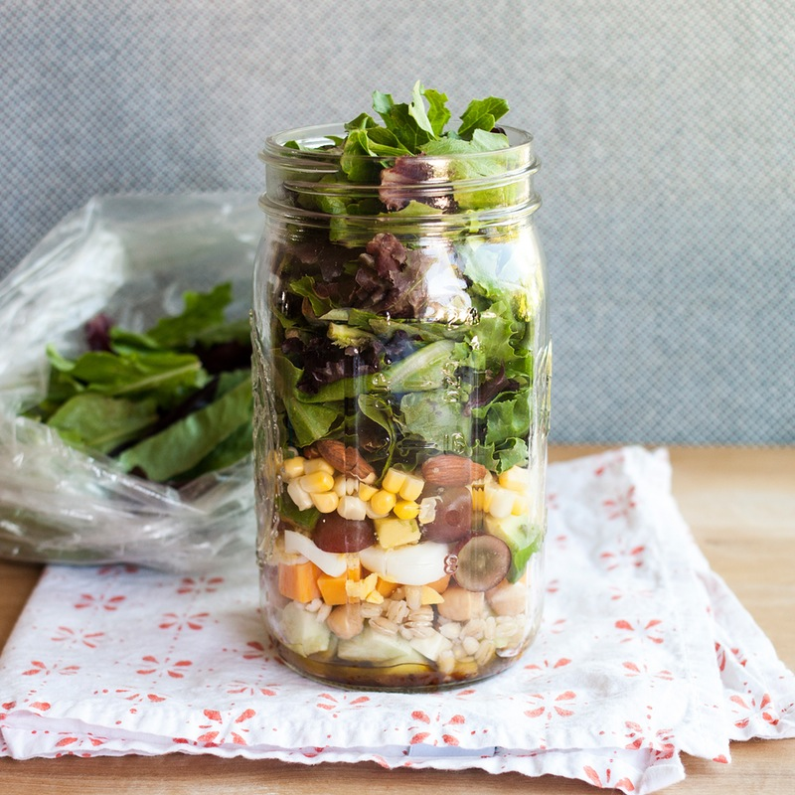***Mason Jar Salads***

**How do the greens not get soggy?**

The basic idea when packing salads in jars is to start with the heaviest and most non-absorbent ingredients with the dressing on the bottom of the jar and work your way up through the lighter ingredients until you end up with the salad greens themselves. As long as your jar doesn't accidentally tip over in your bag, the delicate greens will be well-protected from the dressing until you're ready to eat.

**How does everything get mixed together?**

When you're ready to eat your salad, just unscrew the cap and shake it into a bowl. Everything gets pretty compacted in the jar, so some vigorous shaking may be needed! This shaking also helps to toss the salad ingredients with the dressing. Once the salad is in the bowl, you can toss it some more with your fork to make sure everything is evenly coated.

**What's the best jar to use?**

Any canning jar can be used, but wide-mouthed jars are the easiest for both packing the salad into the jars and shaking them out again. Pint-sized jars are great for individual side salads of mostly greens with just a few "extra" salad toppings. Use quart-sized jars for larger lunch and dinner salads that have a lot of extra veggies and salad goodies. Two-quart jars (or larger) are great if you're taking the salad to a potluck or cookout.

**How long will jars of salad keep in the fridge?**

With the lid sealed tightly, these salads can last for several days in the fridge — up to five days or so.

**How to Pack the Perfect Salad in a Jar**

**Ingredients**  
1 to 4 tablespoons salad dressing, A Mix of raw and cooked vegetables, fresh and dried fruit, nuts, cheese, and other salad ingredients such as salad greens, a wide-mouth canning jars with tight-fitting lids: pint jars for side salads, quart jars for individual meal-sized salads, 2-quart jars (or larger) for multiple servings

**Instructions**

1. **Salad dressing:** Pour 1 to 4 tablespoons of your favorite salad dressing in the bottom of the jar. Adjust the amount of dressing depending on the size of the salad you are making and your personal preference.
2. **Hard vegetables:** Next, add any hard chopped vegetables you're including in your salad, like carrots, cucumbers, red and green peppers, cooked beets, and fennel.
3. **Beans, grains, and pasta:** Next, add any beans, grains, and/or pasta, like chickpeas, black beans, cooked barley, cooked rice, and pasta corkscrews.
4. **Cheese and proteins (optional):** If you'll be eating the salad within the day, add a layer of diced or crumbled cheese and proteins like tuna fish, diced (cooked) chicken, hard-boiled eggs, or cubed tofu. If you're making salads ahead to eat throughout the week, wait to add these ingredients until the day you're planning to eat the salad and add them on top of the jar.
5. **Softer vegetables and fruits (optional):** Next, add any soft vegetables or fruits, like avocados, tomatoes, diced strawberries, or dried apricots. If you're making salads ahead to eat throughout the week, wait to add these ingredients until the day you're planning to eat the salad and add them to the top of the jar.
6. **Nuts, seeds, and lighter grains:** Next, add any nuts or seeds, like almonds, walnuts, and sunflower seeds. If you're making a salad with lighter, more absorbent grains like quinoa or millet, add them in this layer instead of with the beans.
7. **Salad greens:** Last but not least, fill the rest of the jar with salad greens. Use your hands to tear them into bite-sized pieces. It's fine to pack them into the jar fairly compactly.
8. **Storing the salad:** Screw the lid on the jar and refrigerate for up to 5 days. If you're including any cheese, proteins, or soft fruits and vegetables, add these to the top of the jar the morning you plan to eat your salad.
9. **Tossing and eating the salad:** When ready to eat, unscrew the lid and shake the salad into the bowl. The action of shaking the salad into the bowl is usually enough to mix the salad with the dressing. If not, toss gently with a fork until coated.

**Citrus Dressing**

### Ingredients

* 1/4 cup fresh lemon juice
* 2 tablespoons fresh orange juice
* 2 tablespoons of fresh lime
* 2 tablespoons extra-virgin olive oil
* 1 tablespoon honey
* 2 teaspoons grated lemon rind
* 1/2 teaspoon kosher salt
* 1/8 teaspoon coarsely ground black pepper

### Directions

1. Combine all ingredients in a small bowl, stirring with a whisk. A shortcut to quickly juice lemons and to get the most juice, bring them to room temperature. Then roll them across the countertop while applying pressure with the palm of your hand.

**Balsamic Vinaigrette**

**Ingredients**

* 1/2 cup extra virgin olive oil
* 1/2 cup balsamic vinegar
* 1 clove crushed garlic
* 1 pinch salt
* ground black pepper to taste

## Directions—in a small bowl, whisk together olive oil, balsamic vinegar, and garlic. Season to taste with salt and black pepper. Stir in minced fresh herbs if desired.