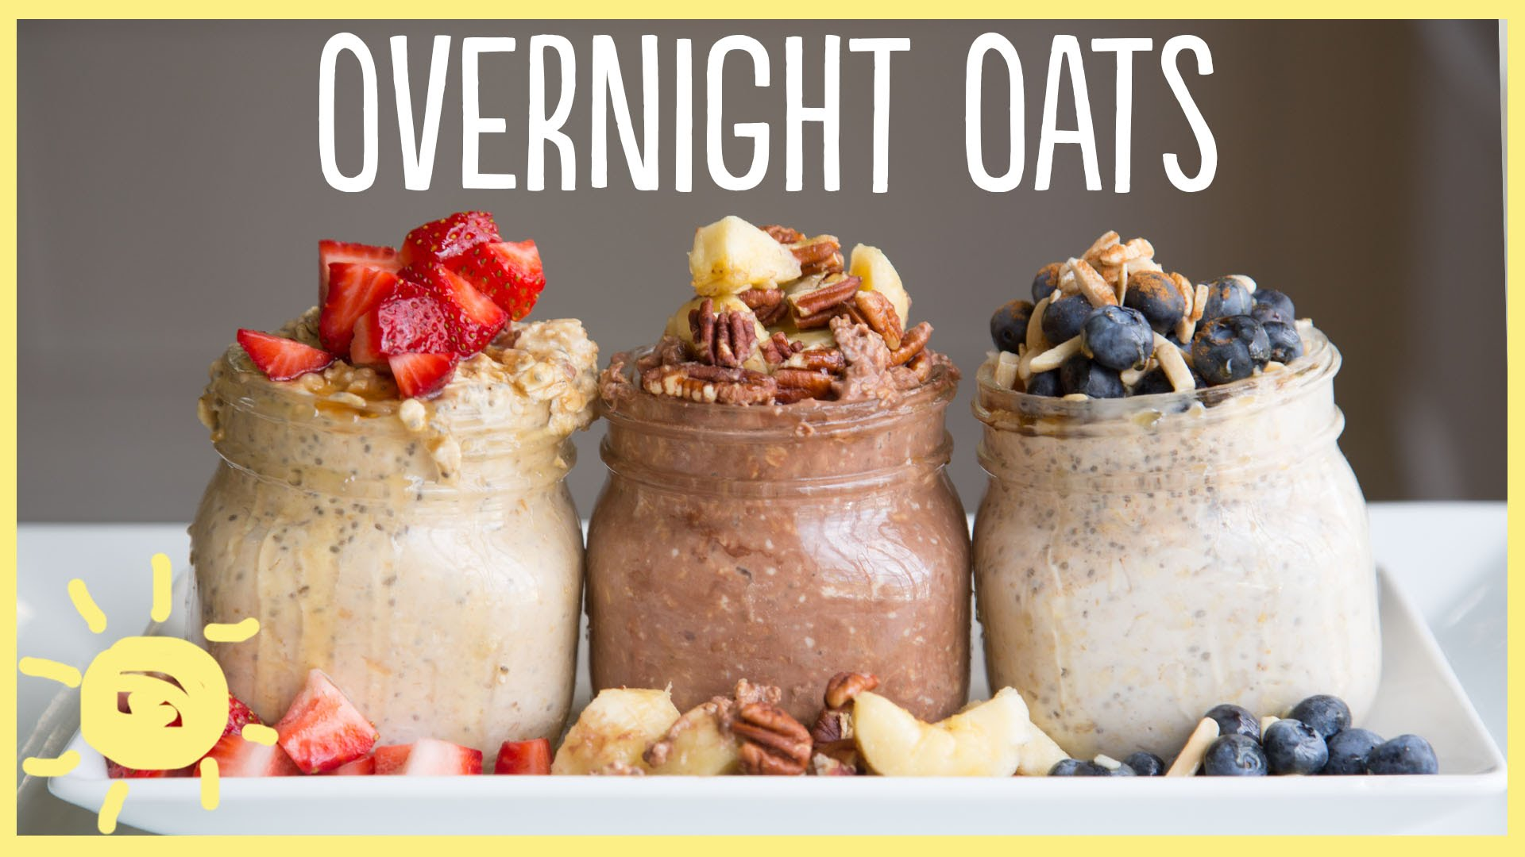

Ingredients:

* 1/2 cup oats, rolled (raw)
* 2 tablespoons walnuts, chopped
* 2 tablespoons dried cherries
* 2 tablespoons dried cranberries
* 2 teaspoons chia seeds
* 1/4 cup yogurt, skim milk
* 1/4 cup milk, skim
* Coconut flakes
* Cinnamon
* Drizzle of honey or maple syrup
* Flax seed (optional)
* Chocolate nibs (optional)
* Chocolate protein powder (optional)
* ½ cup cooked quinoa (optional)

Directions:

1. Add all ingredients to a pint size mason jar.

2. Store overnight in refrigerator or at least 6 hours.

**Overnight Oatmeal -- 5 Delicious Ways!**  
<http://bit.ly/1oIB3qR>  
  
**For the oatmeal:**  
1/3 cup rolled oats  
1 tbsp chia seeds  
¼ cup Greek yogurt  
¼ - ½ cup almond milk (soy, hemp, rice or dairy work too)   
  
**Carrot Cake**  
¼ cup carrot, shredded  
1 tbsp maple syrup  
2 tbsp pecan, chopped (optional)  
¼ tsp cinnamon  
  
**Blueberry Lemon**  
1 tbsp blueberry jam  
½ tsp lemon rind  
¼ tsp vanilla extract  
¼ cup blueberry  
  
**Chocolate Strawberry**  
1 tbsp honey  
1 tsp cocoa powder  
1 tbsp chocolate, shavings  
¼ cup strawberries, hulled and sliced  
  
**Banana Nut**  
1 tbsp honey  
1 tbsp natural nut butter  
2 tbsp walnuts, chopped (optional)  
½ banana, sliced  
  
**Pina Colada**  
1 tbsp honey  
1 tsp coconut, shredded  
1 tbsp almonds, slivered  
¼ cup pineapple, diced  
  
Combine all of the ingredients in a mason jar.   
Add less milk or more milk based on how thick you prefer your oatmeal.  
Shake well and refrigerate overnight.  
Enjoy it cold, straight from the fridge or heat it up for a healthy, hot breakfast!