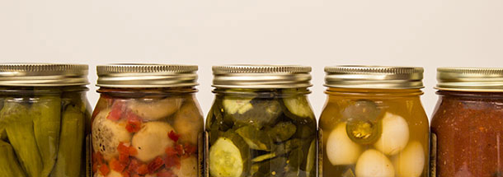

PICKLING

Quick pickles are the simplest pickles to make without any complicated canning steps. You can use almost any vegetable, like cucumbers, baby carrots, cherry tomatoes, cauliflower, green beans, zucchini, or even okra, and after one day, they are ready to enjoy on your favorite sandwich. Feel free to experiment with the brine by using different spices or herbs, like coriander, dill seeds, or chili flakes. Onions and garlic are a favorite too.

* 1-pound baby carrots (about 2 bunches), green stems trimmed to 1/2 inch, peeled, and halved lengthwise
* 1-pound medium cucumbers (about 4), quartered lengthwise
* 1-pound medium zucchini (about 4), quartered lengthwise, then halved crosswise
* 12 ounces’ cauliflower (about 1/2 medium head), cut into 1-inch florets
* 12 ounces’ green beans, stem ends trimmed
* 12-ounce container of cherry tomatoes poked with toothpicks

**Brine 1**

* 1 tablespoon brown mustard seeds
* 1 teaspoon whole black peppercorns
* 1 1/4 cups cider vinegar or regular
* 3/4 cup water
* 1/4 cup granulated sugar (you can omit this)
* 2 tablespoons of kosher salt
* Sprigs of fresh dill
* 1 bay leaf

**Brine 2**

* 1/2 cup cider vinegar or regular
* 1 tablespoon sugar
* 1 ½ teaspoons of kosher salt

**Brine 3**

* 1 teaspoon whole black peppercorns
* 1 1/4 cups cider vinegar or regular
* 3/4 cup water
* 2 tablespoons of kosher salt
* Sprigs of fresh dill
* 1 bay leaf
* 1 clove of garlic spliced
* Sugar (optional)IngredientsServings: Makes about 1/2 cup

1/2 cups apple cider vinegar

1 tablespoon sugar

1 1/2 teaspoons kosher salt

Ingredients

Servings: Makes about 1/2 cup

1/2 cups apple cider vinegar

1 tablespoon sugar

1 1/2 teaspoons kosher salt

**Directions**

1. Pack your vegetable of choice tightly in a 1-quart glass jar, leaving about 1/2 inch of room at the top. Set aside.

2. To make the brine, toast the mustard seeds and peppercorns in a small saucepan over medium heat until fragrant, about 2 minutes. Add the remaining ingredients and stir until the sugar and salt has dissolved. Bring to a boil.

3. Immediately, pour the brine into the jar, making sure to cover the vegetables completely. Allow the mixture to cool to room temperature, about 1 hour. Seal the jar with a tightfitting lid and shake or rotate it to evenly distribute the brine and spices. Store in refrigerator for at least one day (or up to one week) before using. The jar can be kept in the refrigerator for up to one month.

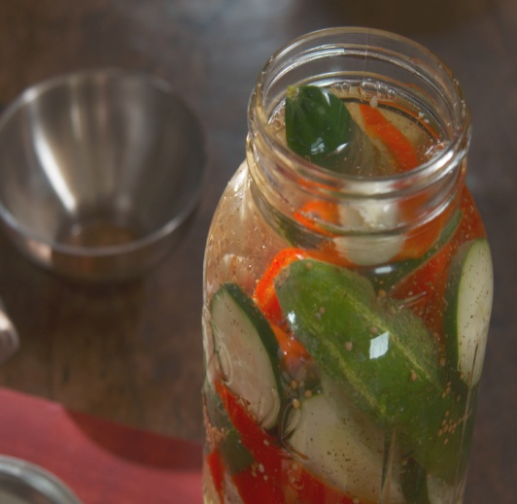**Grandma Ma's French Pickles**

* 2 small Kirby cucumbers, cut into spears
* 1 large garden cucumber, cut into 1/2-inch thick disks
* 1 red bell pepper, cut into 1-inch pieces
* 1/2 head cauliflower, chopped into 1-inch pieces
* 1 cup pearl onions
* 2 cups white vinegar
* 1 cup sugar
* 1/2 cup kosher salt
* 2 tablespoons yellow mustard seeds
* 1 tablespoon celery seeds

**Directions**

* Mix the Kirby cucumbers, garden cucumber, bell pepper, cauliflower and pearl onions in a large glass jar with a lid.
* Put the vinegar, 1 cup water, the sugar, salt, mustard seeds and celery seeds in large pot.
* Bring to a boil over high heat, and then use a funnel to pour the pickling over the vegetables to cover completely.
* Let cool to room temperature, then cover tightly and refrigerate for at least 2 hours before serving. The pickles will keep, refrigerated, up to 2 weeks.

http://www.foodnetwork.com/videos/grandma-mas-french-pickles-0238373.html?ic1=tbla

**Refrigerator Pickles: Cauliflower, Carrots, Cucumbers; You Name It**

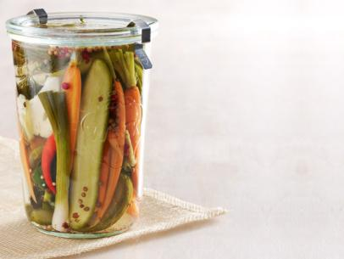**Ingredients**  
For the brine:

* 10 cloves garlic, peeled
* 2 cups white vinegar
* 6 teaspoons kosher salt
* Several sprigs of fresh dill
* 1 teaspoon celery seed
* 1 teaspoon coriander seed
* 1 teaspoon mustard seed
* 1/2 teaspoon black peppercorns
* 1/2 teaspoon pink peppercorns (if you have 'em)

**For the vegetables:**

* 6 Kirby cucumbers, quartered lengthwise
* 6 young spring carrots, peeled and cut in half lengthwise
* 1 handful large scallion pieces or green beans
* A few pieces of cauliflower to tuck wherever they'll fit
* 4 small hot red chiles or 2 jalapenos

**Directions**

* In a medium saucepan, bring 4 cups water to a boil, reduce the heat so the water simmers and add the garlic. Cook for 5 minutes. Add the vinegar and salt, raise the heat and bring to a boil, stirring until the salt dissolves. Remove from the heat.
* In 2 clear 1-quart jars, place a few sprigs of dill. Divide the seeds and peppercorns between the jars. Using tongs, remove the garlic from the brine and place 5 cloves in each jar. Then pack the jars full of cucumbers, carrots, scallions or green beans, cauliflower and chiles. You want them to be tightly stuffed.
* Bring the brine back to a boil, pour it over the vegetables to cover completely, let cool, then cover and refrigerate. The pickles will taste good in just a few hours, better after a couple of days. And they'll keep for about 3 months.

http://www.foodnetwork.com/videos/in-a-pickle-0133019.html

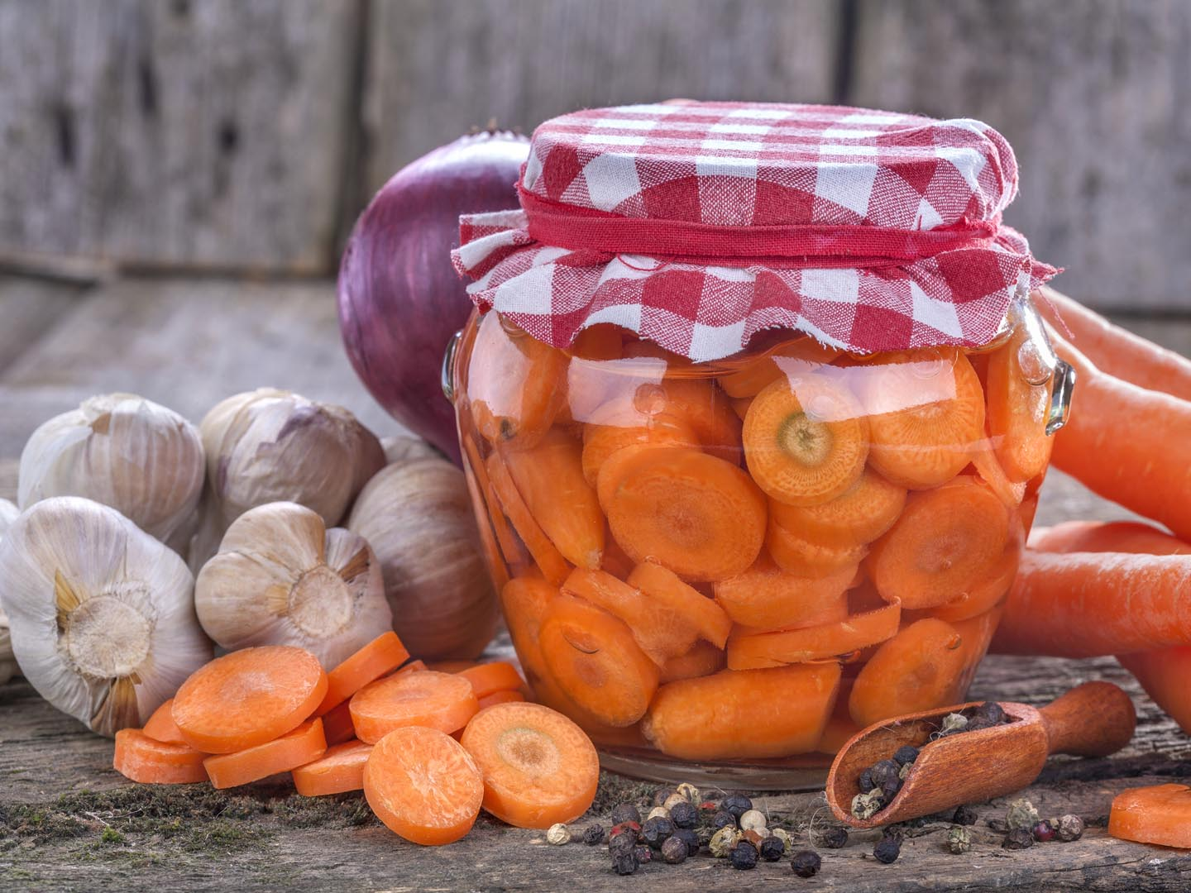**Pickled Vegetables from Dr. Andrew Weil**

Pickled carrots, jicama, cauliflower, and string beans make a healthy snack to have on hand. The carrots offer a great deal of beta-carotene and iron. The jicama and cauliflower provide vitamin C and potassium, and the sting beans have a good deal of antioxidants and also add some color to the combination. The vinegar here is well seasoned with the essence of mustard, dill weed, and garlic, all offset with a hint of sweet and balancing brown sugar. The pickling liquid makes an excellent dressing for any salad.

**Ingredients**

~1/2 pound carrots, peeled and cut in round on the diagonal (about 2 cups)  
~1/2 pound string beans  
~1 small head of cauliflower, broken into florets (about 2 cups)  
~1/2 raw jicama, peeled and cut in half and cut into sticks

**Dressing**  
~2 cups purified water  
~2 1/2 cups cider vinegar  
~1/4 cup olive oil  
~3 tablespoons brown sugar  
~1 teaspoon salt  
~1 tablespoon dill weed  
~6 cloves garlic

**Tips from Rosie’s Kitchen:**

1. Blanching your vegetables makes them porous to absorb flavor from the dressing. Cooling them rapidly shocks the vegetables and stops any further cooking; shocking them quickly keeps your pickles crisp and crunchy rather than limp and rubber.
2. The jicama is porous enough raw, so it doesn’t need to be blanched. Each vegetable is blanched separately because some vegetables need more time than others, and we want them all to be crisp and flavorful.

**1/4 cup pickling spices or:**

~5 bay leaves   
~1 tablespoon mustard seed  
~1 tablespoon dill seed  
~1 1/2 teaspoons red chili flakes

**Instructions**

* Fill a large pot with 5 cups of water and bring to a boil. First drop in the carrots and parboil for 2 minutes, then quickly scoop them with a strainer or large slotted spoon and transfer to a pot filled with cold water and ice to shock them.
* Drop the sting beans into the boiling water and cook just until they turn bright green (about 3 minutes), then quickly transfer them to the ice water. The cauliflower will only need to parboil for 1 minute.
* Let all the vegetables sit in the cold water for a few minutes to cool. Drain the cold water, remove the cooled vegetables to a big bowl, and add the raw jicama.
* Put all the **dressing** ingredients including the pickling spices in a stainless-steel pan set over medium heat, bring it to a boil, and cook for 2 minutes. Pour the cooked dressing over the vegetables and allow them to cool at room temperature.
* Once cooled, put the vegetables into a 1-gallon glass jar or lidded plastic container and fill it with as much dressing as the jar will hold. Cover and refrigerate for 2 days before eating.

https://www.drweil.com/diet-nutrition/recipes/pickled-vegetables/