**CITRONELLA CANDLES (class recipe)**

**Ingredients:**

* All-Natural Citronella Candles Wax (soy or beeswax) This recipe uses a 2 cup tin bucket, so approx. 2 cups wax.
* 25 drops Citronella essential oil (per jar) - (Insect Repellant!)
* Candle wicks Stick or skewer
* Metal clip Jars or clean, empty cans
* Double boiler
* Lavender (optional)

**Directions:**

1. Melt the wax in the double boiler until completely liquefied.

2. Dip the metal end of the wick into the heated wax and press it to the bottom of your jar or can and allow the wax to harden.

3. Wrap the end of the wick around the skewer and use the metal clip to affix the string to the skewer, holding the wick in place.

4. If using the Lavender, add 10-20 drops in the bottom of the jar.

5. Once the wax is completely melted, add the essential oil drops and mix (I used another skewer for this).

6. Carefully pour the melted wax into the jar. Allow to harden completely before removing the clip and skewer and trimming the wick.

7. To use, light in a well-ventilated space to discourage unwanted guests.

**OUTDOORS SPRAY (class recipe)**

Ingredients:

* 1oz witch hazel (I prefer alcohol-free with aloe vera)
* 1oz water
* 2 Purification Essential Oil (Contains Citronella: Insect Repellant!)
  + 2 drops Thieves Essential Oil
  + 2 drops Peppermint Essential Oil

1. Add all ingredients to an 8oz spray bottle. Shake and spray before each use! 2. To enhance your spray even more you can add Citronella, Lemongrass, and/or Tea Tree essential oils

**CITRONELLA CANDLES**

**Ingredients:**

* All-Natural Citronella Candles Wax (soy or beeswax) This recipe uses a 4 cup tin bucket, so approx. 4 cups wax.
* 20 drops Cedarwood essential oil (per jar)
* 30-35 drops Citronella essential oil (per jar) - (Insect Repellant!)
* Candle wicks Stick or skewer
* Metal clip Jars or clean, empty cans
* Double boiler
* Lavender (optional)

**Directions:**

1. Melt the wax in the double boiler until completely liquefied.

2. Dip the metal end of the wick into the heated wax and press it to the bottom of your jar or can and allow the wax to harden.

3. Wrap the end of the wick around the skewer and use the metal clip to affix the string to the skewer, holding the wick in place.

4. If using the Lavender, add 10-20 drops in the bottom of the jar.

5. Once the wax is completely melted, add the essential oil drops and mix (I used another skewer for this).

6. Carefully pour the melted wax into the jar. Allow to harden completely before removing the clip and skewer and trimming the wick.

7. To use, light in a well-ventilated space to discourage unwanted guests.

**OUTDOORS SPRAY**

**Ingredients:**

* 4oz witch hazel
* 4oz water
* 10 drops Purification Essential Oil (Contains Citronella: Insect Repellant!)
* 10 drops Thieves Essential Oil
* 10 drops Peppermint Essential Oil

**Directions:**

1. Add all ingredients to an 8oz spray bottle. Shake and spray before each use!

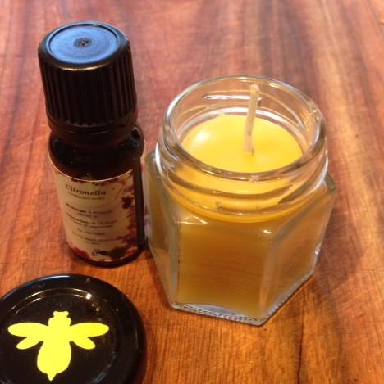2. To enhance your spray even more you can add Citronella, Lemongrass, and/or Tea Tree essential oils

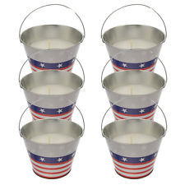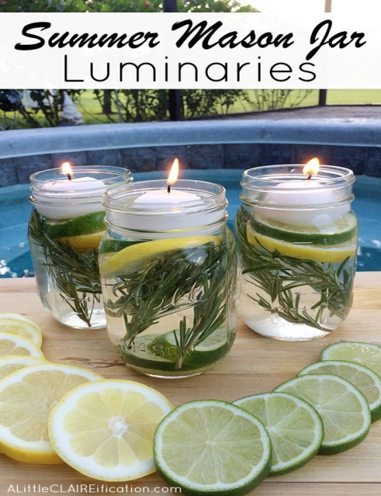

**Citronella oil** is steam distilled from the leafy parts of the citronella plant, also known as Cymbopogon nardus. Thanks to its fresh, welcoming aroma, Citronella essential oil is a common element in perfumes and cosmetic products and is well known for its use in outdoor candles, sprays, lotions, and other camping and outdoor essentials.

As a relative of Lemongrass, Citronella has a slight citrus scent that provides a pleasant and inviting experience whenever it’s used. Its versatility makes it a great household product to add to your beauty routine or to refresh indoor and outdoor spaces.

**Citronella Essential Oil Uses**

* Apply topically before and during outdoor activities.
* Use Citronella's bright scent to sweeten a custom fragrance or diffusion blend.
* Apply topically to refresh and moisturize skin.
* Use as an alternative to deodorant. Combine with [Tea Tree](https://https:/www.youngliving.com/en_US/products/tea-tree-melaleuca-alternifolia) essential oil for added strength.
* Create a [DIY floating candle bowl](https://www.youngliving.com/blog/diy-citronella-floating-candle-bowl) to create a peaceful ambiance and pleasant aroma during outdoor parties.

**How to Use**

1. Topical: Dilute 1 drop with 1 drop of V-6™ or olive oil and apply to desired area as needed.
2. Aromatic: Diffuse up to 30 minutes 3 times daily.
3. Caution: Keep out of reach of children. For external use only. Keep away from eyes and mucous membranes. If you are pregnant, nursing, taking medication, or have a medical condition, consult a health professional prior to use.
4. Storage: Keep in a cool, dark place.

**Thieves® essential oil** is a powerful combination of Clove, Lemon, Cinnamon, Eucalyptus Radiata, and Rosemary essential oils for an aromatic blend that fills any space with a rich, spicy aroma. Inspired by the legend of four 15th-century French thieves who formulated a special aromatic combination composed of clove, rosemary, and other botanicals used while robbing the dead and dying, Thieves is one of Young Living’s most popular products.

With the benefits of Thieves oil including cleaning power and an irresistibly spicy scent, Young Living offers it as an essential oil blend and as an important ingredient in a full range of home cleaning and personal care products, from dish soap to toothpaste. Looking to make your home smell as clean as it looks? Diffuse Thieves oil throughout the house for an aroma that makes every room smell more like fall baking than harsh cleaning formulas.

**How to Use**

1. Topical: Dilute 1 drop with 4 drops of V-6™ or olive oil. Test on small area of skin on underside of arm. Apply to desired area as needed.
2. Aromatic: Diffuse up to 10 minutes 3 times daily.

**Thieves essential oil uses:**

* Refresh musty carpets by adding 5 drops of Thieves to a cup of baking soda; combine well and let sit overnight until the oil is absorbed. Sprinkle over carpets and vacuum thoroughly.
* Diffuse 6–8 drops of Thieves to help create an environment of peace and security. Customize your Thieves experience by adding a few drops of Orange, Tangerine, or Nutmeg essential oil.
* Put in a few drops of Thieves essential oil blend in your dishwater or dishwasher to thoroughly clean dishes and eliminate odor.
* Storage: Keep in a cool, dark place.

**Purification® essential oil**: Ditch overpowering and harsh chemical-based sprays and keep your home smelling fresh and clean with Young Living’s Purification® essential oil. This blend is made up of six essential oils for the ultimate weapon against odors. Citronella, Lavandin, Lemongrass, Rosemary, Myrtle, and Tea Tree work together to create a refreshing, bright scent that keeps you and your family happy and comfortable.

With Purification oil, you’ll never need to feel embarrassed by bad odors from cooking, laundry, pets, or anything else life throws your way. Diffuse it throughout your house or use a more targeted approach so you always feel confident in your home, in the car, or on the go!

**How to Use**

* Topical: Apply 2-4 drops directly to desired area. Dilution not required, except for the most sensitive skin. Use as needed.
* Aromatic: Diffuse up to 30 minutes 3 times daily.
* Caution: Keep out of reach of children. For external use only. Keep away from eyes and mucous membranes. If you are pregnant, nursing, taking medication, or have a medical condition, consult a health professional prior to use.

**Product Tips:**

1. Add a few drops to laundry to give your wash a great-smelling boost.
2. Place a few drops on cotton balls and stash them wherever necessary: the car, closets and drawers, air vents, or shoes.
3. Use in the car with a [USB Diffuser](https://www.youngliving.com/en_US/products/usb-diffuser-black) to eliminate lingering scents of fast food trips or the soccer carpool.
4. Refresh linens with a spritz of Purification, diluted with distilled water.
5. Create an on-the-go air freshener with a spray bottle, distilled water, and Purification. Keep it in your bag to freshen up offices, public restrooms, hotel rooms, and cars.
6. Storage: Keep in a cool, dark place.

**Ingredients**

Cymbopogon nardus† (Citronella) oil, Rosmarinus officinalis† (Rosemary) leaf oil, Cymbopogon flexuosus† (Lemongrass) oil, Melaleuca alternifolia† (Tea tree) leaf oil, Lavandula hybrida† (Lavandin) oil, Myrtus communis† (Myrtle) oil

†100% pure, therapeutic-grade essential oil