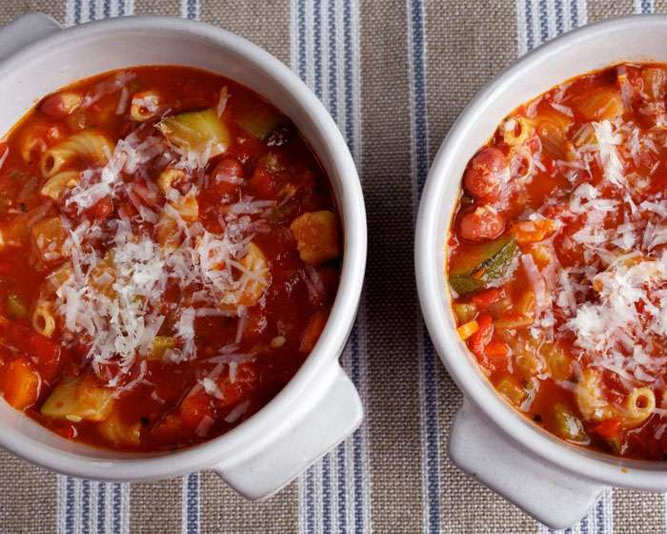**Minestrone Soup**

**Ingredients**

* 2 tablespoons olive oil
* 1 large onion, diced
* 2 ribs celery, diced (1/2 cup)
* 1 large carrot, scrubbed well, then diced
* 1 medium red bell pepper, seeded and diced
* 1 medium zucchini (about 8 ounces), diced
* 4 cloves garlic, minced
* 1 teaspoon dried oregano
* 1 teaspoon dried basil
* 1 teaspoon kosher salt
* 1/2 teaspoon freshly ground black pepper
* 28 ounces canned, no-salt-added crushed tomatoes
* 48 ounces (6 cups) no-salt-added vegetable broth or chicken broth
* 15 ounces canned, no-salt-added small red beans, drained and rinsed
* 1/2 cup dried, whole-grain elbow pasta (optional)
* 1/3 cup freshly grated Parmigiano-Reggiano cheese, for garnish

**Directions**

1. Heat the oil in a large soup pot over medium heat. Once the oil shimmers, add the onion,

celery, carrot and bell pepper; cook for about 6 minutes, stirring occasionally, until they begin

to soften.

2. Add the zucchini, garlic, oregano, basil, salt and pepper; cook, stirring, for 2 minutes.

3. Add the tomatoes and broth; bring to a boil, then reduce the heat to medium-low. Partially cover and cook for 10 minutes, stirring once or twice, then add the beans and pasta. (adding pasta is optional)

4. Uncover; increase the heat to medium-high just long enough to return the soup to a boil, then

reduce the heat to medium-low and cook uncovered for 10 to 15 minutes, until the pasta and

vegetables are tender.

5. Divide among individual bowls; garnish each portion with the cheese.

6. Makes 6 servings; makes 11 1/2 to 12 cups

http://www.elliekrieger.com/recipe/minestrone-soup/