Panzanella with White Beans *(Tuscan Salad)*

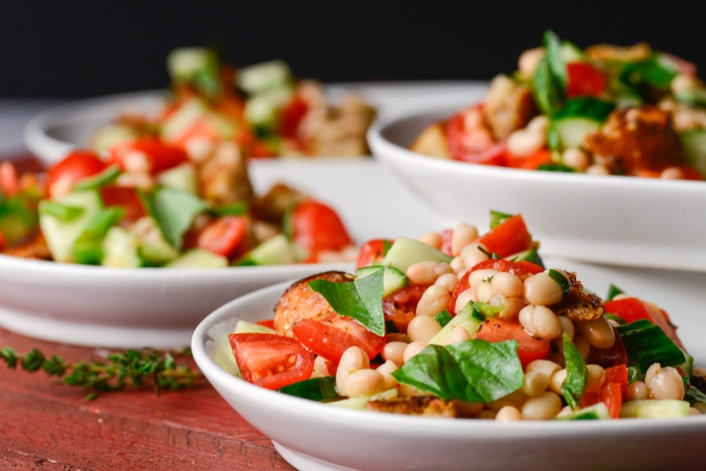

**Ingredients**

* 1/4 cup extra-virgin olive oil
* 1 1/2 cups cubed crusty whole-grain bread (1/2-inch cubes)
* 3 cups grape tomatoes, cut into quarters
* 1 medium English (seedless) cucumber, cut into 1/2-inch dice
* One 15-ounce can no-salt-added small white beans or Great Northern beans, drained and rinsed
* 2 scallions (white and green parts), sliced thinly on the diagonal
* 1 1/2 teaspoons chopped fresh thyme (may substitute 1/2 teaspoon dried thyme)  
  1 1/2 tablespoons red wine vinegar
* 1/2 teaspoon salt
* 1/4 teaspoon freshly ground black pepper
* 8 large basil leaves

**Directions**

1. Heat 1 tablespoon of the oil in a medium skillet. Add the bread cubes and toss to coat. Cook for about 6 minutes, stirring occasionally, until toasted and crisp. Let cool.
2. Toss together the tomatoes, cucumber, beans, scallions and thyme in a large bowl. Drizzle with the remaining 3 tablespoons of oil and the vinegar; season with the salt and pepper, and toss to coat.
3. Fifteen to 20 minutes before serving, add the toasted bread cubes to the bowl. Tear the basil leaves into small pieces, letting them fall into the bowl, then toss to incorporate.
4. Makes 4 servings

http://www.elliekrieger.com/recipe/panzanella-with-white-beans/