**Homemade Granola**

**Ingredients**

* 1 to 1 1/2 cups steel cut oats or Quaker Oaks
* 1/2 to 1 cup whole flax seeds
* 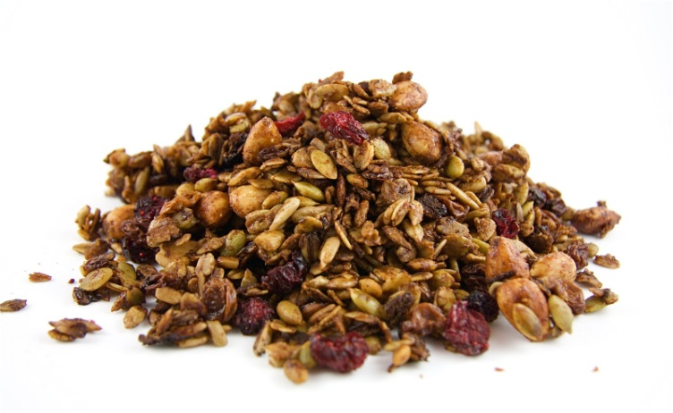1 lb of almonds
* 1 lb of pecans
* 1 lb of walnuts
* 1/2 cup brown sugar (optional)
* 1/2 to 2/3 cup maple syrup (just until moist)
* Cinnamon to taste
* All-spice or nutmeg (optional)
* 1 or 2 tablespoons of vanilla
* Dried cranberries or raisins (optional)

Mix dry ingredients together. Add maple syrup and vanilla. Spread thinly over a cookie sheet (may use wax paper if desired). Bake at 250 to 275 degrees for 1 to 1 hour and 40 minutes. (Ovens vary so 1 hour may be sufficient). Stir periodically and bake until crunchy. Add dried fruit at the end.

# Quinoa-Pumpkin Seed GranolaQuinoa-Pumpkin Seed Granola

**Ingredients**

* **3/4**cup uncooked quinoa, rinsed and well-drained
* **1/2**cup raw pumpkin seeds (pepitas)
* **1/2**cup whole and/or slivered almonds
* **1/4**cup flax seed
* **1/4**cup honey
* **2**tablespoons canola oil
* **1**teaspoon ground cinnamon
* **1/2**teaspoon coarse salt
* **3/4**cup dried cherries, cranberries, golden raisins and/or snipped dried apricots

Directions:

1. Preheat oven to 350 degrees F. In a large bowl combine quinoa, pumpkin seed, almonds, and flax seed. In a small microwave-safe bowl heat honey on 100 percent power (high) for 20 seconds. Stir in oil, cinnamon, and salt. Pour honey mixture over quinoa mixture; toss to coat. Spread in a 15x10x1-inch baking pan.

2. Bake, uncovered, 20 minutes or until golden, stirring twice. Stir in dried fruit. Cool for 15 minutes in the pan. Spread out on foil. Cool completely, breaking up any large pieces. Transfer to an airtight container to store. Store up to 2 weeks in the refrigerator.

http://www.bhg.com/recipe/quinoa-pumpkin-seed-granola/

**Pumpkin Seed Dried Cherry Trail Mix**

Recipe courtesy Claire Robinson, 2009

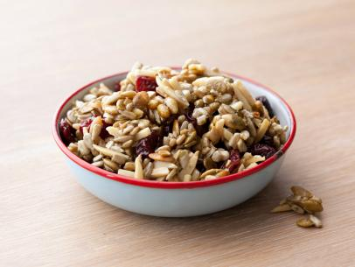**Cook Time**: 20 min

**Level:** Easy

**Serves:** about 6 cups

**Ingredients**

* 2 cups baby pumpkin seeds (pepitas)
* 1 cup slivered almonds
* 3/4 cup raw sunflower seeds
* 6 tablespoons pure Grade B maple syrup (can substitute maple syrup, honey, or agave)
* Coarse salt
* 1 cup dried cherries or cranberries (optional)

**Directions**

Preheat the oven to 300 degrees F. Line 2 baking sheets with parchment paper or silicone baking mats. In a large bowl, toss the pumpkin seeds, almonds, and sunflower seeds and the syrup until evenly coated. Spread the nuts and seeds out, in an even single layer, on the lined baking sheets and season with salt to taste. Bake the nuts, stirring several times with spatula or wooden spoon, until just golden, about 20 minutes.

Cool the nuts completely on the pan then add the cherries and toss to combine. Store cooled trail mix in an airtight container at room temperature.

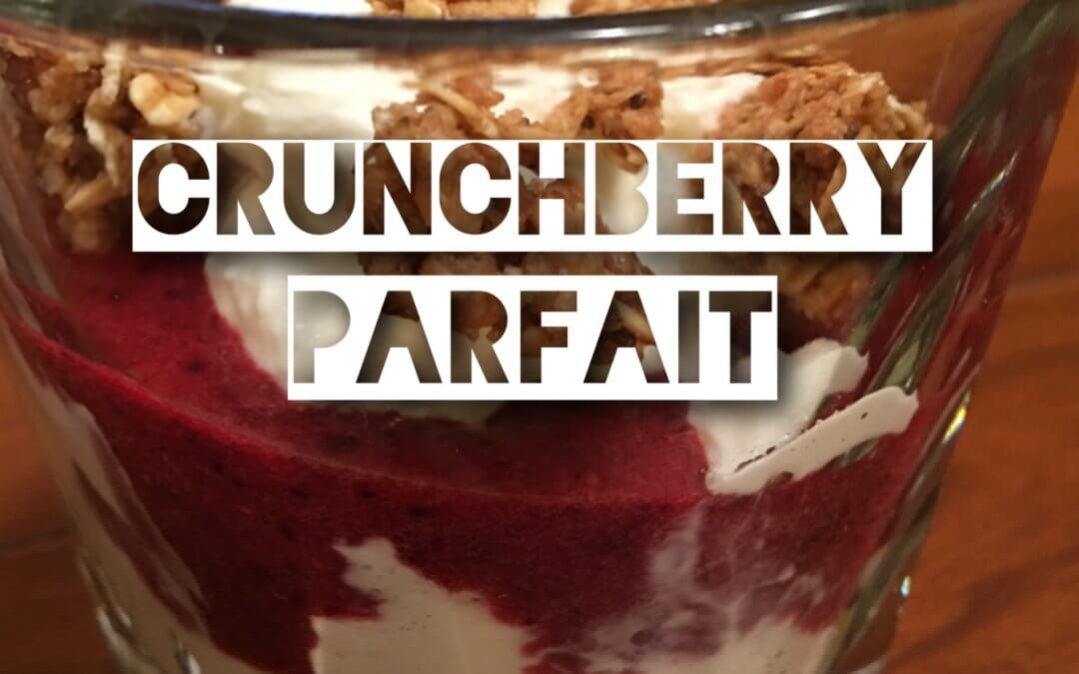**CrunchBerry Yogurt Parfait**

* 1 pint blueberries
* 2 teaspoons pure vanilla
* 2 tabelspoons lemon juice
* 1 cup low-sugar granola
* ½ cup walnuts
* 32 ounces plain Greek yogurt
* 1 teaspoon stevia extract
* 4-6 leaves fresh mint

**Instructions**

In a food processor, puree berries until smooth and transfer to a bowl. Add vanilla extract, lemon juice, and stevia to the berry puree. Chill until ready to assemble parfaits. In individual glasses, layer a few spoonfuls of yogurt, a spoonful of berry mixture, then sprinkle with walnuts. Repeat. Top with fresh mint. Serves 4-6

http://tammygilles.com/2016/10/06/crunchberry-yogurt-parfait/